**Mechanism of Hydroelectric Power Plant**

Student Name

Institutional

Professor

Course

Due date

**The Mechanism of Power Generation in Hydroelectric Power Plants.**

Hydroelectric power, a sustainable energy source, is produced by altering the natural flow of a river or other body of water using a dam or other structure. Utilizing water as a fuel that is neither diminished nor eliminated during the production of electricity, hydroelectric power relies on the infinite, perpetually renewing system of the water cycle (Hu et al., 2023). This study aims to demonstrate how hydroelectric power plants generate electricity using a sketch. It will focus on the functions of various components of a hydroelectric power plant and how they assist in producing electricity. The mechanism of a hydroelectric power plant comprises of the following major parts; high water reservoir, intake structure, penstock, surge chamber, hydraulic turbines, power house, draft tube and tailrace as shown in figure 1.

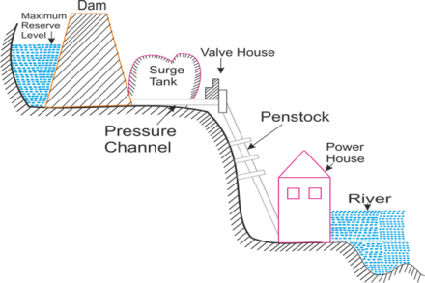

**Figure 1**

*Sketch of a hydroelectric power plant*

High level water reservoir is used to hold water temporarily before entering an intake chamber in a hydroelectric plant. Based on the region's needed water demand, the amount of water to be stored in the reservoir is chosen. The water from the reservoir is gathered by an intake structure, which then sends it into the penstocks. At the entrance to the penstock, there are trash racks to collect the floating garbage that might otherwise seriously harm other components of the hydroelectric power plant. In addition to trash racks, rakes and trolley arrangements for cleaning trash racks, as well as penstock closing gates, are also included in the intake structure.

Penstocks are long, slanted pipes that transport water from the intake structure or reservoir to the turbines. The hydroelectric power plant has a surge chamber, which is a cylindrical tank with an open top that controls the pressure in penstock. It is linked to the penstock and as close to the power house as possible. A hydraulic turbine is also a component of hydroelectric power plant that converts hydraulic energy into mechanical energy, which is then transformed into electrical energy by connecting the turbine's shaft to a generator. In this scenario, when high-pressure water from the penstock strikes the circular blades or runner, it rotates the shaft in the center, causing the generator to produce electrical power in the powerhouse.

A power house is a structure designed to safeguard hydraulic and electrical equipment. Draft tubes are part of the power plant that links the turbine outlet to the tailrace if reaction turbines are being used. The diameter of the draft tube gradually increases to ensure that the water enters the tailrace at a safe rate of speed. Finally, water flows from turbines to a stream and this is known as a tailrace. It is preferable if the power plant is situated close to the stream. According to Zahedi et al. (2022), if the tailrace is positioned far from the stream, a channel must be built to transport water into the stream. Otherwise, the water flow could harm the plant in a number of ways, including through cavitation, damaging the turbine blades, and diminishing turbine performance.

**Explanation of the Major Components of a Reaction Turbine**

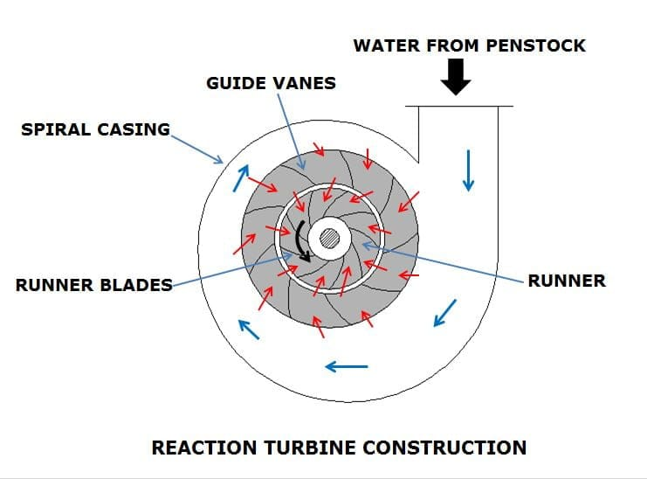The reaction turbine is a type of turbine that creates torque by opposing the mass or pressure of a liquid or vapour. The major components of a reaction turbine include guide vane, draft tube, spiral casing, runner and volute. The various components are explained using figure 2

**Figure 2**

*Major components of a reaction turbine*

The purpose of the guide vanes is to let water pass without hitting the runner. The draft tube is used to convert a significant amount of the kinetic energy leaving the carrier into stress power or pressure energy and to permit the installation of a turbine above the bottom racing category without the head failing. The spiral casing on the other hand is used to accurately measure the liquid's kinetic and potential energy and reach the necessary conclusion for the rational operation of the turbine's runner. Because the cross-sectional area of the casing lessens their notification along the perimeter, this preserves a constant speed straight via numerous entrances that have been provided for the fluid to reach the blades. The runner is where liquid power is transformed into the rotating force that drives the turbine's generator. The most obvious amount of energy from the liquid is captured by its blades. Finally, the main function of a volute is to strengthen the rotor with the ensemble progression at the desired junction to optimize the execution.

**Explanation of the Mechanism of the Reaction Turbine**

Newton's third law of motion serves as the foundation for the reaction turbine's operation. With low heads and high velocity, the water enters the spiral casing. Starting with the guiding vanes, water flows into the runner blades. Guide vanes' primary purpose is to direct water flow so that it strikes the runner's blades at a precise angle to provide the most power. Now the casing, rotor, gearbox, and generator are connected by a shaft. A rotor has a nozzle that discharges water under high pressure. When the water exits the nozzle, it encounters a return or reaction force that rapidly turns the nozzle. Fluid traveling on the runner blades also produces a reaction force. The reaction force causes the runner to rotate. The rotational energy created by the conversion of mechanical energy to rotation is then transformed to electrical energy via the gearbox and generator, where it is then connected to the transmission line (Kumar, 2022). Finally, after passing over the runner blades, the water moves through the draft tube and to the tailrace.

**Major Components of the Impulse Turbine**

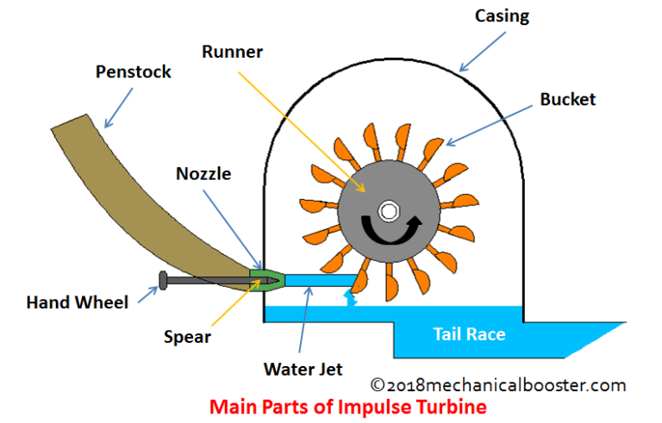The main components of impulse turbine include runner, buckets, nozzle, casing and penstock as shown in figure 3.

**Figure 3**

*Main components of the Impulse Turbine*

The runner is made up of a central cylindrical shaft and a circular disk to which many curving blades also known as buckets are attached. The nozzle adjusts and jets the fluid flow to strike these buckets. Buckets are a series of spoon-shaped cups installed around the runner to transfer energy between the fluid and the turbine. After leaving the nozzle, the fluid jet strikes these buckets, causing the turbine to revolve and exiting the bucket's outer edge. An impulse turbine's casing acts as a screen over the turbine to keep water from splashing and to direct it toward the spillway, which collects surplus water to safeguard the dam's structural integrity (Peng et al., 2023). Penstocks, which are pipelines and channels, are used in hydroelectric power plants to transport water from dams and reservoirs to turbines.

**Mechanism of the Impulse Turbine**

The initial step in the impulse turbine's process of drawing energy from the water is to transform the available head into kinetic energy, which is then released as a high-velocity jet from the nozzle. The nozzle is where the whole pressure drop happens, and the runner runs at constant static pressure. Mechanical energy is created when water splashes against the buckets installed on the runner's outside edge. An impulse turbine has buckets that are fashioned like a double-hemispherical cup. The water rotates through 160 degrees inside the bucket-shaped structure, which is the greatest angle at which the return water may depart without interfering with the approaching flow, and then drops as waste water to the ground below. The cups are made to extract the most energy from the water and are fastened in buckets or bucket-like structures around the edge of the runner.

**The Working Principle of Francis Turbine**

The Francis turbine can be thought of as a hybrid between an impulse and response turbine, with the blades fastening with both the impulse and result forces of the liquid flowing through them to produce energy more effectively. High-pressure water enters the turbine through the snail-shell casing (the volute) in these power plants. Water pressure drops as it curves through the tube in this motion, but the flow rate is unaffected. The water then flows through the guide vanes after passing through the volute and is angled optimally at the runner's blades. The water is fairly redirected sideways as it passes over the runner's precisely bent blades (Yu et al., 2022). As a result, some of the water's "whirl" motion is lost. Additionally, water is diverted in an axial direction so that it is able to exit a draft tube and enter the tail race.

**The Working Principle of Pelton Turbine**

The working principle of the Pelton turbine is through employment of the concept of impulse force. High kinetic energy water is discharged from the nozzle along the runner's route. The water from the nozzle jet pushes the bucket when it makes contact with it; this force is known as the impulse force (Nasir et al., 2023). In order to regulate the amount of water that hits the runner, a spear-shaped or needle-shaped nozzle is attached to the end of the penstock. The turbine receives the water's momentum throughout this procedure. The water's motion causes an impulse force that turns the turbine. In order to balance the wheel (runner), the two twin semi-ellipsoidal buckets split the water jet into two equal halves. This ensures that the water jet is sent to the turbine wheel without interruption. The water jet is integrated into the turbine such that its velocity is double that of the bucket's in order to maximize efficiency and power.

References

Hu, J., Yang, J., He, X., Zhao, Z., & Yang, J. (2023). Transient analysis of a hydropower plant with a super-long headrace tunnel during load acceptance: Instability mechanism and measurement verification. *Energy*, *263*, 125671. https://doi.org/10.1016/j.energy.2022.125671

Kumar, E. A. (2022, February 1). What is Reaction Turbine? Parts, Working, Types Explained in detail [Notes & PDF]. Retrieved from THEMECHANICALENGINEERING.COM website: https://themechanicalengineering.com/reaction-turbine/

Nasir, L. M., Seriki, O. L., & Onche, E. (2023). Modification, Simulation and Demonstration of Laboratory Scale Pelton Turbine for Waterfall Hydropower Plant. *ABUAD Journal of Engineering Research and Development*, *6*(2), 57–72. https://doi.org/10.53982/ajerd.2023.0602.07-j

Peng, N., Wang, E., & Wang, W. (2023). Design and analysis of a 1.5 kW single-stage partial-admission impulse turbine for low-grade energy utilization. *Energy*, *268*, 126631. https://doi.org/10.1016/j.energy.2023.126631

Yu, A., Tang, Y., Tang, Q., Cai, J., Zhao, L., & Ge, X. (2022). Energy analysis of Francis turbine for various mass flow rate conditions based on entropy production theory. *Renewable Energy*, *183*, 447–458. https://doi.org/10.1016/j.renene.2021.10.094

Zahedi, R., Reza Eskandarpanah, Akbari, M., Rezaei, N., Paniz Mazloumin, & Omid Noudeh Farahani. (2022). Development of a New Simulation Model for the Reservoir Hydropower Generation. *Water Resources Management*, *36*(7), 2241–2256. https://doi.org/10.1007/s11269-022-03138-9