**PYTHON AS USED IN ELECTRICAL ENGINEERING**.

Python is a high-level programming language that is widely used in in the field of electrical engineering for tasks such as data analysis, machine learning, and image processing.

In the world of Electrical and Electronics Engineering, Python has come to be a necessary device. Its simplicity, readability, and in-depth library atmosphere make it an ideal match for duties ranging from circuit design and analysis to statistics processing and control structures. This article explores the myriad approaches Python is used in Electrical and Electronics Engineering, showcasing its important position in shaping the destiny of this field.

Python as used in this field is applied in the following areas:

* **Data Analysis and Visualization:** Data analysis is an integral part of Electrical and Electronics Engineering, from signal processing to power machine analysis. Python's libraries, which include NumPy, Pandas, and Matplotlib, offer effective gear for data manipulation, analysis, and visualization. Engineers can maneuver big datasets, perform statistical analysis, and create informative plots and graphs for useful resource selection.
* **Circuit Design and Simulation:** Python is extensively utilized in Electrical Engineering for circuit design and simulation. Tools like SPICE (Simulation Program with Integrated Circuit Emphasis) have Python interfaces, permitting engineers to version and examine electronic circuits correctly. Libraries like PySpice and SciPy simplify the simulation of complex circuits, enabling engineers to test and optimize their designs before bodily implementation.
* **Control Systems:** Python is extensively used in the design and implementation of control structures. Libraries, like manage and SciPy, provide advanced control gadget layout and analysis equipment. Engineers can version, simulate, and manipulate dynamic structures, making Python a critical tool in industries along with robotics, automation, and aerospace.
* **Education and Research:** Python's accessibility and ease of getting to know make it a great desire for academic functions in Electrical and Electronics Engineering. It is extensively utilized in college courses and research projects, empowering students and researchers to discover complex ideas, increase prototypes, and behavior experiments more effectively.
* **Image and Signal Processing:** Python is a powerful language for image and signal processing obligations, which might be common in various electrical and electronic applications. Libraries like OpenCV and SciPy provide a wide range of gear for duties like photo enhancement, item detection, and signal filtering. These competencies are essential in fields such as medical imaging, far-flung sensing, and audio processing.
* **Machine Learning and Artificial Intelligence:** Machine gaining knowledge of and AI are revolutionizing Electrical and Electronics Engineering. Python's system gaining knowledge of libraries, including TensorFlow, Keras, and scikit-analyze, permits engineers to expand predictive models, optimize tactics, and implement clever manipulation systems. These applications are, in particular, vital in strength structures, fault detection, and strength control.

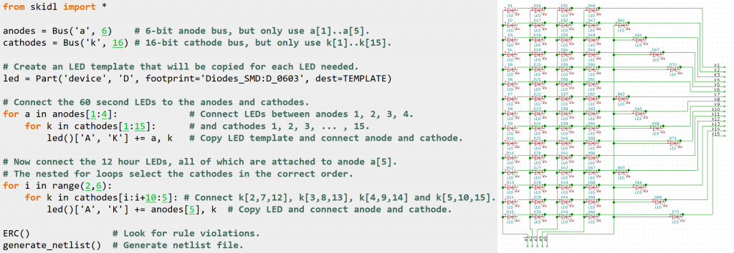

**Reasons for Implementing Python in Electrical and Electronics Engineering.**

**1. Easy Implementation:** When compared to other languages, which include Java.NET, and others, the features, training, objects, loops, and overall syntax are quite simple.

There are a number of Electronics projects that can be both smooth to hold and efficiently meet their needs with the assistance of Python.

**2. Adaptable:** Even if you are an Electronics engineer, knowing a programming language along with Python permits you to paint for your project more definitely due to the fact you can manipulate both hardware and software program difficulties on your very own.

**3. Simple and Flexible:** As an Electronics engineer, Python brings up a global of possibilities, which include report parsing, design automation, statistics, technological know-how, and so forth.

Python has firmly installed itself as an essential device in Electrical and Electronics Engineering. Its versatility, ease of use, and tremendous library support have made it fundamental for circuit design, fact analysis, management systems, IoT improvement, picture and sign processing, gadget learning, and academic functions.

As technology keeps on improving, Python's function in shaping the destiny of Electrical and Electronics Engineering is set to develop, allowing engineers to tackle increasingly more complicated challenges and drive innovation inside the subject. Embracing Python isn't always simply an alternative; it is a necessity for engineers trying to excel within the ever-evolving world of the electrical and electronics era.