Project 2

1. The rock cycle:

The molten rock (magma) is forced to the surface due to pressure underneath. When the molten rock reaches the earth surface it undergoes the solidification process whereby the lava cools due to atmospheric pressure and low temperatures. The solidified magma on the earth surface forms the extrusive igneous rocks. There might be some magma that failed to reach the earth surface, this magma is deposited in cracks and openings in the earth’s crust. The magma undergoes the crystallization process to form the intrusive igneous rocks. The composition in the igneous rocks depend on the magma from which they are formed. They are mainly classified according to their texture and composition.

The igneous rocks undergo the weathering process. This is achieved by different agents of weathering like climate. They are then transported by different agents like rainfall and wind, and thereafter deposited as sediments in low areas. The sediments are deposited on top of one another. Lithification process takes place. This process takes place when sediments are cohesively bound leading to the formation of sedimentary rocks. Sedimentary rocks are classified based on their mineral composition and texture.

The sedimentary rocks then undergo the metamorphism process. The process involves extreme heat and pressure below the earth surface. This is due to the overburden crustal rocks. This process leads to the formation of the metamorphic rocks. The metamorphic rocks then undergo the melting process due to the extreme high temperatures to form the magma. The magma is then forced towards the earth surface again to continue with the cycle.

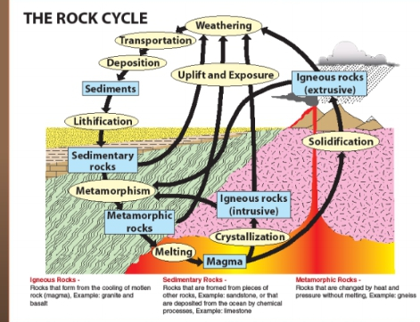

1. Definition of:

Texture:

It describes .the physical characteristics of the minerals such as grain size. Intrusive rocks are course grained while extrusive rocks may be fine grained.

Composition:

It refers to the rock’s specific mineralogy and chemical composition. The cooling history can relate to the changes that occur to the composition of igneous rocks.

1. Definition of rock textures:

Aphanitic:

The texture of plutonic or volcanic igneous rocks with grains that are not visible to the naked eye.it is as result of faster cooling and solidification of liquid magma.

Phaneritic:

Igneous rock texture that describe rocks with large crystals visible to the naked eye.

Porphyritic:

Igneous rock texture in which large crystals are set in a finer grained or glassy groundmass. They occur in course, medium and fine grained igneous rocks.

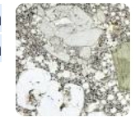

Vesicular:

This rock texture is characterized by a rock being pitted by many cavities at its surface and inside.

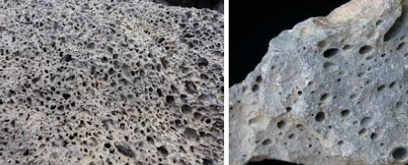

Glassy:

This rock texture is characterized by a block of glass like rock with no visible mineral crystals. It due to extremely rapid cooling that no crystals could form. 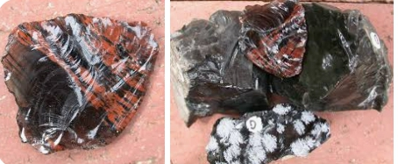

Pegmatitic:

This rock texture is characterized by mineral grains that are exceptionally large. This texture is found in intrusive rocks. 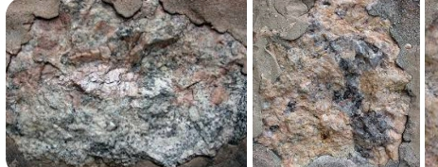

1. Common igneous rock forming minerals:
2. Olivine (Mg,Fe)2SiO4
3. Pyroxene XYSi2O6
4. Amphibole R14[(OH)4Si16O44]
5. Calcium Ca
6. Sodium Na
7. Potassium K
8. Muscovite KAI2(Si3AI)O10(OH)2
9. Quartz SiO2
10. Define:

Ultramafic:

Igneous rocks with extremely low silica composition, being made of almost all olivine and pyroxene.

Mafic:

It is a silicate mineral or igneous rock rich in magnesium and iron. Most are dark in color. Common mafic rocks include basalt, diabase and gabbro.

Intermediate:

It’s a volcanic rock with medium silica composition, equally rich in felsic minerals and mafic minerals. They are commonly dark grey in color and contain somewhat equal amounts of minerals that are light and dark in color.

Felsic:

These are igneous rocks that are rich in feldspar and silicon. They are made up of lighter elements and tend to be more buoyant than mafic rocks.

1. State if it is extrusive/intrusive and whether it is ultramafic, mafic, intermediate or felsic:
2. Peridotite:

It is an intrusive, ultramafic rock.

1. Basalt:

It is an extrusive, mafic rock.

1. Gabbro:

It is an intrusive, mafic rock.

1. Andesite:

It is an extrusive, intermediate rock.

1. Diorite:

It is an intrusive, intermediate rock.

1. Rhyolite:

It is an extrusive, felsic rock.

1. Granite:

It is an intrusive, felsic rock.

1. Three types of volcanoes:
2. Composite volcanoes: they are tall cone shaped volcanoes that produce explosive eruptions.
3. Shield volcanoes: they form very large, gently sloped volcanoes with a wide base.
4. Cinder cones: Are the smallest volcanic landform formed from accumulation of many small fragments of ejected material.