**Types of Data Base System Diagrams**

Name

Institution

Instructor

Course

Date

Database systems are essential software relied upon in organizing a collection of structured information into an interface that allows users to create, assess, update and delete data in a database while also ensuring that a logical framework and processes are maintained. The information structure that defines how a particular database system operates is outlined by a database system diagram. A database system diagram is a graphical representation of the structure of the database in addition to relationships existing between database objects. There are five major database system diagrams which include, relational, hierarchical, network, object-oriented, and entity-relationship diagrams.

Relational Database Diagram

This is the most common type of database diagram and it is generally defined by an information structure that allows the identification and management of attributes of a particular data entity and also accounts for the types of relationships between those tables. According to Dietrich (2021), the relational database system diagram is usually written in structured query language (SQL) and arranges data into tables that are also called relations. The relations are outlined columns and rows where each column lists the attributes of a particular entity of the whole dataset while the rows or tuples provide data on a specific instance of the entity in question such as a particular student’s name or ID number. All the attributes of a particular entity are called a domain. The diagram usually labels a particular or a combination of attributes as the primary key and uses it to evaluate the relationship it has with other data groups also called foreign keys. The main advantages of the relational database diagram include easiness of use since its categorization of data is simple, high accuracy levels as data duplication is limited by the table structure and improved security and collaboration capacity since different users can access and manipulate the data according to access limitations that can be set on even specific columns. On the other hand, the relational database diagram is limited by its structuring and maintenance challenges, inflexibility and lack of scalability issues. These problems arise due to the need for high creativity in organizing data into tables consistent management and optimization and the inability to handle large unstructured data and horizontally scale well when multiple servers or storage structures are involved. The image below shows what a relational database system diagram looks like.

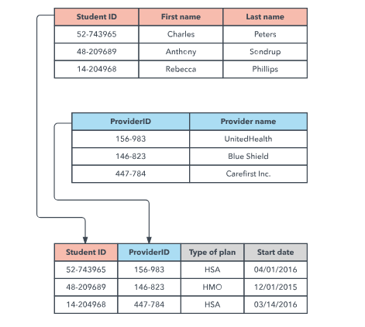

Hierarchical Database Diagram

A hierarchical database is founded on the organization of data in a tree-like information structure that ensures each recorded item has a single root. The data items recorded under the root records or items are aligned in a particular ranking order that is used as the physical order for storing data in the database. The main advantages that come along with using this model are linked with its great capacity to effectively describe real-life problems, undertake fast and efficient data retrieval, and organize data structurally and predictably. Nevertheless, the hierarchical database diagram is disadvantaged by inflexibility and incompatibility shortcomings, lack of standardization, and maintenance and manipulation challenges given that the diagram is based on a simple but rigid structure prone to such operational inefficiencies. An example of the database diagram is shown in the image below.

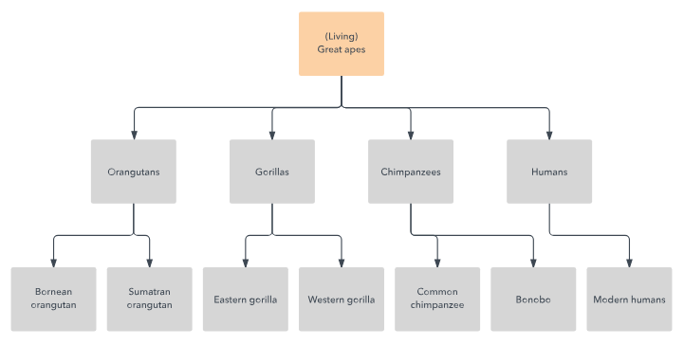

Network Database Diagram

Network database diagrams act as a build-up or transformation of the hierarchical database diagram structure that is based on a set of mathematical theories that are developed according to the related data entities being handled. Each mathematical theory set consists of one parent or root entity and one or more member or child entities. Given its ability to record a member or child data entity in multiple sets, this diagram is acknowledged to come with the advantage of allowing one to effectively describe and understand complex relationships (Hoyt & Muenchen, 2019). Nevertheless, the model requires a high level of technical skills and knowledge to define and manipulate which makes it complex and difficult to design, implement, and maintain. The diagram can be seen in the image provided below.

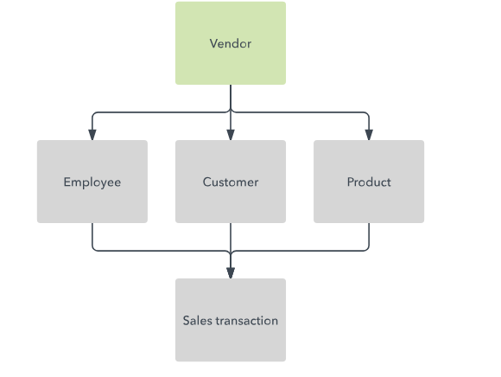

Object-Oriented Database Diagram

The object-oriented database diagram structures the database as a collection of objects or data items that entail associated features and methods. There are two main types of object-oriented database diagrams and they include a multimedia database which focuses on incorporating datasets that are not storable in the relational database system diagram, such as images and the hypertext database that allows one to link any object or entity to any other object. It’s useful for organizing lots of disparate data, but it’s not ideal for numerical analysis. The main advantage of using this database diagram is that it has high data reusability, modularity, encapsulation, and inheritance capabilities which expands its flexibility and applicability. The disadvantages of the database system diagram include being complex, time-consuming, and costly to develop and manage. The diagram is outlined in the image below.

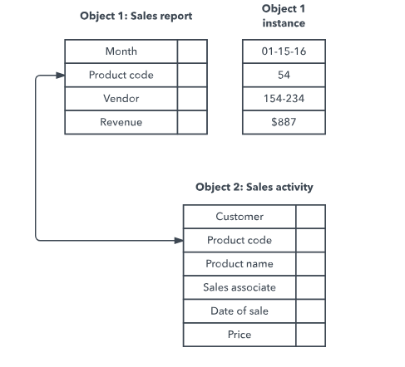

Entity-Relationship Database Diagram

This type of database system diagram is used for capturing data on the relationships between real-world entities without directly binding them to the physical structure of the database. Instead of tying a data entity to a particular physical structure, the entity-relationship database diagram designs the database conceptually where each entity recorded attributes at certain data points to comprehensively make up a domain for that entity (Wang et al., 2022). The database also maps out the relationship between domains and entities within the database system. The main advantages of this database system diagram include being conceptually simple, easy to convert, flexible, scalable, highly integrated, effective to use in communication and a better visual representation of the database structure than some of the older diagrams. On the other hand, the diagram is limited by reliance on user understanding, loss or hiding of information, and lack of representation of data manipulation. The entity-relationship database system diagram looks like the structure in the image below;

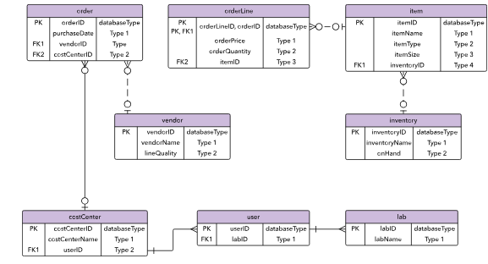

# References

Dietrich, S. W. (2021). *Understanding Databases: Concepts and Practice.* John Wiley & Sons.

Hoyt, R., & Muenchen, R. (2019). *Introduction to Biomedical Data Science.* Lulu.

Wang, S., & Wang, H. (2022). *Business Database Technology.* Universal-Publishers.