**Social Issues & Policies Affecting African-Americans**

Name:

Date:

Like any other race, African-Americans and Black communities in America deserve a chance at getting employed in high-paying jobs and living in safer and cleaner neighborhoods. They deserve to gain access to high-quality health and educational services and perhaps an easier life around the judicial system. The social issues the group encounters shows that there is more that future governments can do to reduce on the injustices. African-Americans and Black communities have social issues related to how they earn an income, how they raise their families, and their ability to own homes. Fortunately, the Biden Administration has made it easier for the Black communities in America, with the new policies the administration continues to implement. There are many issues affecting the community. However, in this paper, the focus is more on the key issues as highlighted below.

**Economic/Financial Inequality**

African-Americans and Black communities in American are generally earning lower and living below the standards of living than any other group in the country. Porter (2021), states that scholars in the country such as Darrick Hamilton, support this argument saying that there are only a few jobs available. Additionally, these jobs are only available to people in positions of power and certain races. The issue stems from the problems the community has faced related to structural racism and stereotypes about Black communities. Some of the stereotypes that the community faces include myths and beliefs that a Black person cannot own or drive an expensive car, or live in a safe and well established neighborhood. It is the same stereotype faced by other groups of Black people in America, which all stem from the past. A look at the wealth distribution margins in Black homes and that of other groups in the country also proves there is a large disparity. Porter's article also shows that racism is one of the many reasons for a lag in pay among the African-Americans (2021). Films are often used by members of the society to depict the kind of issues the people face and only a small percentage are in fictional or fantasy forms. It is not surprising to find most of the films and other entertainment channels depicting the group as economically incapable of taking their children to expensive schools or owning homes.

Data from the Aladangady and Forde (2021) shows that the household wealth for African-Americans is at 15.6% compared to the Caucasians at 86.5% and Hispanics at 10.9%. The figure below is a sample graph provided by Porter, in his newspaper article on the pay progress made by Black workers.

***Figure 1: Graph showing the percentage of earnings between Black and Caucasians***

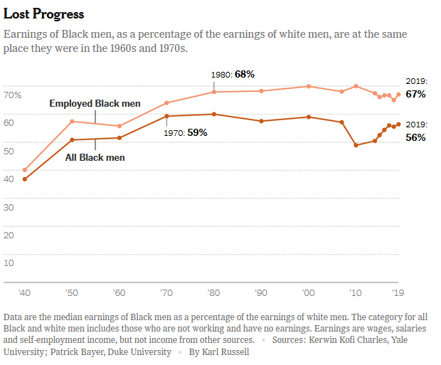

**Source:** Porter (2021)

In some work settings some employers pay some of their employees less salaries compared to their colleagues, for similar tasks or work load. The disparity in payment is as a result of social injustices like racism, stereotypes and gender inequalities. Data from Porter (2021) shows that the percentage of earnings for Black employees is still at the same level as it was in the 1960s and 1970s. Porter (2021) adds that even in instances where the African-American employees have an advanced degree or diploma they still earn slightly lower amounts than their Asian or Caucasian colleagues with a similar level of education.

**Broken Homes/ Increased Single Parent Homes**

The first point on economic inequality partly contributes to the groups' family setups. Black communities are mostly affected when it comes to their family setups. There is a rise of single-parent homes and a diminishing of a father and mother family unit or setup. However, take note that broken families do not always form naturally, a partner may die or the couple can divorce. Some people may argue that one parent is capable of raising the children well just like in any other home. It is true, anyone whether male or female is capable of raising children to the best of their capabilities. The problem comes in when some people voluntarily decide to give their children a single-parent family setup. It is an issue because a single-parent raising a child of the opposite sex, at one point has to seek help from the aunts or uncles of the child. Moreover, it is natural for boys to seek advice from men they view as their guardian father's or male representatives. Girls are also more likely as teenagers to seek advice on some issues from their guardian mothers or female representatives. I believe that most people would want their children to enjoy being raised by both parents. However, some societal issues are unavoidable such as the presence of dead-beat dads and moms. There are also economic disparities in Black communities, where you find that one partner is more economically stable. Hence, in family courts the partner that is more stable financially ends up playing the role of father and mother.

**Higher Crime Rates**

One of the complains I noted from some of my colleagues at school that have had the opportunity of traveling around the world is the constant stereotypes about Black communities in America engaging in some sort of "thug life". There is a general assumption by other groups of people that African-Americans live in un-safe neighborhoods and it is only a few of them that do not have their sons and daughters engaging in crime. It is a stereotype that was earlier created in the 1990s when gangs were more pronounced among African-American families than they are today. One of my friends adds that she was surprised to learn that people were shocked to discover that she came from a family that did not necessarily have to join a gang or any other criminal activity to sustain their lives. In addition, higher crimes rates are likely to emerge in any community that faces structural disparity when it comes to wealth or job allocation and limited job opportunities.

**Lack of Solidarity**

The African-American race and other members of the Black community have constantly become criticized for not supporting each other. For example, a look at the most vulnerable members in the community like the elderly, teenagers, disabled and the less fortunate shows that most seems neglected. Most people on the streets in America are more likely to come from the African-American race. In addition, there is a perception that once a person of African-American decent or any Black community becomes successful, they forget about their friends and relatives who are still struggling. In an article by Nancy Averett, she gives example from experiences of a professor called Mattis who questions why the media constantly portrays Black community as one that is not united and dysfunctional in all aspects. According to Averette (2021), Mattis would always wonder why the media showed members of the Black communities living in societies the scholars would term as dysfunctional. The dysfunctional societies depicted had lower employment rates, higher rates of crime and a proliferation of baby mamas who lack the financial and emotional support for their children. Most notably, the media focused on the negative side of the community than the positive side.

Another way in which African-Americans show they are not united is their treatment of other members of African descent. It is not surprising to hear Africans that have visited the country complaining of poor reception from African-Americans. Most say that they tend to get along easily with Caucasian or Asian Americans than they do with African-Americans. Some argue that African-Americans view Africans in a negative light citing that they blame them for slavery and incapable of governing themselves. The lack of unity between these two groups highlights the need for intervention to bring the two groups together.

**Policies to Change the Social Issues**

**Place-Based Policy**

Macioleck (2020) proposes the use of place-based reforms where the federal government channels in more funds to the Black communities and their neighborhoods. She proposes that the government can invest more in Black community neighborhoods. The investment can be in the form of allocating more federal funds to schools, hospitals, and other public institutions in Black communities. According to Macioleck (2021), about 26% of Black communities live in high-poverty neighborhoods compared to only 5% of their Caucasian colleagues. The high-poverty neighborhoods that Macioleck talks about are characterized by high unemployment rates, low-quality educational and health services and high rates of crime. Hence, the implementation of such a policy should eventually create a trend where African-Americans and Black communities, in general, feel that they have access to high-quality healthcare, education and other government-funded services.

**A Reformed Criminal Justice Policy**

Briefings from the white house show that the current government is using a hands-on approach to change the harsh criminal justice policies used against African-Americans and Black communities. The Biden Administration is making this possible by ensuring there are more Black judges getting hired (The White House, 2021). The hiring and confirmation of more Black judges in the criminal justice system will promote diversity. In addition, hiring more Black judges should prove to the communities that they have members that are skilled, professional and capable of working in good and well-paying jobs. Adding to this point, Maciolek (2020), states that the only way that the systematic-injustices done on African-Americans can change is only when there is a serious policy implementation in the criminal justice system.

**Heirs’ Property Lending Program**

Implementing policies that promote a fair allocation of title deeds and other ownership documents to Black families will result in more legal ownership. According to the briefings from the White House, heirs from Black families have in the past had problems claiming ownership of their fathers’ land because of legality issues related to their land (The White House, 2021). Given their inability to show ownership, heirs from African-American families in rural areas cannot gain access to grants and other financial services. A policy that works on eliminating the issue of land ownership will ensure that more Black families in the future own homes at a higher rate than they do today.

In conclusion, there is still hope for changes in the social lives of Black communities in America. The social issues are many, but highlighting and changing those that affect the community more might just provide the much needed quick relief. As mentioned, earlier, the Biden Administration has made and continues to make things easier for the Black communities in America. A lot of effort and togetherness from the group is a must for the policies and other initiatives to work. The change can only occur if the members of the Black communities actively participate in making and accepting the changes.

**References**

Aladangady, A., & Forde, A., (2021). Wealth Inequality and the Racial Wealth Gap. federeserve.gov. Retrieved June 23, 2023, from https://www.federalreserve.gov/econres/notes/feds-notes/wealth-inequality-and-the-racial-wealth-gap-20211022.html.

Averett, N. (2021). *Social Capital in Black Communities Is Often Overlooked  Altruism, Spirituality and Civic Engagement Are Keys to Resilience*. https://www.scientificamerican.com/article/social-capital-in-Black-communities-is-often-overlooked/

Maciolek, A. (2020, December 15).How we rise: 6 policies to address social problems affecting Black boys and men. Retrieved June 23, 2023, from https://www.brookings.edu/blog/how-we-rise/2020/12/15/six-policies-to-address-social-problems-affecting-Black-boys-and-men/.

Porter, E. (2021, June 28). *Black Workers Stopped Making Progress on Pay. Is It Racism?* Retrieved June 23, 2023, from https://www.nytimes.com/2021/06/28/business/economy/Black-workers-racial-pay-gap.html.

The White House (2021). Fact Sheet: The Biden-⁠Harris Administration Advances Equity and Opportunity for Black Americans and Communities across the Country. whitehouse.gov. Retrieved June 23, 2023, from https://www.whitehouse.gov/briefing-room/statements-releases/2023/02/27/fact-sheet-the-biden-%E2%81%A0harris-administration-advances-equity-and-opportunity-for-Black-americans-and-communities-across-the-country/.