**Semiconductor Assignment**

Student’s Name

Institution Affiliation

Course

Instructor

Date

1. What are semiconductors? Give two examples.

Semiconductors (including metals) possess electrical conductivities between insulators and conductors, making them valuable components in many electronic devices. The conductivity of semiconductors can be altered by adding impurities or applying external electrical forces, with germanium (Ge) and silicon (Si) being famous examples. Silicon is the go-to semiconductor material in electronics due to its abundance and exceptional electrical properties, used extensively in transistors, integrated circuits, solar cells, and solar panel production. Though now less widely utilized, germanium was one of the pioneering materials utilized for electronic device production and was an essential contributor to shaping modern electronics.

1. What is Fermi distribution?

The Fermi Distribution, named after the Italian scientist Enrico Fermi describes the probability of a particle having an energy state in thermal equilibrium with a system. The Fermi distribution is used widely to characterize electron distributions in solid materials. Based on the Fermi Dirac statistics that govern fermions (particles half-integer in spin), the Fermi distribution functions determine the probability of an electron occupying a certain energy level at a particular temperature. The Fermi function considers the Pauli exclusion rule, which states that no two fermions can occupy the same quantum state. The distribution function is close to unity for energies below Fermi (corresponding states occupied) and near zero for energies above Fermi (corresponding unoccupied states).

1. What are p-type and n-type semiconductors?

The p-type and n-type semiconductors are intentionally doped to change their electrical properties. Impurities are used to introduce holes into P-type semiconductors, causing them to become the majority of charge carriers. These impurities, also called acceptors, readily accept electrons in the semiconductor's valence band and leave behind positively-charged holes. Impurities like boron (B) or gallium are commonly used to dope p-type semiconductors. Impurities are used to dope n-type transistors, which introduce extra electrons. Donors are impurities that donate electrons extra to the semiconductor conduction band. Commonly used impurities for doping n-type semiconductors include phosphorus (P) or arsenic (As). These additional charge carriers have a significant impact on conductivity. By forming p-n junctions that exploit each type's different charge carrier properties, n-type and p-type semiconductors can be combined to form electronic devices such as transistors and diodes.

1. Explain the process for fabricating p-type and n-type semiconductors.

Fabricating p-type and n-type semiconductors involves doping, which introduces impurities into the pure semiconductor material to alter its electrical properties. For p-type semiconductor fabrication, a small amount of a group III element, such as boron or gallium, is added to the base material (e.g., silicon). This process is called acceptor doping since these impurities accept electrons and create holes in the valence band, resulting in a net positive charge. For n-type semiconductor fabrication, a small amount of a group V element, such as phosphorus or arsenic, is added to the base material. This process is called donor doping, as these impurities donate extra electrons to the conduction band, resulting in a net negative charge. The doped materials are then heated to allow the impurities to diffuse and incorporate into the crystal lattice. This creates regions with surplus holes (p-type) or excess electrons (n-type), forming the desired semiconductors.

1. What is a p-n junction?

A p-n junction is the junction between two semiconductor types and represents one of the fundamental building blocks of semiconductor devices. Excess electrons from an n-type region diffuse to the p-type region, where they recombine with holes to produce depletion zones that deplete charge carriers; similarly, diodes function like diodes by allowing current to flow in one direction while blocking it in the opposite (reverse bias), similar to how electronic devices such as diodes, solar cells, and transistors control current flow through these junctions.

1. What is the difference between the photoelectric effect and the photo voltaic mechanism?

The photoelectric effect and photovoltaic mechanism are two separate phenomena related to light's interaction with materials. The photoelectric effect refers to electron emission from material surfaces exposed to sufficient light energy; similarly, photovoltaics involve light being converted to electrical current within cells or materials and stored as energy as electricity in batteries for later use. Instantaneously, photons (particles of light) transfer their energy directly into electrons, bypassing materials' work functions. These electrons, known as photo-electrons, depend on the frequency of incident light-emitting. Photovoltaic energy conversion involves using photovoltaic cells or solar cells to convert light energy to electrical energy in an enclosed device called a solar or photovoltaic cell. Solar cells typically consist of semiconducting materials like silicon with p-n junctions for maximum conversion efficiency. As soon as light hits a solar cell, photons with energy more significant than its band gap can generate electron-hole pairs in its semiconductor material, triggering its built-in electric field at its p-n junction to separate charges into voltage differences and electric current. This current can be harnessed for various applications, including powering electronic devices or feeding into the electrical grid.

1. How are batteries different from photovoltaic cells?

Batteries and photovoltaic (PV) cells are different in their principles of operation and the type of energy they store. Batteries are energy storage devices that convert chemical energy into electrical energy. They consist of one or more electrochemical cells that utilize redox reactions to generate an electric current. Batteries store electrical energy and can be discharged over time to power devices. On the other hand, PV cells, also known as solar cells, convert light energy directly into electrical energy through the photovoltaic effect. They are made of semiconducting materials, typically silicon, and produce electricity when exposed to sunlight. PV cells do not store energy like batteries; instead, they generate electricity in real time as long as sunlight is available.

1. What are different technologies used for improving the efficiency of a photo voltaic cell?

Various technologies are employed to improve the efficiency of PV cells. One such technology is anti-reflective coatings on the cell's surface, which reduces the reflection of incident light and increases the amount of light absorbed by the cell. Another technique is the implementation of passivation layers to reduce surface recombination, minimizing electron-hole pair losses. Texturization of the cell surface can enhance light trapping, allowing for better absorption and increased interaction with the semiconductor material. Moreover, developing tandem or multijunction cells that combine different semiconductors with varying band gaps enables efficient utilization of a broader spectrum of sunlight. Additionally, concentrator systems use lenses or mirrors to focus sunlight onto small, highly efficient PV cells, increasing the amount of light per unit area and improving overall efficiency.

1. What is a multi-junction cell? Explain how the efficiency of a cell improved using these techniques.

Multi-junction cells, also called tandem cells, are solar cells composed of multiple semiconductor layers with distinct band gaps stacked on top of one another and designed to absorb different portions of the solar spectrum. For instance, high energy photons from short wavelengths are captured in the top layer while long wavelength ones are in the lower ones. Multi-junction cells offer greater efficiency than single junction cells due to using combinations of semiconductor materials designed specifically to capture specific wavelengths. The top layer absorbs high-energy photons while letting lower-energy photons pass through for further absorption by subsequent layers, thus optimizing solar spectrum utilization. Multijunction cells benefit from sequential photon absorption to achieve greater efficiencies, minimizing thermalization losses and better-matching energy levels with band gaps of different layers. Maximizing absorption across a broader wavelength spectrum maximizes energy conversion efficiency for multi-junction cells.

1. What is the Shockley-Queisser limit?

William Shockley and Hans-Joachim Queisser proposed the Shockley-Queisser limit 1961 as a theoretical limit that measures the maximum efficiency of single-junction solar cells at converting sunlight into electrical energy. Based on thermodynamic principles and sunlight properties, it sets an upper bound on conversion efficiency based on principles such as photon energy levels in sunlight; according to this criterion, the maximum efficiency for such cells at standard terrestrial conditions is roughly 33% (depending on factors like band-gap material used within their construct; thermalization losses); this limit results from photon energy being converted from photon energy which arises due to factors like photon energy available from sunlight; band-gap material used within their construction; thermalization/recombination losses.

1. With a diagram explaining the process of solar-electricity generation in a p-n junction cell.

Figure 1

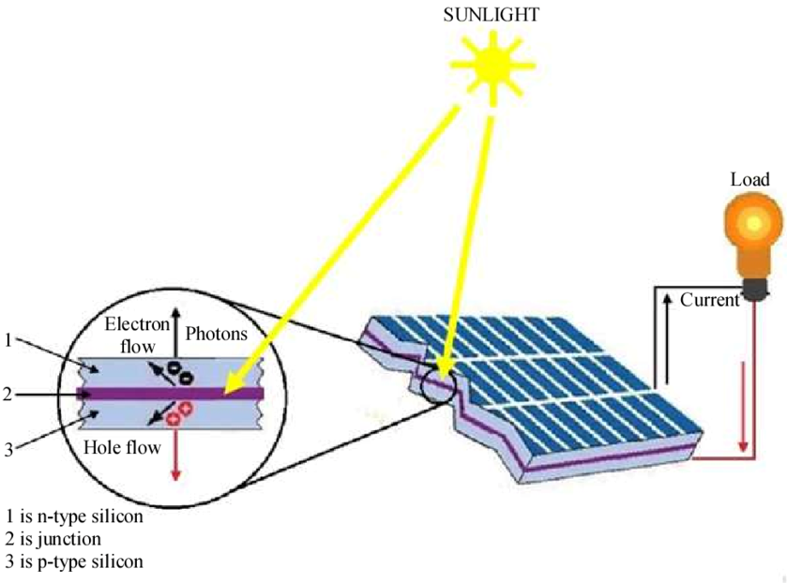

Solar electricity is produced in several steps in a solar panel with p-n junctions. When sunlight (photons), which are higher in energy than the band-gaps of semiconductors (e.g., silicon), strikes the cell's surface, they are absorbed. This absorption causes electrons to move out of the valence into the conduction bands, forming electron and hole pair. The electric field created at the p - n junction separates electron-hole pairs, pushing electrons towards the n-type and holes toward the region of p. This separation produces a voltage at the p-n intersection. The accumulated electrons flow through the external load when connected to the cell. The current is created. The holes move in the opposite direction as the electrons flow. The flow of electrons in the solar cell creates electricity. The process continues as long as the sun shines and an external load is attached.

1. Explain the power and Voltage characteristics of a typical solar cell.15 pages

**Abstract**

Solar cells, also known as photovoltaic cells, convert sunlight directly into electrical energy through the photovoltaic effect. They play a crucial role in harnessing renewable energy from the sun and have become increasingly important in our quest for sustainable power sources. Solar cells' power and voltage characteristics are influenced by incident light intensity, spectrum, temperature, charge carrier separation, and collection efficiency.

Furthermore, aspects of solar cell technology face limitations such as intermittency of solar energy, efficiency constraints, environmental impact, and cost considerations. Strategies to overcome these limitations include energy storage systems, improving efficiency through novel materials and device architectures, sustainable manufacturing practices, and cost reduction efforts. As is widely known, a connection exists between solar cell technology and the global issues of climate change and global warming. The role of solar energy in reducing greenhouse gas emissions and transitioning to a low-carbon economy is significant.

The potential of solar cell technology is immense, but challenges must be addressed. By continuing to advance the technology, improve efficiency, reduce costs, implement supportive policies, and invest in infrastructure upgrades, we can overcome these challenges and pave the way for a cleaner, more sustainable future powered by solar energy. The widespread adoption of solar cell technology can be pivotal in mitigating climate change, reducing dependence on fossil fuels, and ensuring a more resilient and environmentally friendly energy system.

**Introduction**

Solar cells (also called photovoltaic cells) convert sunlight directly into electricity via the photovoltaic effect, acting as key players in our pursuit of sustainable power sources from the sun. Since their invention in the mid-20th century, solar cells have undergone rapid advancement and now find application everywhere, from small-scale portable devices to large-scale power plants.

Power and voltage are essential concepts when discussing the properties of a solar cell. Power is defined as the rate at which energy is transferred or converted, representing how much electrical energy was produced; usually measured in watts (W), it reflects both voltage and current. Voltage measures electric potential differences between two points that determine forceful charge flow - it also measures electrical potential produced by it and measured as volts (V).

The SI (International System of Units) unit for power is the watt (W), named for Scottish engineer James Watt and defined as one joule per second; one joule being one unit of energy. Voltage measurement follows Alessandro Volta, who invented the voltaic pile; 1 V equals 1 J/coulomb of electric charge. Both parameters play an essential role in understanding efficiency and performance in solar cells, with accurate characterization and comparison between various technologies being possible through measurement.

**Literature Review**

Previous solar cell studies have aimed to understand better their working principles, efficiency improvement techniques, and material properties. Many investigations have focused on various types of cells, including silicon-based cells, thin film solar cells, and emerging technologies like perovskite solar cells Deibel, C. (2023). Researchers have explored factors affecting performance, such as light absorption, charge carrier generation processes, recombination, and materials/device architecture influences that influence performance.

So far, solar cells operate using the photovoltaic effect, where semiconductor material absorbs incident photons from sunlight to excite electrons and create electron-hole pairs. Once created, an electric field in the p-n junction separates these charge carriers to generate an electric current through voltage differences at its p-n junction and an increase in the current generation. Their efficiency depends on band gap material quality and optical and electrical losses within their device.

However, more research needs to be conducted. One key area is identifying novel materials with broader absorption spectra and improved charge transport properties to increase solar cell efficiencies. Understanding and mitigating loss mechanisms like recombination and resistive losses remains a significant focus area of investigation. Developing more cost-effective and scalable manufacturing processes for solar cell fabrication is an ongoing challenge. Moreover, solar cells' durability and long-term stability under real-world operating conditions, including temperature, humidity, and irradiance, require further research to ensure their long-term performance and reliability. Deibel, C. (2023). Overall, continued research efforts are needed to advance solar cell technology's efficiency, durability, and affordability for widespread deployment in renewable energy systems.

**Discussion**

Solar cells, also known as photovoltaic cells, harness the power of sunlight to convert it directly into electrical energy. They play a crucial role in renewable energy by providing a clean and sustainable source of electricity. Solar cells have gained significant attention due to their potential to mitigate environmental issues associated with traditional energy sources. The operation of solar cells is based on the photovoltaic effect Green, M. (2023). When sunlight strikes the surface of a solar cell, it excites electrons in the semiconductor material, creating electron-hole pairs. The built-in electric field within the cell then separates these charge carriers, leading to the generation of an electric current. This electricity can power various devices, from small-scale applications like calculators and streetlights to large-scale solar power plants that feed electricity into the grid.

Solar cells offer numerous advantages. They provide a renewable and abundant energy source since sunlight is freely available. Solar energy is also clean and does not produce greenhouse gas emissions, contributing to reducing environmental pollution and climate change. Moreover, solar cells can be installed and distributed, allowing energy generation at the point of use, reducing transmission losses, and increasing energy resilience Deibel, C. (2023). Solar cells continue to advance in efficiency, cost-effectiveness, and versatility as the demand for sustainable energy grows. Ongoing research and technological advancements aim to improve the performance of solar cells, making them more accessible and widely adopted as a critical component of the global transition to clean and renewable energy sources.

**Power Output**

Several key factors influence the power output of a solar cell. First and foremost, the incident light intensity plays a crucial role. The power output is directly proportional to the amount of light energy the solar cell receives. Higher light intensity results in more photons being absorbed, leading to an increase in the generation of electron-hole pairs and, consequently, higher power output. Another factor is the spectrum of the incident light. Solar cells possess different absorption characteristics for different wavelengths of light. Their power output is optimized when its spectrum aligns with the semiconductor material used to construct it; variations due to atmospheric conditions or different light sources may compromise this outcome and reduce cell output.

Temperature also has a profound impact on solar cell performance. As temperatures increase, the charge carrier separation and collect efficiency may diminish due to higher recombination rates. Higher temperatures can alter the electrical characteristics of solar cells and lead to decreased power output, so we must recognize their thermal effects and devise plans to mitigate them for maximum performance. Deibel, C. (2023). Efficiency in charge carrier separation and collection is a crucial power output component. Effectively separating electron-hole pairs at different electrodes is necessary to maximize power output. Recombination losses at the surface and within bulk materials of solar cells can reduce overall efficiency and power output, thus necessitating design and materials selection optimization to optimize charge carrier separation while limiting recombination losses to increase these devices' power output. Optimizing materials that promote charge carrier separation while decreasing recombination losses is essential in increasing power output.

Solar cell power output is determined by incident light intensity, spectrum, temperature, charge carrier separation, and collection efficiency. Understanding and optimizing these factors are vital for improving solar cell performance and efficiency in converting sunlight to electrical energy. Ongoing research seeks to develop advanced materials, device architectures, and optimization techniques to maximize power output under differing operating conditions.

**Voltage Characteristics**

Voltage and current are critical components in defining the voltage characteristics of solar cells, while electric fields at their p-n junction play an essential part in setting their voltage difference. As sunlight hits a solar cell, it excites electrons in its semiconductor material to form electron-hole pairs that the built-in electric field separates, pushing electrons toward its n-type region. At the same time, holes move towards its p-type region. Separation creates a voltage difference across the cell. How much voltage a solar cell produces is determined by factors such as incident light intensity, charge carrier separation efficiency, and internal resistance losses within its resistive losses. Under open-circuit conditions, where no external load is connected to a solar cell, its voltage reaches maximum while no current flows through. This characteristic voltage represents the maximum potential difference across the cell and can accurately reflect its performance characteristics.

As external loads connect to a solar cell, its voltage drops due to increased current flow; its I-V curve typically depicts this relationship between voltage and current flow. I-V curves provide valuable insights into the behavior of solar cells under various operating conditions. They depict voltage and current characteristics such as short-circuit current (Isc), open circuit voltage (Voc), maximum power point (MPP), and fill factor. Voltage characteristics of solar cells play a vital role in determining their maximum power output and efficiency, with researchers looking to optimize both design and materials to increase voltage characteristics to enhance solar cells for increased performance Green, M. (2023). Attempts are made to minimize resistive losses, enhance charge carrier separation and limit recombination to create a higher voltage across them. Materials, device architectures, and optimization techniques are constantly being explored to maximize these characteristics and optimize the overall efficiency of these panels.

**Maximum Solar Cell Power Point**

The Maximum P of a solar cell is the operating point where its output reaches its highest potential power output, which is an essential determinant of efficiency and performance. The MPP represents the optimal balance between voltage and current at which power production peaks; also alter this equation with incident light intensity changing its position, shifting with changing irradiance or shading effects and shifting closer towards higher currents with lower voltages increasing power production output.

Temperature can also play an influential role. Solar cells exhibit temperature-dependent characteristics, including changes to their voltage and current. Open circuit voltage decreases in higher temperatures while short-circuiting current increases significantly. Temperature fluctuations may alter the position and stability of an MPP, impacting its overall output from solar cells. Furthermore, the materials used can affect their placement and stability. Factors such as the band gap of semiconductor materials, junction quality, and cell recombination rates all impact voltage and current responses; optimizing these material properties can improve MPP location and stability. Resistive losses within solar cells can also impact their MPP, with internal resistances like series and shunt resistance leading to voltage drops and current losses. Minimizing these resistive losses through appropriate cell design, contact materials, and interconnections are crucial to reach stable MPP and maximizing power output.

Maximum Power Point Tracking (MPPT) techniques identify and sustain an MPP in solar cells. MPPT algorithms adjust load or operating conditions to maintain an MPP under changing environmental and operating conditions and ensure optimal power production Deibel, C. (2023). Factors influencing an MPP include incident light intensity, temperature, material properties, and resistive losses. Thus, understanding and optimizing these factors through appropriate cell design materials and MPPT techniques is critical to maximizing solar cell power output and efficiency.

**Effect of Temperature**

The temperature enormously influences a solar cell's power and voltage characteristics, as its outputs become subject to additional influences as it warms. One important aspect of solar cells is the temperature coefficient, which measures changes in power or voltage based on temperature changes. A temperature coefficient may be positive or negative depending on its direction and magnitude of change. Positive temperature coefficients indicate that as temperature increases, power, and voltage decline. Conversely, negative coefficients indicate increased power and voltage as the temperature rises. Temperature coefficients depend on the materials and technologies utilized within solar cells and may differ accordingly.

Temperature changes also cause thermalization, which refers to the interaction between charge carriers, lattice vibrations, and other thermal processes. At higher temperatures, charge carriers increase energy, enhancing thermalization effects. Recombination rates increase, and efficiency decreases due to this condition, with both power and voltage outputs becoming less productive as recombination increases. Temperature changes also impact the electrical properties of materials used for solar cells. Temperature can cause the conductivity of semiconductor materials to increase, leading to higher current but lower voltage outputs. Furthermore, changes in the band-gap energy of materials may alter photon absorption and voltage characteristics accordingly.

Thermal management techniques can be employed to reduce the detrimental effects of temperature on power and voltage output. They aim to regulate and decrease the operating temperature of solar cells while simultaneously decreasing thermalization for improved overall performance. Thermal management strategies may include heat sinks and passive and active cooling systems. Temperature is an influential factor in solar cell power and voltage output characteristics. Temperature coefficient and thermalization play critical roles in influencing how power and voltage change with temperature, so understanding these effects and creating effective thermal management strategies are essential for optimizing solar cells across all temperature variation conditions.

**Efficiency Consideration**

Efficiency is paramount when considering solar cells since their primary goal is converting sunlight into usable electrical energy. Solar cell efficiency can be measured as the ratio between power output and input; higher efficiency indicates its ability to convert sunlight to electricity more effectively. Solar cell power, voltage, and efficiency are complex, with many trade-offs and challenges (*New Efficiency Record for Solar Cell Technology*, 2022). Both power and voltage are essential in improving overall solar cell efficiency. Higher power output indicates more electrical energy being generated while increased voltage reflects its strength; however, both factors come with a price; increasing power usually leads to decreased voltage or vice versa. This trade-off arises from power being the product of voltage and current, and adjusting one parameter can impact the other. Therefore, finding the optimal balance between power and voltage is crucial for maximizing the overall efficiency of a solar cell.

Challenges arise in the pursuit of simultaneously maximizing power output and efficiency. One challenge of solar cell design lies in minimizing losses. Resistive losses, including series and shunt resistance, can lower power output and reduce efficiency; improving solar cell materials, design, and interconnections can help mitigate these losses and boost power and efficiency. Green, M. (2023). Another hurdle lies with charge carrier separation and collection efficiency: for optimal electron-hole pair separation to avoid power losses that occur from recombination. Optimizing quality p-n junctions or material properties may enhance this aspect and increase power and efficiency.

Solar cells possess different absorption characteristics for different wavelengths of light. Design solar cells that can use as much of the solar spectrum as possible to maximize power output and efficiency. Finding an optimal balance between power, voltage, and efficiency in solar cells presents both trade-offs and challenges. Optimizing this relationship is vital to maximizing efficiency. Minimizing losses, improving charge carrier separation and collection rates, and considering incident light spectrum considerations are critical elements in realizing higher power output and efficiency for solar cells. Ongoing research into materials, design, and optimization techniques is vital in meeting these challenges and taking the efficiency of solar cells to new heights.

**Characterization**

Characterization involves measuring and evaluating the properties, behaviors, and performances of materials, devices, or systems over time. Characterization involves collecting data and information through various experimental techniques and analysis methods to fully comprehend a studied object (Green, M. 2023). Characterization aims at uncovering its core attributes, functional capabilities, and limitations. Characterizing solar cells involves measuring power, voltage, current, efficiency, spectral response, and charge carrier dynamics to gain insight into their performance, behavior, and quality. Characterization techniques aim to portray how sunlight converts into electricity and responds to different environmental or operating conditions.

Numerous experimental techniques and methodologies are utilized to accurately and reliably assess and characterize solar cell power and voltage characteristics, with one widely-utilized technique measuring current-voltage (I-V) curves. Solar cells are subjected to various voltage biases while measuring current flow with this technique. This results in an I-V curve spanning from open circuit voltage through short circuit voltage, measuring its effect on current. It offers valuable information regarding parameters such as open-circuit voltage, short-circuit current, and maximum power point.; see the figure below for an I-V curve:

Figure 2

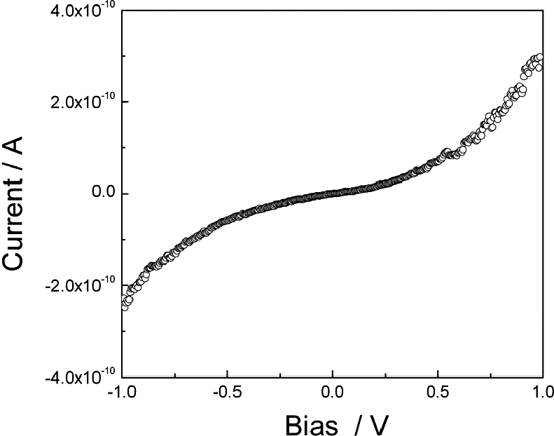

Another technique in solar cell characterization is measuring power-voltage (P-V) curves. This method measures solar cell power output at various voltage biases by multiplying voltage and current values at each point on the P-V curve, with calculations on its maximum power point location and output values (see figure below for an illustration of the power-voltage curve).

Figure 3

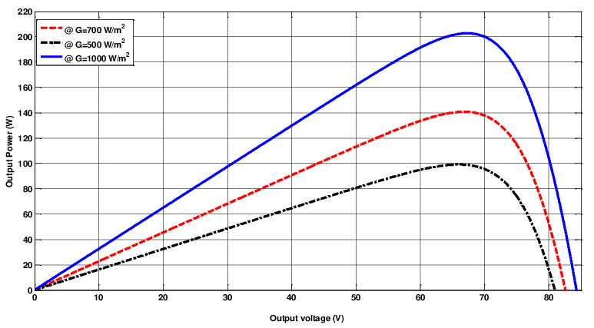

External quantum efficiency (EQE) measurements can also help characterize solar cells' performance. EQE measures how efficiently a solar cell converts photons to electric current as a function of wavelength; its spectrum can be obtained by observing how much current it generates at each wavelength; these measurements provide information about the solar cell's spectral response as well as charge carrier generation and collection efficiency across its solar spectrum.

Transient response techniques like time-resolved photoluminescence (TRPL) are used to study carrier dynamics within solar cells Green, M. (2023). TRPL measures light emitted from a cell after receiving an excitation pulse. It analyzes its decay over time to provide valuable information about charge carrier recombination rates and lifetimes, offering insight into its efficiency as an energy conversion technology.

Characterization techniques such as current-voltage (I-V) curves, power-voltage (P-V) curves, external quantum efficiency (EQE) measurements, and transient response techniques play an integral role in understanding and evaluating solar cells' power and voltage characteristics. They provide vital data about performance, efficiency, and behavior under various operating conditions - ultimately leading to more cost-efficient and effective solar cell technologies being developed.

**Performance Evaluation**

Solar cells' performance evaluation involves evaluating various metrics that characterize their efficiency, power output, and overall performance. Critical metrics for assessing solar cells include fill factor (FF), which measures power conversion efficiency. It can be calculated as the ratio between the maximum power output of the cell and the product of open circuit voltage (Voc) and short circuit current (Isc). This represents how efficiently power can be delivered, considering losses caused by recombination, resistive, and non-ideal behavior losses. A higher fill factor value indicates increased power conversion efficiency.

Voc (Open circuit voltage) is another crucial metric, measuring the maximum voltage a solar cell can generate when no external load is connected, representing its electric potential difference across its surface without current flow; higher open-circuit voltages indicate more potential for power generation. Conversely, Isc (Short Circuit Current) measures the maximum current that flows through a solar cell terminal being shorted together; higher short-circuit currents indicate a more remarkable ability to convert incident light into the electrical current output from incident light sources.

Maximum Power Point Tracking (MPPT) techniques optimize a solar cell's power output. MPPT does not rely on one metric; instead, this technique continuously tracks and adjusts the operating conditions of the cell in order to produce maximum output power. MPPT algorithms use MPPT algorithms to adjust solar cells' load or operating point to achieve their maximum power point (MPP), representing an ideal balance between voltage and current for maximum power generation. These metrics collectively provide a comprehensive evaluation of solar cells' performance, allowing researchers and engineers to compare technologies, designs, operating conditions, and cell efficiency/performance between technologies/designs/operating conditions. By understanding and optimizing these metrics, researchers/engineers can improve solar cells' efficiency/performance ratios, encouraging the widespread adoption of renewable energy as an environmentally sustainable power source.

**Power and Voltage Optimization**

Recent advancements in solar cell technology have focused on optimizing power and voltage characteristics to boost overall performance and efficiency. Various strategies and techniques have emerged for optimizing these parameters in solar cells. One area of advancement lies in exploring novel materials for solar cell fabrication Aghaei et al., (2020). Materials with improved light absorption properties, such as perovskites and quantum dots, have proven promising in increasing power output. These materials facilitate broader absorption spectra, capturing more of the sunlight's wavelengths and increasing photon capture rates. Tandem or multijunction solar cells utilizing multiple semiconductor materials with differing band gaps allow more effective spectrum utilization and increase power output.

Innovative device architectures have also been introduced to optimize power and voltage characteristics. Nanostructured interfaces such as nano-textured surfaces or back contacts improve light trapping and increase light absorption within solar cells, leading to more significant electron-hole pair generation and higher power output. Furthermore, passivated and carrier-selective contacts have also been implemented as innovative designs to minimize recombination losses while increasing open circuit voltage.

Light management techniques have attracted increasing attention for power and voltage optimization in solar cells. Antireflection coatings, plasmonic nanoparticles, and light-concentrating systems like lenses or mirrors have proven highly successful at increasing light absorption and photon intensity. With the use of techniques designed to manage incident light efficiently, these strategies maximize power generation and enhance voltage characteristics in solar cells. Advancements in power electronics have played a crucial role in optimizing both power generation and voltage in these solar cells. Technologies such as maximum power point tracking (MPPT) algorithms and power converters facilitate efficient voltage regulation and conversion. MPPT techniques use dynamic adjustments of operating conditions of solar cells to ensure they operate at their maximum power point, increasing output. Power converters such as inverters efficiently convert DC power generated by solar cells into AC power for grid integration while minimizing losses and improving system performance.

Recent advancements in solar cell technology have introduced various strategies to optimize power and voltage characteristics. Utilizing novel materials, innovative device architectures, light management techniques, and advancements in power electronics have collectively contributed to improving solar cells' power output and voltage performance. Continued research and development in these areas are expected further to enhance solar cell technology's efficiency and effectiveness, making it an increasingly viable and sustainable renewable energy source.

**Limitations**

While solar cell technology holds great promise for harnessing renewable energy, certain limitations are associated with its implementation and the underlying principles of the photovoltaic effect. One significant limitation is the intermittent nature of solar energy. Solar cells generate electricity only when exposed to sunlight, making them dependent on weather conditions and daily sunlight availability. This intermittency challenges providing a consistent and reliable power supply, especially in areas with variable weather patterns (*Solar Photovoltaic Technology Basics*, n.d.). Energy storage systems, such as batteries, are often required to store excess energy during periods of low sunlight, increasing the complexity and cost of solar energy systems.

The efficiency of solar cells is another limitation. Despite significant advancements, current solar cell technologies have efficiency limitations that affect how much energy can be converted from sunlight Aghaei et al., (2020). The maximum theoretical efficiency based on the Shockley-Queisser limit for single-junction solar cells is around 33.7%. Real-world solar cells typically have lower efficiencies due to reflection losses, thermalization, and non-ideal behavior. Enhancing efficiency through improved materials, design, and manufacturing techniques remains an active area of research. Environmental impacts associated with solar cell production and disposal are also of great concern, with manufacturing processes often using energy-intensive and harmful materials. In contrast, end-of-life solar panels present additional waste management and recycling issues. Therefore, sustainable manufacturing techniques, as well as efficient recycling systems, must be established in order to alleviate such concerns.

Cost remains one of the significant barriers to widespread solar cell adoption. While solar cell costs have steadily reduced over time, they are still relatively higher than conventional energy sources. Factors including materials costs, manufacturing processes, and installation all play an integral part in determining the overall costs associated with solar energy systems. Further research and technological innovations are crucial to reduce costs and make them more accessible to a broader population. Solar cell technology and photovoltaic effect both present several limitations that should be considered, including intermittency of solar energy production, efficiency restrictions, environmental impacts, and costs. Addressing these limitations requires ongoing research and development to create innovative energy storage, increasing solar cell efficiency for sustainable manufacturing costs. By overcoming these constraints, solar cell technology will become an even greater force in meeting global energy demands while contributing toward creating a cleaner and more sustainable world.

**Overcoming the limitations**

In order to address the limitations of solar energy, various approaches are being investigated. Energy storage systems have been created to accommodate its intermittent nature; surplus energy during sunny periods can be stored away until needed (*A New Efficiency Record in Solar Cell Technology*, 2022). The development of battery technologies such as lithium-ion cells has enabled efficient and cost-effective solutions for energy storage. Innovative techniques such as compressed air energy storage and pumped hydro storage are also being investigated to store solar power in alternative forms.

Enhancing the efficiency of solar cells is an area of intense study. Researchers are exploring various strategies to increase efficiency, such as creating multi-junction cells that capture more of the solar spectrum; using advanced materials, such as perovskites and quantum dots in cell designs for higher efficiency; designing tandem structures and light trapping designs with light-trapping designs to maximize light absorption while minimizing losses; as well as research into novel concepts like hot carrier solar cells and multi-excitation generation in order to extract maximum energy from each photon that enters solar cells; among many others.

In order to reduce the environmental impacts associated with solar cell production and disposal, efforts are being made to establish sustainable manufacturing processes. This involves using less hazardous materials for production techniques and adopting recycling programs for end-of-life panels. Material science advancements aim to produce eco-friendly, non-toxic materials for solar cell manufacturing. In contrast, thin film solar cells or roll-to-roll production may offer opportunities to lower material consumption while improving eco-footprint.

Cost reduction is critical to addressing the limitations of solar cell technology. Ongoing research and development efforts are driving advancements in manufacturing processes that lead to economies of scale and increased cost-effectiveness. Increased production capacity, technological innovations, and competition within the solar industry have all significantly affected the costs of solar cells. Continued efforts to optimize materials, increase production efficiency and streamline installation processes will further reduce costs - making solar energy more affordable and accessible to broader adoption Aghaei et al., (2020). Solar cell technology and photovoltaic effect limitations can be mitigated through advances in energy storage technology, improved efficiency measures, sustainable manufacturing practices, and cost-cutting efforts. Research, technological innovations, and policy support are vital in realizing the full potential of solar energy as a reliable, clean, and cost-effective renewable power source.

**Challenges to advancement**

Solar cell technology still needs to be developed despite its great promise as a renewable energy source due to various factors. A key one is the high upfront cost of installations despite declining solar panel costs, although initial investments for solar energy systems remain relatively high. This may deter individuals and businesses from adopting solar technology where conventional sources are less expensive (*Advances in Solar Technology*, 2021). Such costs include installation expenses and any required components or upgrades over time. However, it is worth noting that ongoing advancements and economies of scale are gradually reducing the cost barrier.

Another factor is the intermittency of solar energy. Unlike conventional power sources, solar energy generation depends on sunlight availability, which varies throughout the day and is subject to weather conditions. This intermittency poses challenges to providing a stable and consistent power supply. Energy storage technologies, such as batteries, are necessary to store excess energy during periods of low sunlight. However, the cost and efficiency of energy storage systems remain areas of improvement to ensure reliable solar power delivery. Policy and regulatory frameworks can also impact the development of solar cell technology. In some regions, more supportive policies or complex and consistent regulations must be needed to ensure the solar industry's growth (*Solar Photovoltaic Technology Basics*, n.d.). Uncertainty around government incentives, subsidies, and long-term energy policies can discourage investment in solar energy projects. Clear and stable policies that promote renewable energy adoption, provide financial incentives, and facilitate grid integration are crucial for fostering the development of solar cell technology.

Infrastructure limitations are another factor impeding the progress of solar cell technology. Grid infrastructure must be upgraded to accommodate large-scale solar power generation integration. This includes addressing issues related to grid stability, transmission capacity, and system balancing with intermittent renewable energy sources. Upgrading infrastructure requires significant investment and planning, which can slow the deployment of solar energy projects (*Advances in Solar Technology*, 2021). Therefore, while solar cell technology holds immense potential, factors such as high upfront costs, intermittency, policy uncertainties, and infrastructure limitations impede its rapid development. Addressing these challenges through continued technological advancements, supportive policies, cost reductions, energy storage innovations, and grid upgrades will play a vital role in accelerating the growth and adoption of solar cell technology in the global energy landscape.

**Conclusion**

Solar cell technology plays a significant role in addressing the issue of global warming and climate change. Burning fossil fuels for energy generation significantly contributes to greenhouse gas emissions, accumulating heat-trapping atmospheric gases. As a renewable energy source, solar cells offer a clean and sustainable alternative that produces electricity without emitting greenhouse gases. By harnessing the power of sunlight, solar cells help reduce reliance on fossil fuels and mitigate the carbon footprint associated with conventional energy generation. The widespread adoption of solar cell technology can contribute to global efforts to mitigate climate change and transition to a low-carbon economy.

One of the significant economic reasons behind the limited uptake of solar cell technology is initial installation costs. Though solar panel costs have significantly decreased over the years, initial investments in solar energy systems remain prohibitive for many individuals and businesses. These costs include purchasing and installing panels, inverters, wiring components, and accessories. Energy storage systems may also be necessary to provide continuous power, adding another cost factor. However, solar cell technology often yields long-term economic advantages that outweigh initial expenses through reduced electricity bills and potential revenue generation through excess energy feed-in.

The economic viability of solar cell technology can also be affected by factors like government policies and subsidies and any available financial incentives. Supportive policies and financial incentives, such as tax credits, rebates, and net metering, can significantly impact solar installations' economic feasibility and attractiveness. Regions with robust policies and attractive incentives tend to experience higher solar adoption rates. Conversely, limited or inconsistent policies can create uncertainty for investors and slow down the widespread deployment of solar cell technology.

Furthermore, the existing energy infrastructure and market dynamics can present economic barriers to the widespread adoption of solar cell technology. The established energy systems are often geared towards conventional energy sources, making integrating large-scale solar power generation challenging (*Solar Photovoltaic Technology Basics*, n.d.). Upgrading the grid infrastructure to accommodate distributed solar generation and balancing intermittent energy sources can require substantial investments. In some situations, the existing energy market structures and pricing mechanisms may need to adequately value the benefits of solar energy, creating economic disincentives for solar cell technology adoption. For solar cell technology to achieve widespread adoption and overcome economic obstacles, continued research and development efforts must focus on reducing costs, improving efficiency, and increasing overall economics. Furthermore, supporting policies, long-term energy strategies, and incentives that properly value environmental and societal benefits from solar energy can create an economic climate favorable to its widespread deployment.

Solar cell technology represents a viable solution to global warming and climate change challenges. Solar cells offer a renewable, carbon-neutral means of electricity generation that cuts reliance on fossil fuels while mitigating greenhouse gas emissions. However, some obstacles must first be removed to facilitate the widespread adoption of solar cell technology - these include upfront costs, intermittency issues, policy uncertainty concerns, and infrastructure limitations. Reducing costs, supporting policies, developing energy storage innovations, and upgrading grids are necessary to meet these challenges and expedite solar cell technology development and deployment. By addressing economic constraints and taking advantage of advances in solar cell technology, we can pave the way towards a cleaner energy future and contribute towards creating a more resilient planet.

**References**

Green, M. (2023). All solar cell efficiencies at a glance – updated. PV Magazine. <https://www.pv-magazine.com/2023/06/22/all-solar-cell-efficiencies-at-a-glance-> updated/

Deibel, C. (2023). Breakthrough in understanding charge transport in organic solar cells. Phys.org. <https://phys.org/news/2023-06-breakthrough-solar-cells.html>

*Solar Photovoltaic Technology Basics*. (n.d.). NREL. <https://www.nrel.gov/research/re-photovoltaics.html>

New efficiency record for solar cell technology. (2022, January 22). ScienceDaily. <https://www.sciencedaily.com/releases/2022/01/220121124856.html>

Aghaei, M., Mustapha, A., Eskandari, A., Ahmed, H., De Oliveira, A. L., & Chopra, S. S. (2020). Solar PV systems design and monitoring. In *Elsevier eBooks* (pp. 117–145). <https://doi.org/10.1016/b978-0-12-819610-6.00005-3>

*Advances in solar technology*. (2021, May 25). The University of Sydney. <https://www.sydney.edu.au/news-opinion/news/2021/05/25/advances-in-solar-technology.html>