**Sustainable Insulation Material**

Students Name

Institutional Affiliation

Course

Instructors Name

Date

**Sustainable Insulation Material**

Insulation materials reduce transfer of heat, moisture, sound and radiations between a building and its environment by use of special engineering methods and processes (MindsetEco 2019-2022). For instance, in cold weather, insulation helps reduce heat loss from a building and in areas experiencing high temperature, it helps reduce surplus heat in a building and also be used to control temperatures between rooms.

Use of inefficient materials and unsustainable installation methods and techniques has led to environmental damages. With the growing demand for efficient construction materials, there is a need for environmentally friendly, economical, energy saving and comfort offering materials (Inhabitat 2023). Below are the most sustainable insulation materials.

**Glass wool insulation**

Is also known as fiber glass and was discovered in the 19th century by a researcher, Russel James. It is one of the oldest and widely used insulation material in the world. It is made of recycled glass (thus sustainable) which is heated in a furnace and put in a spinner where it is spined to create fibers with numerous tiny air pockets that makes it a poor heat conductor. This also helps it achieve a texture similar to wool. Boron and aluminum are also added to the glass to increase its insulating property.

Glass wool is flexible and not prone to sagging and settling, easy to install, affordable and easily available. It has high thermal resistance, low thermal conductivity and acoustic absorption thus reducing cooling cost of a building. It has the ability to resist fire and is environmentally friendly. It is odorless, non-biological hence discourages the growth of fungus and vermin. It chemically inert thus does not cause corrosion.

Installation of glass wool is easy and economical. It involves the use of studs and timber where the glass wool is stuck. Much care should be taken during installation as it can cause irritation to eyes, skin and respiratory track system. It has an R value of 2.2 to 2.7 and can be stocked in layers to increase efficiency and can withstand temperatures of up to 1,100 degrees Fahrenheit. It is used in walls, roofs and ceilings to keep the interiors warm or cool.

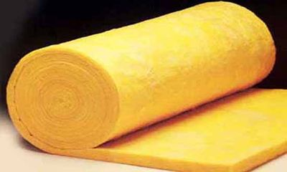 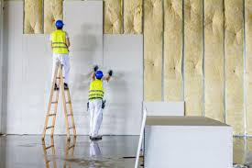

*Picture of glass wool roll and glass wall wall insulation*

**Polysterene insulation**

Polysterene is a plastic made of recycled synthetic marterials. When expanded, it forms a lot of air sacks inside of it making it have low thermal conductivity. In addition, polysterene marterial has high heat resistance of 3.8 per inch and is non-flammable unless exposed to extreemly high tempetatures and also warerproof. It has no breathable fibers or dust particles thus friendly to asmatic individuals and most cost effective form of insulation.

It is odorless, chemically inert, non-toxic and non irritable marterial thus safe to touch unlike fiber glass and mineral wool. This marterial is rot proof and permanent after a proper installation (MindsetEco 2019-2022). Polysterene can be used in walls, floors,exposed soffits and in pitched roofs. It is applicable in extreamly cold areas such as walk in coolers and freezers as it is less water vapour absobent.

It is widely used in construction due to its light weight ,great copmresive strength and rigidity.Although it is usualy supplied in sheets,polysterene is versatile and can be moulded to a required shapes and sizes to suit a particular task. Never the less, it does not require special equipment or skills to install as it can be cut using hand saw and hot wire cutter. Unlike other traditional insulation marterials, polysterene does not require compuction when being used in structural fill.(Green Insulation Options ,2023). Although this marterial is non-biodegradable and aften ends up in land fills, it is still sustainable. This is due to the fact that it is 100% recycable. Its large off cuts can be used elsewhere in construction and the smaller pieces can be taken back by the manufacture to create new products,(Designing Buildings Ltd, 2023)

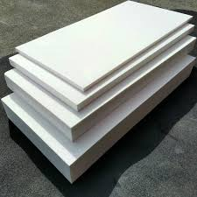 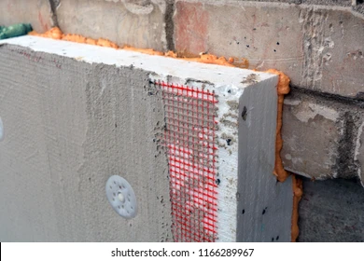

*Picture of polystyrene boards and polystyrene installation*

**Sheep’s wool insulation**

Sheep are animals that are known to survive in very cold temperature areas because of the wool that help keep their bodies warm. This technique has been applied in the construction industry to help regulate temperatures in buildings. Wool naturally grows on sheep, thus, an environmentally friendly form of insulation, (Inhabitat, 2019). When compressed the wool forms tiny air pockets that makes it an insulator. It has a value of R-13 to R-19 which is much greater than any other insulation material thus very suitable for home use.

Sheep’s wools are durable due to its elastic nature that makes it resistant to breaking and tearing. Its semi-permeable nature helps absorb moisture from high saturation area and release it to the less saturated area due to its water repelling exterior and water tolerant interior. The helical shape of sheep wool also makes it a noise barrier and more specially it has ability to convert sound energy to heat (MindsetEco 2019-2022). Sheep’s wool has ignition point of 500 degrees Celsius which and can be treated with additive to reduce flammability. It is made up of keratin which resist the growth of mold.

It is used in walls, floors, roofs and lofts. Between studs and partitions 80mm or 100mm thick wool is used and in floors 100 mm thick wool is used. It is available in different width sizes i.e., 50mm, 75mm,100mm, 140mm,380 mm and 570mm. This insulation material is not easily available in all parts and is relatively expensive compared to its counterparts but most sufficient and sustainable.

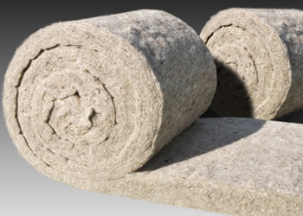 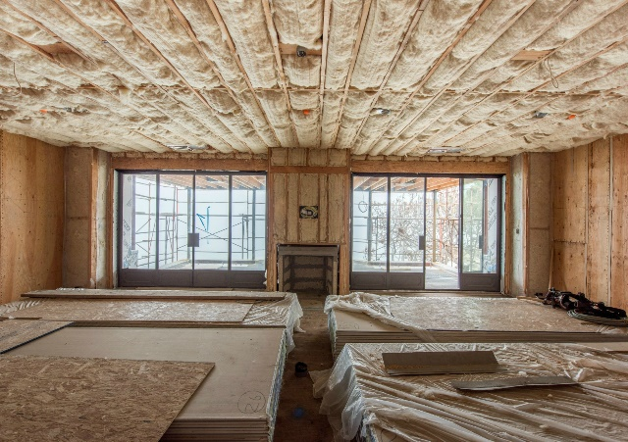

*Picture of sheep wool rolls and sheep wool insulated ceiling*.

**Cellulose insulation**

It is a feather like thick, dense and clampy material that is made up of 75% to 85% post-consumer papers products. The 15% to 25% remaining consists of fire retardant such as boric sulphate and ammonium sulphate which is used to reduce the combustibility of the product. Cellulose is naturally biodegradable thus environmentally friendly (Eco Insulation ,2015). It has low density of 3.5 PCF and value of R-3.8 per inch. It acts as an acoustic insulation and is cheap. It has a high ability to seal walls from air infiltration asides limiting convection when properly installed thus cutting cooling and heating cost of a building. As much as cellulose is odorless and contains no harmful chemicals, it contains additives such as ammonium sulphate which produces volatile organic compounds.

**Fabricated cellulose panels** are made in different sizes and thickness to suit the required task. They are soft thus easy to handle, transport, install and are aesthetic. Are used in roofs and walls of modern buildings without frames for support. They can be left exposed, painted or covered with dry wall (Green Insulation Options ,2023). **Loose cellulose fibers** can be in installed as loose fill or as wet spray. In loose fill, air pressure is used to blow the fibers into wall cavities, roof cavities and attics by use of a hose. In wet spray, the fiber is mixed with moisture and adhesives and is blown into wall cavities separated by studs.

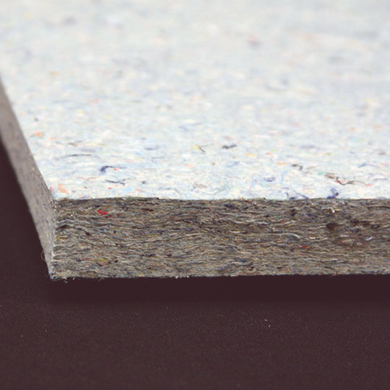 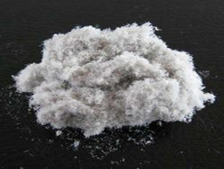

*Picture of fabricated cellulose board and cellulose loose fiber*

**Aerogel insulation**

Was discovered in 1931 by bySamuel Stevene Kistler. It consists of 90% to 95% air, the remaining 5% to 10% is made up of silica, mimerals such as iron oxide, gold , copper and organic polymers. It is manufactured by removing liquid from silica under high pressure and temperature (MindsetEco 2019-2022).. Has a structure that makes it highly resistant to temperature thus not sugging or shrinking when exposed to extreme cold or high tempetarures and also makes it control room temperatures. Has 99.8% porous thus preventing corrosion .

It has an R-value of R-10.3 per inch with an exremely low desity of 0.3g/cc thus strucuraly sufficient. Has a specific heat capacity of 18J/goc and operating temperatures of 40oC to 100oC. Are available in sheets of about 5mm to 10mm which are stuck in studs on walls.

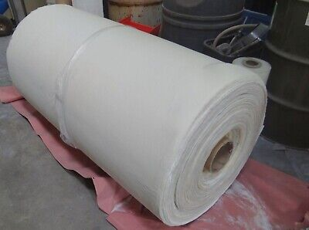 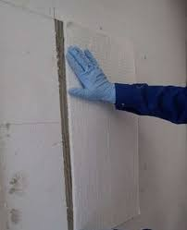

*Picture of aerogel roll and aerogel wall installation in process*

**Therma Cork insulation**

Cork is a material that is made from the bark of a cork oak tree. The use of cork oak bark dates back to 27BC to seal wine bottles without contaminating it and also for floats in fishing nets. It is 15% made of solid and the rest is air. It is an elastic, impermeable and chemically stable material thus it offers acoustic insulation, heat resistant, water resistant, fungal protection and discourages insects (Green Insulation Options ,2023) Cork is naturally fire resistant which makes it attain fire class B2 safety rating. Has an R-value of 3.6 to 3.8 per inch with a density of 220kg/m3 and thermal conductivity of 0.040 to 0.060W(Mk). It costs 7 to 60 euros per m2.

Application can be done in spray form, cork rolls, sheets or as boards. The spray can be done in open cavities or used outdoors as a render. Light duty cork rolls are fixed using adhesives into a place, pressed to ensure it is flat and smooth then plastered on instead of being left as a finish. The boards are fitted on the wall using an adhesive and is plastered over. (Green Insulation Options 2023) Cork needs no binder or chemical additives during manufacturing process due to presence of suberin. It has a life span of 50 years after which it naturally decomposes leaving no chemicals thus sustainable.

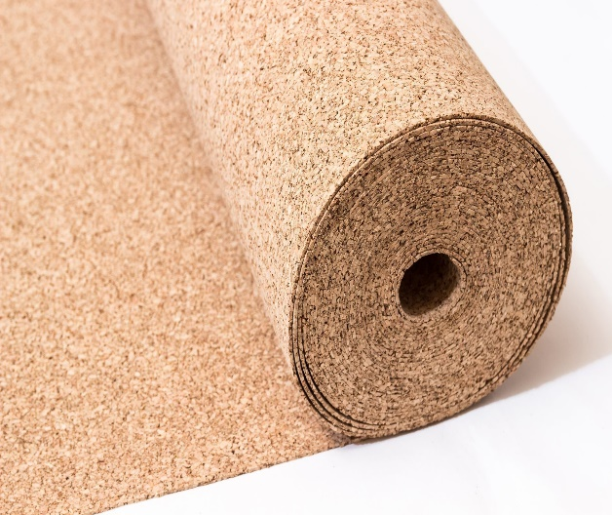 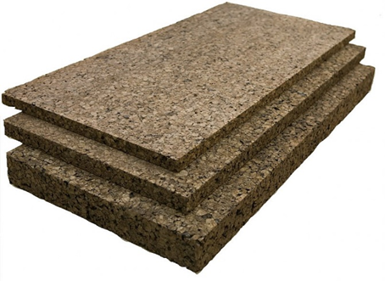

*Pictures of cork sheets and cork boards*

**Cotton wool insulation**

Is made of 85% recycled cotton fibers. During manufacturing, the cotton is treated with borate to make it fire resistant and to protect it from rodents and insects. It is semi permeable therefore has ability to absorb and release moisture in its environment making it suitable for insulation and does not allow convection of heat. (ECI, 2023) Cotton insulation has no toxins but rather ability to absorb toxins from the atmosphere as well as resist fungus and micro-organisms. Has an R- value of 3.4 with acoustic insulation capability.

Cotton has a density of 55kg/m3, heat resistance of 300 C and40 0C, dimensions of W1392 1000 by 600 by 40 mm and W139 1200 by 1000 by 40mm. installation involves the use of studs to which the cotton wool is stuck. It can be used I walls, roofs and floors.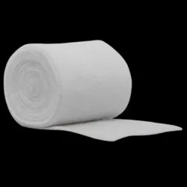 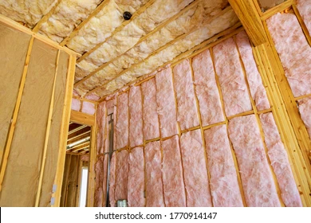

*Pictures of cotton wool roll and cotton insulated room*

**References**

ecomike. (2015 May 1). Why use Cellulose Insulation « Eco Insulation | Go Green. Save Green. Eco Insulation | Go Green. Save Green. <https://ecoinsulation.ca/cellulose-insulation>

Miller, P. (2019). 7 eco-friendly insulation alternatives for a green home. Inhabitat. <https://inhabitat.com/7-eco-friendly-insulation-alternatives-for-a-green-home/>

Mindset Eco. (2023). The Essential Guide to Eco-friendly Home Insulation. <https://mindseteco.co/eco-friendly-insulation/>

Perritano, J. (n.d.). Top 5 Green Insulation Options. HowStuffWorks

<https://home.howstuffworks.com/home-improvement/construction/green/5-green-insulation-options.htm>

ECI. (n.d.). Cotton Wool Insulation Batt/Blanket. ECI. <https://www.eci.com.tr/productdetail/cotton-wool-insulation-batt-blanket>