1. **What are Semi-conductors, give 2 examples.**

Some substances have the ability to conduct electricity (conductors) whereas others lack that ability (insulators). A semi-conductor is a substance that has both characteristics. This makes it the perfect medium to control electric current as it can regulate the conditions under which it conducts electricity. There are two types:

* **Intrinsic semi-conductors –** These are conductors in their purest form, free of impurities from other elements.
* **Extrinsic semi-semiconductors –** in order to improve the conductive ability of a pure semiconductor, suitable atoms (impurities) are added to it in a process called doping. The result of doping intrinsic semi-conductors creates extrinsic semi-conductors.

1. **What is Fermi Distribution?**

Also known as Fermi-Dirac statistics, it’s used to determine the probability that an energy state when under equilibrium conditions is filled with electrons. The distribution can only be used under equilibrium conditions. In a semi-conductor, it can be the maximum energy level at zero temperature occupied by an electron orbital. As solids are warmed, their Fermi Levels change with the addition and removal of electrons from the solid. Fermi energy is the value of Fermi level at absolute zero temperature. It determines the electrical and thermal characteristics of solids. The closer the Fermi level is to the conduction band energy, the easier it will be for electrons in the valence band to transition into the conduction band.

1. **What are P- Type and N- Type Conductors?**

During the doping of pure semiconductors with impurities, electrons are either added or removed from the substance. Those doped with electron rich impurities produce n-type semiconductors. We create deficits by removing electrons resulting in p-type semiconductors. What makes the two semiconductors distinct from each other is the primary material used during the doping process. The movement of negative charged electrons produces n-type semiconductors and positive charge movement creates p-type semiconductors.

Arsenic materials are mainly added to produce n-type semiconductors while those such as gallium or boron are used in the production of p-type semiconductors.

1. **Process of fabricating P- type and N- type semiconductors.**

Trivalent impurities, when added to pure semiconductors in small amounts produce a large number of holes resulting in p-type semiconductors. Impurities that produce p-type semiconductors are known as Acceptors because the atoms create holes that accept bonded electrons. In p-types, holes are the majority charge with free electrons in the minority.

Impure elements such as Phosphorus and Arsenic are known as penta valent impurities. When added to extrinsic semiconductors, they create n-type semiconductors. The doping elements are added to the n-type semiconductor so as to increase the number of electrons that conduct. N-type semiconductors carry a majority charge of free electrons with holes in the minority.

1. **What is a p-n junction?**

A p-n junction is a boundary that is formed between two semiconducting materials, a p-type and an n-type inside a semiconductor. Doping is used to create the junction. Diffusion and drift currents are produced in the creation of the junction. Holes from the p-side diffuse to the n-side, and electrons to the p-side to the n-side.

The junction in circuits represents an electrical component that allows electricity to flow freely in one direction than the other. They’re also known as diodes.

1. **Difference between photo electric effect and photo voltaic mechanism.**

Photo electric effect occurs when electrons are ejected from the surface of a metal when light shines on it. The phenomenon occurs when charged particles are released within a material when it absorbs electromagnetic radiations. Electrons are completely knocked out of a material by light photons

Photovoltaic effect occurs when electric and voltage currents are produced in a material when exposed to light in a chemical and physical occurrence. Here photons from a light source move only electrons from their atomic orbitals. They flow freely while remaining in the material.

1. **How batteries are different from photo voltaic cells.**

Normal rechargeable batteries can only hold one full charge while solar batteries have the ability to store energy from multiple charge cycles. A lithium-ion cell continuously stores electricity while the solar cell only generates electricity and not storage. Batteries i.e. lithium-ion batteries use chemical reactions to generate electricity while solar cells convert solar energy to electricity. Battery power comes from stored power source electricity while photovoltaic cells store power from the sun.

1. **What are the different technologies used for improving the efficiency of a photo voltaic cell?**

Using High Concentrated Photovoltaic cells (CPV). They work by focusing sunlight onto high efficiency solar cells. Regular solar cells operate at 22% and CPV cells at 46% efficiency.

Ensuring the solar panel is clean because dusty surfaces reduce the surface area receiving sunlight thus reducing efficiency.

Placing the solar cells in strategic areas away from direct heat. Extreme temperatures may damage the solar cells and materials affecting the panels’ efficiency and lifetime.

Using cell surfaces that minimize the reflection of light from the solar cells surface. The best and most efficient cells are black/ dark blue in color.

Placing solar panels away from shaded areas. Photovoltaic cells generate electricity from sunlight.

1. **What is a multi-junction cell?**

Multi-junction (MJ) solar cells are solar cells formed by having more than one semiconductor made of different materials. The individual p-n junctions react to different wavelengths. Using multi-junction cells increases the efficiency of the cells sunlight to electrical energy conversion. They enhance the utilization of the solar spectrum thereby improving the solar cell stability. It also results in higher levels of power production because of increased output levels. One major disadvantage of the MJ’s is that their production cost is astronomically high thus restricting their use to space exploration activities.

Multi-junction cells allow for the absorption of different wavelengths, enhancing its efficiency in electricity production. By adding more junctions to a semiconductor (they can have infinite combinations) it increases cell efficiency.

1. **What is Shockley-Queisser limit?**

Also known as the Radioactive Efficiency Limit or the Shockley Queisser Efficiency Limit is the maximum amount of theoretical efficiency by a solar cell when using a single p-n junction for power collection from the cell where radioactive recombination is the only loss mechanism. The limit only applies to standard solar cells with a single p-n junction.

Multi junction cells cannot fit into this limit. It’s one of the methods used to overcome the limit for solar conversion. They utilize the different semiconductors with different band gaps.

1. **With a diagram, explain the process of solar-electricity generation in a p-n junction cell.**

Sunlight hits the p-n junction when photons enter through a small p-type layer. This leads to the creation of a number of electron-hole repairs. The thermal equilibrium condition of the meeting is broken by incident light. Free electrons move to the n-type side while holes move to the p-type side of the junction. The p-n hub behaves like a small battery cell due to the concentration of the holes and electrons in the p-n junction respectively. The voltage produced is known as photo voltage and when a small load is connected, current flows through it.

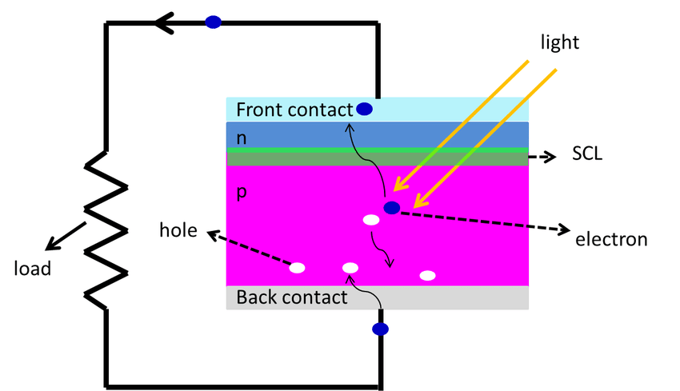

1. **Explain the power and voltage characteristics of a typical solar cell.**

The short-circuit Current (Isc) – This is the current that flows through a solar cell between points where the current does not normally flow. It’s caused when there is excessive flow between two conductors supplying electricity to a circuit.

Fill Factor (FF) - A measurement that assesses the performance of solar cells. The ratio increases at low intensities and decreases at higher radiation intensities.

Open-circuit Voltage (Voc) – It measures the voltage available in a solar panel when the current is not flowing. It occurs due to breaks or interruption to the circuit flow. An open circuit can completely shut down a circuit.

Solar energy conversion efficiency – Refers to the amount of sunlight converted to energy and electricity in a solar cell.