Case Study: Semiconductors

Student Name
Institutional
Professor
Course
Due date

Case Study: Semiconductors
What are semiconductors? Give two examples
Semiconductors are crystalline compounds that have their electrical conductivity being between those of a conductor and an insulator. Their electrical conductivity is intermediate between the metals which are characterized as conductors and the non-conductors which are characterized as insulators. Semiconductors are materials with 4 electrons in the outermost shells. They are made up of Holes and electrons which are charge carriers that account for the flow of current in the semiconductors. Holes and electrons are opposite in polarity though equal in magnitude. Examples of the semiconductor include the Germanium and Silicon which are characterized as pure elements (Sze & Lee, 2012).

What is Fermi distribution?
Fermi distribution is the description of probability for a quantum state of energy E to be occupied at a given temperature T by fermions n (E). It is described the following formulae:

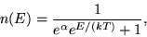
Where k is the Boltzmann’s constant and defines number of particles at temperature T.
Fermi distribution at different temperatures can be explained using the plot diagram below:
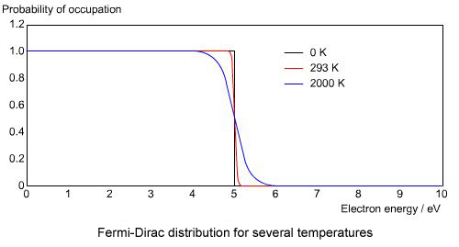
A
B
From the above diagram, the chemical potential, μ, is set at 5eV and at absolute zero it is defined as Fermi energy. At temperature 0K, electrons do not have much energy and occupy lower energy states A below fermi level. As temperatures rise, electrons gain energy and rise to the conduction band and upon observation; it is not easy to differentiate between occupied and unoccupied state levels shown by line B above in the Fermi distribution curve.

What are p and n type’s semiconductors?
P type semiconductor is an extrinsic category semiconductor developed by adding a trivalent impurity into a pure semiconductor through a process called doping. The impurity adds extra holes into the semiconductor resulting to the holes being the majority charge carriers. Hence, the semiconductor becomes positively charged due to excess holes and becomes a P type semiconductor.
N type semiconductor on the other hand is an extrinsic semiconductor derived by adding a pentavalent impurity into a pure semiconductor through doping. The impurity provides the semiconductor with extra electrons resulting to electrons being majority of charge carriers. Hence, the semiconductor becomes negatively charged due to excess electrons and it is named n-type semiconductor (Sze & Lee, 2012).
Explain a process for fabricating the p and n type’s semi-conductors
A pure semiconductor such as Si and Ge uses four valence electrons in its nucleus to form four covalent bonds. The electrons and holes are normally equal in number when there is no impurity in the semiconductor. When an impurity with three valence electrons such as Boron is added to the semiconductor, the electron-hole balance leaves an excess hole and this makes the semiconductor positively charged and hence a P type semiconductor.
A pure semiconductor with the four valence electrons in its nucleus can be doped with an impure element in the group five atoms such as Arsenic As which has five valence electrons. After the doping process, the electron-hole balance leaves the lattice with an extra excess electron making the semiconductor negatively charged with electrons as the majority carriers. The negatively charged semiconductor is called the n-type semiconductor (Sapoval & Hermann, 2003).
What is p-n junction?
A p-n junction constitutes a boundary created between the p and n types semiconductors. The p region has excess holes and the n region has excess electrons. The holes shift towards the electron dominance in the n-region while the negative electrons shift towards the whole dominance in p-region of the semiconductor. As both the holes and electrons diffuse across each layer to the opposite side due to the attraction a boundary is formed between the p and n layers and this constitutes the p-n junction. They two sides are joined together to form p-n junction through doping process which involves addition of impurities into the semiconductor.
What is the difference between photo electric effect and photo voltaic mechanism?
Photoelectric effect is the process of emitting electrons from a surface due to incident light. The incident light is absorbed and then the electrons are emitted. Hence, photoelectric effect requires incident light to activate electron emission.
The photovoltaic effect is the process in which electrical voltage is produced when two different materials close to each other are struck by light. The material retains electrons and the effect can occur at any frequency of incident light.
In photoelectric effect only electric current is produced while in photovoltaic effect both the electric voltage and current are produced.
How batteries are different from photo voltaic cells?
Batteries main function is to convert electrical energy received from the photovoltaic cells into chemical energy for easy storage. The conversion is done through reaction process between positive negative plates immersed in an electrolyte. The chemical energy stored by the battery can then be used at any moment as required through conversion into electrical energy.
Photo voltaic cells main function is conversion of sunlight into electricity and supply batteries with the electrical energy for storage purposes. Photovoltaic cells produce Direct Current while the battery store Direct Current power (Fahrenbruch & Bube, 2012).
What are different technologies used for improving efficiency of a photo voltaic cell?
- Use of Bifacial Photovoltaic cells technology that allows the absorption of solar radiation from both PV surfaces when set at the right tilt angle facing the Sun.
- Use of Solar Tracking system technology that automatically positions the photovoltaic cell panels through sensors and automation algorithms to maximize sunlight exposure. The technology minimizes light reflection and increases energy production.
- Use of Solar Photovoltaic/Thermal (PV/T) technology that in cooperates use of phase change materials which improves heat transfer rates and increased storage of thermal heating for solar heating.
- Use of Submerged and Floating Photovoltaic system technology that solves the issue of insufficient space for ground mounted PV plants. The technology allows the cell panels to float on water and still function at their best level.
What is multi junction cell? Explain how the efficiency of a cell improved using these techniques
Multi-junction cell is a solar cell made of stacked materials and with more than one p-n junction. The cell has multiple layers consisting of different materials that produce electric currents in response to differing light wavelengths. Light is absorbed by the solar cells knocking loose the electrons in the semiconductor. The electrons pass through the p-n junction between the layers creating an electrical current.
Efficiency of a cell greatly improved using this technology due to the ability to absorb different wavelengths of sunlight by using multiple layers. Hence, the cell is able to convert much more sunlight into electricity than single-junction cells (Fahrenbruch & Bube, 2012).
What is Shockley-quesser limit?
Shockley-quesser limit is defined as the computation of the topmost logical efficiency of solar cell formed from a single p-n junction. It analyses the quantity of electrical energy extracted per incident photon and equates highest solar conversion efficiency to approximately 33.7% with an assumption of 1.4eV p-n junction band gap. It explains that a normal solar cell characterized with incident solar radiation will produce 337Wm⁻². When a solar emission is at 6000k blackbody emission the highest efficiency is achieved when the bandgap energy Eg is at 1.4eV. The higher bandgaps contains fewer photons with a decreasing density as the energy emitted in a cell is converted into heat (Sapoval & Hermann, 2003).

With a diagram explain the process of solar-electricity generation in a p-n junction cell.
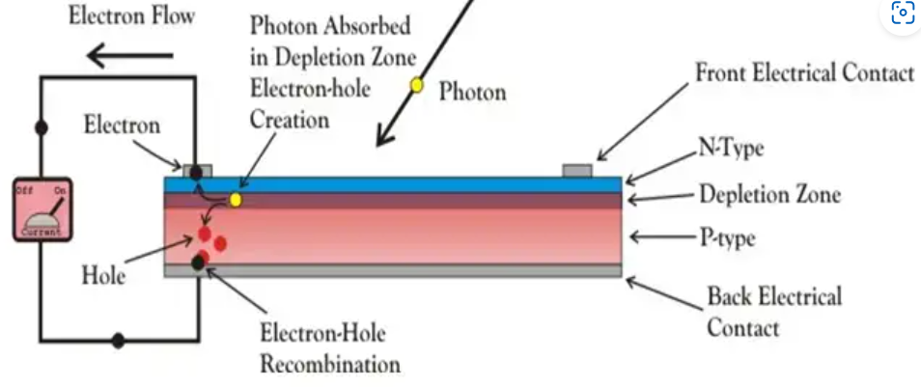

From the above diagram, a p-type layer of the semiconductor is developed on a relatively thick n-type layer with electrodes set on the top p-layer and another electrode collecting current set below the n-layer. P-N junction is below the p-type layer and a thin glass covers the entire assembly for protection against any mechanical shock. Light photons move to p-n junction via the p-type layer producing enough energy to initiate multiple electron-hole pairing and conversion process. The incident light triggers a thermal equilibrium condition of the p-n junction causing free electrons in the depletion region to be shifted to the negatively charged side of the junction while the holes shift to the positively charged side of the junction. The new free electrons are pulled towards the negative region while the new generated holes are pulled to the positive region but they cannot cross back over the junction due to the barrier potential. This electrons and holes separation process across the formed p-n junction allows the cell to function like a small battery cell. This whole process generates voltage and small current flows through a connected load across the junction (Sapoval & Hermann, 2003).
Explain the power and voltage characteristics of a typical solar cell.
The voltage Voc, for an ideal solar cell is determined through the measure of voltage across the cell terminals in the absence of a load. It is dependent upon temperature and the manufacturing technology as opposed to factors such as light and the surface area exposed. The solar cell’s V_{oc} is approximately 0.5 - 0.6 volt.

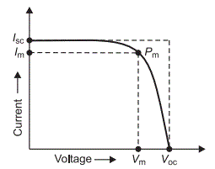

From the above diagram, the maximum power is achieved at the bend point of the V-I characteristic curve denoted as P_{m}. P_{m} is described as the maximum electrical power that one solar cell can produce at its standard test condition. Voltage at P_{m} point from the above characteristics curve of solar cell is shown by V_{m} and it represents the voltage at which maximum power occurs (Smith et al., 2018).

References
Fahrenbruch, A., & Bube, R. (2012). Fundamentals of Solar Cells. Elsevier.
Sapoval, B., & Hermann, C. (2003). Physics of semiconductors. Springer-Verlag.
Smith, R. P., Hwang, A. A.-C., Beetz, T., & Helgren, E. (2018). Introduction to semiconductor processing: Fabrication and characterization of p-n junction silicon solar cells. American Journal of Physics, 86(10), 740–746. https://doi.org/10.1119/1.5046424
Sze, S. M., & Lee, M.-K. (2012). Semiconductor Devices: Physics and Technology, 3rd Edition. Wiley Global Education.

