**COVER PAGE**

INTRODUCTION

A scanning electron microscope (SEM) is a powerful tool used in scientific research and various industries for high-resolution imaging and analysis. Here are some technical tasks and capabilities of an SEM:

* High-Resolution Imaging: SEMs can produce detailed, high-resolution images of the surface of specimens. They use a focused beam of electrons to create images with nanoscale or even atomic-scale resolution.
* 3D Imaging: SEMs can capture three-dimensional images of samples by tilting the specimen and acquiring multiple images from different angles. This is useful for studying the topography and morphology of complex structures.
* Elemental Composition Analysis: SEMs can perform energy-dispersive X-ray spectroscopy (EDS) or wavelength-dispersive X-ray spectroscopy (WDS) to determine the elemental composition of a sample. This helps in identifying the chemical composition of materials.
* Surface Analysis: SEMs are used to analyse the surface roughness, texture, and defects of materials. They can reveal information about the quality and characteristics of surfaces.
* Microanalysis: SEMs can provide microanalysis of particles, crystals, and nanoparticles. They are often used to investigate the size, shape, and distribution of micro-sized objects.
* Biological Imaging: SEMs are used in the life sciences to study biological samples, including cells, tissues, and microorganisms. They offer detailed views of cellular structures and surface features.
* Failure Analysis: In materials science and engineering, SEMs are valuable for analysing the causes of material failures, such as fractures and defects. They can help identify stress points and manufacturing issues.
* Semiconductor Inspection: In the semiconductor industry, SEMs are employed for inspecting and characterizing integrated circuits, identifying defects, and ensuring quality control.
* Nanotechnology Research: SEMs are essential tools for nanotechnology research, enabling scientists to manipulate and visualize nanoscale structures and devices.
* Geological and Earth Sciences: Geologists use SEMs to study mineral composition, rock textures, and the surfaces of geological samples. It aids in understanding Earth’s history and processes.
* Materials Characterization: SEMs help characterize a wide range of materials, including metals, ceramics, polymers, composites, and more. They provide insights into material properties and microstructures.
* Art and Archaeology Conservation: SEMs can assist in the analysis and preservation of cultural artefacts, offering insights into the composition and degradation of historical objects.

**METHODOLOGY**

HOW IT WORKS

Electron Beam Source: SEM uses a focused beam of electrons instead of light to achieve high magnification. Electrons are emitted from a heated filament or an electron gun.

* Electron Lenses: Magnetic lenses focus and control the electron beam’s path, allowing it to scan the specimen’s surface.
* Specimen Preparation: The specimen is typically coated with a thin layer of conductive material (e.g., gold) to enhance imaging quality and reduce charging effects. It is then placed on a stage within the microscope.
* Scanning: The electron beam scans the specimen in a raster pattern, much like a television screen, and interacts with the surface of the specimen.
* Detectors: Detectors capture various signals generated by the interaction of electrons with the specimen. The most common signals include secondary electrons, backscattered electrons, and X-rays.
* Image Formation: The signals are used to create detailed images of the specimen’s surface. Secondary electron images provide topographical information, while backscattered electron images reveal compositional contrast.

**IMAGES**

* Here are some of the Images an SEM can see:

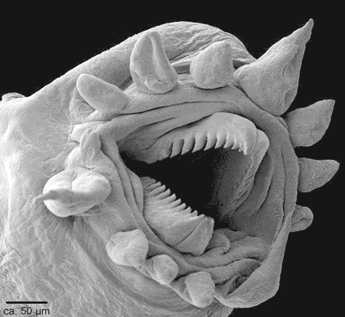

* 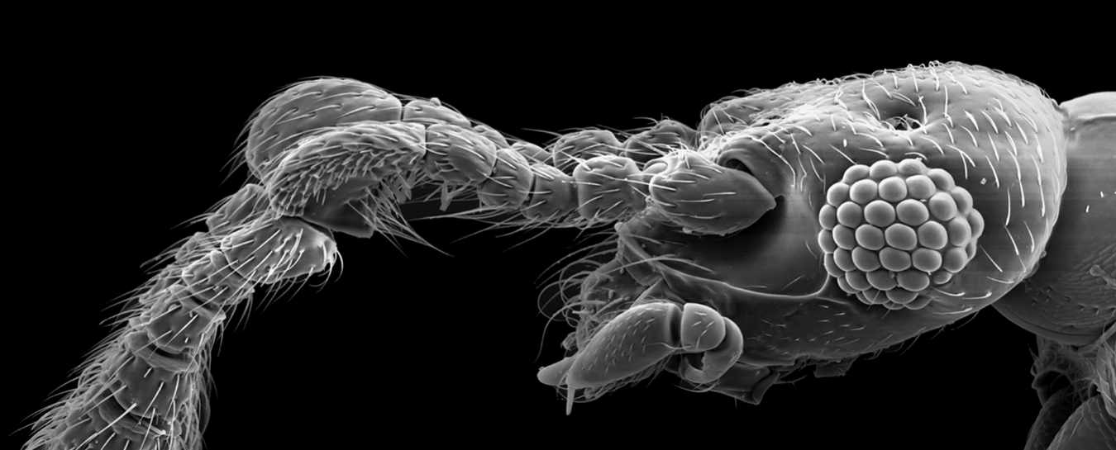

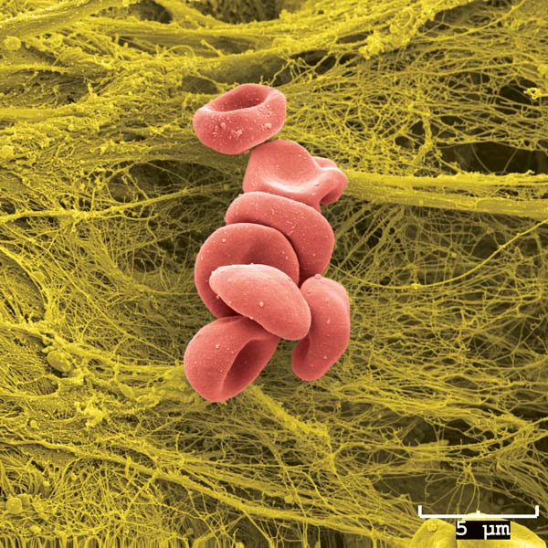

**Real-Life Applications:**

SEM has a wide range of applications in various fields, including:

* Materials Science: Examining the microstructure of materials, such as metals, ceramics, and polymers, to understand their properties and behaviour.
* Biology: Studying biological samples like cells, tissues, and microorganisms for research in cell biology and microbiology.
* Geology: Analysing geological samples to understand mineral compositions, fossil structures, and rock formations.
* Nanotechnology: Characterizing and fabricating nanoscale structures and devices.
* Forensics: Analysing trace evidence, such as gunshot residue, hair, and fibres, in criminal investigations.
* Quality Control: Ensuring the quality and reliability of manufactured products by inspecting surface defects and dimensions.
* Archaeology: Examining archaeological artefacts and materials to gain insights into ancient civilizations.

**References**

Azad Mohammed, Avin Abdullah

Proceedings of the 2018 International Conference on Hydraulics and Pneumatics—HERVEX, Băile Govora, Romania 2018, 7-9, 2018