**Geocentric Astronomy**

Type Your Name Here

National American University

Course number: Name

Instructor

Due Date

Despite its elegant design and philosophical foundations, the geocentric model succumbed to internal inconsistencies and observational limitations, paving the way for the Copernican heliocentric revolution. Geocentric astronomy is a scientific paradigm that has persisted for centuries with an equally philosophical solid structure built by Aristotle. His cosmogony pictured a perfectly designed universe of spheres arranged in layers around each other, all filled with incorruptible and perfect ether. As such, the Earth had pride of place as its central stage on which everything revolved – the Moon, Sun, planets, and stars performed an inevitable ballet. For Aristotle, this geocentric arrangement transcended mere empirical observation; it was ingrained with a deep anthropocentric sentiment – as van der Sluijs 2021 points out poignantly. As humanity's birthplace, Earth naturally became the center of everything in the cosmos. Aristotle's metaphysical and theological underpinnings bolstered this geocentric edifice. He saw an unchangeable, immovable universe in which the celestial bodies moved along perfectly uniform circular paths. However, this vision was based on his theory of motion, which distinguished between natural and artificial movements. Celestial bodies, made from the incorruptible aether, were endowed with an inherent predisposition to circular motion due to their inner perfection.

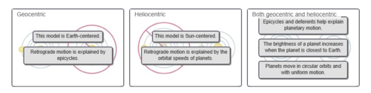

**Figure 1:** *Comparison of Geocentric and Heliocentric Astronomy*

The geocentric model had strong roots in ancient Greece's philosophical and cultural environment. People who identified as Greeks and believed in Earth's centrality appropriated the idea of an organized universe arranged into concentric spheres, and our outermost layers were understood to be godly. This worldview is strikingly reflected in the work of Plato, who proposed a hierarchical order where gods were at the top, and men lay infernally below. Aristotle also favored the geocentric model that agreed with the prevailing philosophical and cultural streams during his time (van der Sluijs, 2021). Anthropocentrism and geocentricity were deeply rooted in the Aristotelian worldview, another philosophical precursor of geocentric astronomy. His metaphysical and theological beliefs and the more extraordinary philosophic cultural fabric of ancient Greece showed in his conception of a stagnant perfect celestial sphere made up of spheres within spheres. Aristotle's cosmological framework reigned supreme for centuries, shaping humanity's understanding of its place within the grand cosmic theatre.

Like a lone herald standing against the tide, Aristarchus of Samos dared to champion a revolutionary vision: a heliocentric solar system envisioning the Sun, not Earth, as the center of creation. This startling suggestion, an antipode to the established geocentric pattern of things, placed a humbling Earth in orbit around the blazing orb. Even though Aristarchus's model was, to some extent, beautiful and logically sound, it remained languishing in the shadows of scientific acceptance for centuries (Krisciunas & Bistué, 2019). Why did this brave scientific proto-revolution fail to set men's imaginations aflame in ancient and medieval times? Several factors worked together to engulf Aristarchus's heliocentric vision in long shadows. First, his model was incompatible with the then-dominant philosophical and cosmological paradigms. The geocentric model, wherein Earth is situated at the center of the cosmos, was deeply rooted in prevailing cultural norms, religious beliefs, and Aristotelian physics. In addition, the infantile status of observational technology in antiquity and during medieval times limited efforts to verify Aristarchus' arguments. He did not have the refined tools and accurate astronomical data necessary to justify his heliocentric idea empirically. His essentially geometric and theoretical arguments had little resonance in an age where observation was more valued than perspective. In addition, the theoretical limits of that era also hindered the acceptance of heliocentrism. The predominant idea of the universe being finite with Earth at its center made the solar-centered model appear illogical and pointless. A vast and complicated Sun-centered cosmos challenged the reigning cosmological imagination, which led most to hold on tightly to familiar Earth-centric picturing. The triumph of Aristarchus's heliocentric idea would have to wait until the dawn of a new scientific age.

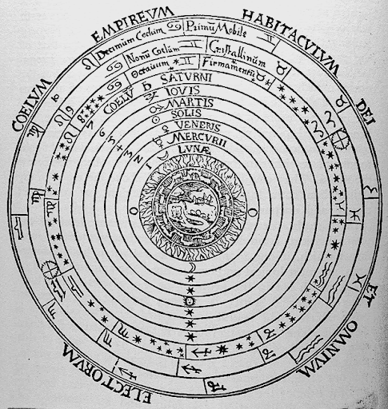

**Figure 2:** *The Aristotelian-Ptolemaic Universe*

Ptolemy's geocentric model, one of the most significant achievements in astronomy history, strived to map out these musical constellations with Earth being an unchanging maestro. Building on Hipparchus' observational heritage (Carman & Recio, 2019), Ptolemy developed an exact model to account for the patterns of observed movement above the heavens. So perplexing was planetary retrogradation. To accomplish this lofty dream, Ptolemy's model included several essential components carefully tuned to resonate with the celestial ballet described earlier. Ptolemy's system was based on the arrangement of epicycle – deferent. In this heavenly pattern, planets moved along epicycles, a minor circle moving over larger deferents. This complicated dance enabled minor deviations from the perfect circular orbits, a necessary compromise to accommodate for this "retrograde" motion observed. The further buildup was by the clever device of a point away from the center "equant," around which the planet moved at constant speed. This beautiful structure accounted for the noticeable differences in planetary speeds and made of them a harmonious cloth out of which it was built. However, why did Ptolemy build this grand astronomical edifice? The driving force stemmed from a fundamental quest: unraveling celestial motions' hidden logic. Why did planets occasionally defy the waltz of celestial bodies and pirouettes in reverse? Why did their velocities seem to vary, and their luminance be unequal? With the careful balance of epicycles, deferents, and equants, Ptolemy tried to shed light on these mysterious issues to devise a system capable of explaining past observations and predicting future celestial positions. In sum, Ptolemy's geocentric structure was not just a descriptive atlas of the skies but an elaborate explanatory model – a determination to unravel cosmic clockwork through painstaking geometry and ingenious celestial mechanisms. Though later replaced by heliocentrism, its explanatory power and beauty kept it in favor for over a thousand years, showing the lasting mystery of astronomical comprehension.

Another of the most obvious weak points in Ptolemy's geocentric structure was his concept of equant. Introduced to account for the unexpected differences in planetary speeds, the equant was a point within a planet's deferent from which its movement looked uniform. Although the equant appears to patch up certain inconsistencies at first glance, this concept casts a long shadow over the internal coherence of the Ptolemaic model (Carman & Recio, 2019). The critical problem was breaking the fundamental law of equal circular motion, a foundation stone on which ancient astronomy had been laid. This principle stated that since celestial bodies were heavenly perfect, they should execute their circular orbits as swiftly. However, this idealized tapestry came with an unwelcome wrinkle in the form of an equant.

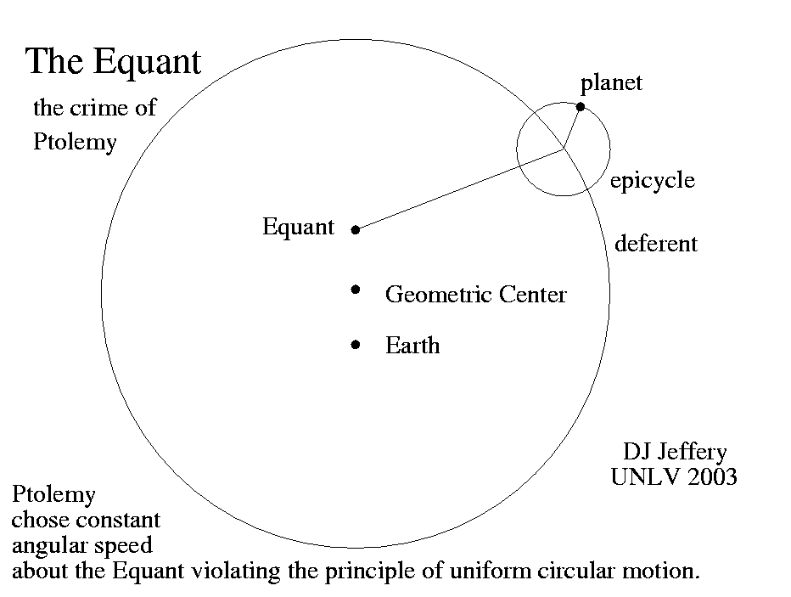

**Figure 3:** *Ptolemy Epicycle Equant*

This mathematical inconsistency, like a parasite gnawing at the core of Ptolemy's system, widened what was already becoming not just an abyss but also a very much visible fissure between astronomical observation and theoretical principle. The heliocentric model promoted by Copernicus eventually offered a more elegant and conceptually less prolix solution to this dilemma. Copernicus demoted Earth from the center of the cosmos and made the Sun command it, thereby eliminating the necessity for an equant, which was a very complicated geometrical device. In this grand celestial ballet, planets twirled around the Sun in circles or ellipses; their speed automatically varied according to how far away they were from that solar pivot. This change of viewpoint eliminated the equant anomaly and created a more straightforward, more mathematically consistent framework for celestial mechanics. The equant was a great reminder of the flaw within the geocentric model. This demon of geocentrism was exorcised by the shift to heliocentrism, leading to a new understanding phase in astronomy.

Although the geocentric model is pretty and based on philosophical principles, it ultimately fell victim to logical flaws and limitations of observation. The complexity of the Ptolemy model, which includes addition equant, challenges this basic idea of ancient astronomy about the perfection of celestial bodies and equal circular motion. These contradictions, added to the fact that observational technology of that period had limitations, already created gaps between theoretical principles and empirical observations. Copernicus provided a more elegant and mathematically consistent solution by proposing the heliocentric model, eliminating problems of inherent flaws in the geocentric framework. Copernicus's move from Earth being at the center of the cosmos and placing it in orbit around the Sun instead laid down a fundamental revolution ever made regarding astronomical subjects. He once again demonstrated how scientific theories changed when they faced internal problems or advanced further with observational functions through technological improvements. Therefore, the Copernican heliocentric revolution appeared as the logical and empirically validated follow-up to the geocentric model, emphasizing the dynamic nature of scientific investigation.

**References**

Carman, C. C., & Recio, G. L. (2019). Ptolemaic planetary models and Kepler's laws. *Archive for History of Exact Sciences*, *73*, 39-124.

Jones, A. (2020). Limits of observation and pseudoempirical arguments in Ptolemy's Harmonics and Almagest.

Krisciunas, K., & Bistué, M. B. (2019). Notes on the transmission of Ptolemy's Almagest and some geometrical mechanisms to the era of Copernicus.

van der Sluijs, M. (2021). Earliest References to the Astronomical World Axis. *Ancient Philosophy*, *41*(2), 267-290.