**Equity and Discrimination in the Workplace: A Case Study of Qantas Airlines**

Student’s Name

Institutional Affiliation

Course Name and Number

Professor’s Name

Date

Introduction

Critical workplace concerns like equity and discrimination can have a wide range of effects on people and companies. This case study examines Qantas Airlines’ wage/gender pay discrepancy, age, and gender discrimination issues. This study offers insights into these problems and solutions for efficiently managing and addressing them by assessing the data and information already accessible.

**Wages/Gender Pay Gap**

The differential in income between men and women in similar employment roles or occupations is known as the gender pay gap. The continuation of the gender pay gap is attributed to several issues, including occupational segregation, unequal representation in leadership roles, and implicit biases in performance evaluation and wage negotiation processes. Qantas acknowledges the gender pay gap and has pledged to close it through open compensation practices and frequent pay equity assessments.

Individuals at Qantas Cabin Crew UK (QCCUK) respect various lived experiences and think their inclusive environment has strengthened and succeeded. Their diverse backgrounds and perspectives help them better understand their clients, make wiser judgments, and complete tasks without incident. They want to maintain their status as a top employer in the UK by maximizing performance and involvement (Gender Pay Gap Qantas Cabin Crew UK Report, 2020)**.** Both the cabin crew and ground team communities comprise Qantas Cabin Crew UK.

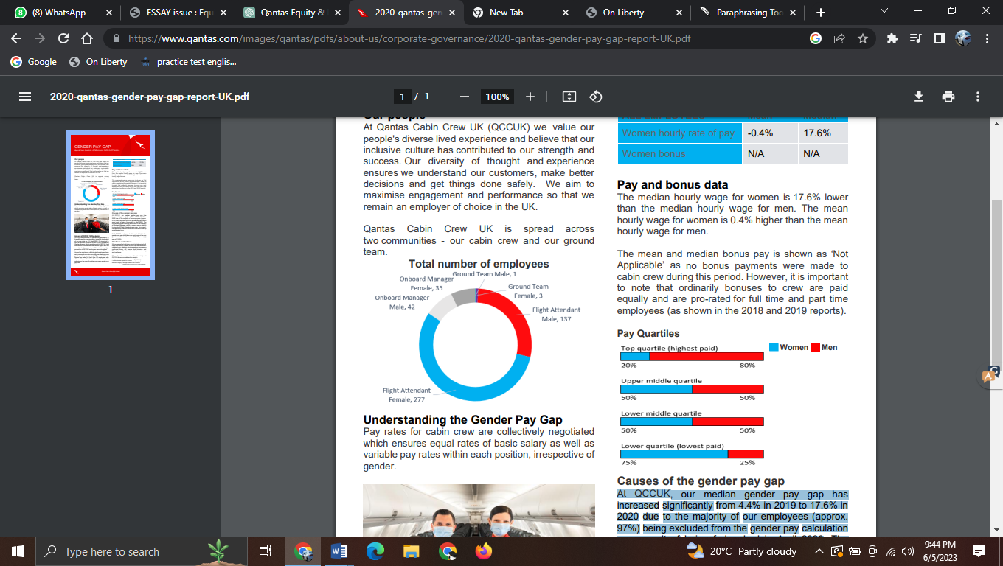

The collectively agreed pay scales for cabin staff provide gender-neutral basic pay rates and variable pay levels for every job. Since most staff (about 97 percent) were furloughed in April 2020, their median gender pay gaps at QCCUK jumped dramatically from 4.4 percent in 2019 to 17.6 percent in 2020 (Gender Pay Gap Qantas Cabin Crew UK Report, 2020)**.** This is because they were not included in the calculation of gender pay. Only men were employed at this time in the Onboard Manager position, a position of greater responsibility than Flight Attendant. As seen from the wage quartiles above, men comprised 80 percent of the top quartile. They would have anticipated that the gender pay gap would have stayed below the 2020 UK gender pay gap of *15.5% if all QCCUK workers had been factored into the calculation.

In addition to affecting specific employees, the gender wage gap negatively affects company culture, staff morale, and productivity. Women may have poorer job satisfaction, less motivation, and higher turnover rates when they feel they are being paid unfairly. This, in turn, impacts the organization's overall success and performance. Qantas can increase employee engagement, establish a more positive work atmosphere, boost productivity, and increase retention rates by tackling the gender pay gap.

**Management and Reduction Techniques for the Gender Pay Gap**

Regular and thorough pay equity evaluations aid in locating pay differences and ensuring that compensation procedures are impartial and fair (Santero-Sánchez, & Núñez, 2022). The dedication of Qantas to carrying out such evaluations is a step in the right direction toward closing the gender pay gap. Qantas can create comprehensive compensation plans with outlined pay scales, requirements for wage increases, and career paths.

**Age Discrimination**

Age discrimination is the term used to describe unjust treatment or prejudice against older workers (Islam, 2014). It can take many forms, such as limiting possibilities for career progression, discriminatory hiring procedures, and unfavorable stereotypes about the skills and productivity of older workers. Given the importance of a varied workforce, Qantas has implemented programs to accommodate older workers, such as flexible work schedules and upskilling opportunities.

Implications for Employee Wellbeing and Organizational Productivity: Age discrimination has broader implications for employee well-being and organizational productivity in addition to its direct effects on the individuals it targets. Age-related biases may cause older workers to report lower job satisfaction, motivation, and engagement. This may result in higher turnover rates and the loss of important institutional knowledge. Qantas may promote a healthy work environment, improve employee well-being, and boost organizational performance by managing and avoiding age discrimination.

Concerns regarding age discrimination are raised by Captain Paul Summers' lawsuit against Qantas Airlines, which also emphasizes the value of equity and fair treatment in the workplace. The Federal Court gave Captain Paul Summers a temporary restraining order, preventing Qantas from firing him until the Human Rights Commission could consider his case. Captain Paul Summers v. Qantas lawsuit draws attention to potential age discrimination problems within the aviation industry (Smith, R. (2021). The fact that the court granted Captain Summers an interim injunction implies that there is enough evidence to support a more thorough investigation of the issue by the Human Rights Commission. This situation calls into question Qantas’ adherence to equity ideals and dedication to fostering an inclusive workplace.

**Combating Age Discrimination**

Qantas should explicitly prohibit age discrimination by establishing and disseminating specific policies (Walker, 1999). The repercussions of breaking the company's commitment to fairness should be outlined in these policies, which should also give employees ways to report discrimination. Offering training sessions on age diversity, inclusion, and bias awareness can help managers and employees become more conscious of age-related prejudice and unfair treatment. Training should promote an inclusive workplace atmosphere and stress the importance of different age groups.

**Racial Discrimination**

The creation of an equitable workplace is hampered by racial prejudice. To address these concerns, Qantas established a Diversity and Inclusion Council and implemented initiatives to improve diversity and inclusion across the board. Qantas should encourage diversity in senior roles, carry out unconscious bias training, and set up channels for reporting and addressing discriminatory incidences to further combat racial prejudice.

Racial discrimination in the workplace has larger effects on employee well-being and organizational performance and impacts the targeted individuals. Racial discrimination may cause workers to be less satisfied with their jobs, be less motivated, and be more stressed. This can result in lower productivity, increased turnover rates, and reputational harm to the business. Addressing racial discrimination can help Qantas improve employee well-being and promote a healthy work environment.

The incident raises concerns regarding equity and discrimination in the workplace concerning a Qantas flight attendant accused of showing racism toward musician Will.i.am (Simple Flying, 2019). In an intense argument with Will.i.am on one of the airline’s regional flights, Qantas has emerged as the star. What started as an angry Tweet has evolved into an intense argument about racial prejudice and, in some cases, outright hatred. The Black-Eyed Peas singer admitted to experiencing racial bias among his 12.8 million fans. Will.i.am, was on a band tour and making his way from Brisbane to Sydney.

The incident involving Will.i.am and the Qantas flight attendant raises the possibility of racial discrimination at the airline. Racist accusations reflect poorly on the accused party and cast doubt on Qantas’ dedication to equity, diversity, and inclusion. Employers must deal with such situations quickly and effectively to preserve a fair and inclusive workplace. Racial discrimination in the workplace, in particular, can have detrimental effects on both people and businesses. If Qantas does not handle this situation properly, it could suffer reputational harm, lose customer faith, suffer low employee morale, and perhaps face legal action. Qantas must take a firm stand against racial discrimination and implement the necessary measures to address the problem.

**Getting Rid of Racial Discrimination**

Qantas should launch a thorough inquiry into the occurrence to comprehend the circumstances and assess whether racial discrimination occurred fully. Employees, clients, and other stakeholders should be informed openly of the investigation's findings and any corrective measures taken (Howard, 2016). Offering diversity and inclusion training courses helps staff members reduce unconscious bias, encourage cultural sensitivity, and build an inclusive workplace. These initiatives should stress the importance of treating everyone with respect, regardless of race or ethnicity. Clear policies and procedures that expressly forbid racial discrimination and spell out the penalties for doing so should be in place at Qantas. All staff members should be informed of these rules and ensure compliance with frequent updates and reminders.

**Conclusion**

Promoting an equitable and inclusive workplace at Qantas Airlines requires addressing equity and discrimination issues, such as the wage/gender pay gap, age discrimination, and gender discrimination. Qantas may establish a workplace that celebrates diversity, offers equitable opportunities for all employees, and fosters a culture of respect and inclusion by implementing the suggested tactics and initiatives. In addition to being morally required, resolving these challenges increases employee engagement and productivity.

**Annotated Reference List**

Gender Pay Gap Qantas Cabin Crew UK Report (2020). Retrieved From: <https://www.qantas.com/images/qantas/pdfs/about-us/corporate-governance/2020-qantas-gender-pay-gap-report-UK.pdf>

The Gender Pay Disparity Qantas Cabin Crew UK Report (2020) offers information on the gender pay disparity among the UK-based Qantas cabin crew. The paper addresses the pay gap between male and female employees and provides information and analysis. It is a useful resource for promoting gender equity in the aviation sector and provides important information for comprehending the gender pay gap at Qantas. The annotation does not contain detailed information on the report’s authorship, methodology, or major findings because it needs to be published. More analysis of the report is required.

Smith, R. (2021, April 23). Qantas in age discrimination case court setback. Human Resource Director. Retrieved from <https://www.hcamag.com/au/news/general/qantas-in-age-discrimination-case-court-setback/253074#:~:text=Qantas%20is%20facing%20a%20setback,a%20report%20by%20The%20Australian>.

The article by Ryan Smith (2021) headlined “Qantas in age discrimination case court setback” details a court setback involving Qantas Airlines and an age discrimination case. The piece, written for Human Resource Director, covers the case's legal history and ramifications. As a news story on the internet, it offers timely insights into the problem of age discrimination at Qantas and summarizes the court's ruling. The article’s author, Ryan Smith, is given credit for it. A closer look at the article is advised to grasp its conclusions and substance better.

Simple Flying. (2019, November 17). Qantas Flight Attendant Accused of Racism towards Will.i.am. Retrieved from <https://simpleflying.com/qantas-crew-will-i-am/>

A Qantas flight attendant was accused of racism toward musician Will.i.am, according to the Simple Flying story “Qantas Flight Attendant Accused Of Racism Towards Will.i.am” from 2019. The article, published on November 17, 2019, gives information about the incident and its background. As an internet news item, it presents a current viewpoint on the problem and how it affects Qantas. The authorship is listed as coming from “SF Staff.” Reading the entire article to gain a thorough grasp of it is advised.

Bibliography

Gender Pay Gap Qantas Cabin Crew UK Report (2020). Retrieved From: <https://www.qantas.com/images/qantas/pdfs/about-us/corporate-governance/2020-qantas-gender-pay-gap-report-UK.pdf>

Howard, G. (2016). The easiest way to get rid of racism? Just redefine it. *The New York Times Magazine*.

Islam, M. R. (2014). Ageism and age discrimination in old age: An overview. *Philosophy and Progress*, 91-108.

Santero-Sánchez, R., & Núñez, B. C. (2022). Pursuing equal pay for equal work: Gender diversity in management positions and the gender pay gap throughout the wage distribution. *BRQ Business Research Quarterly*, 23409444221125239.

Simple Flying. (2019, November 17). Qantas Flight Attendant Accused of Racism towards Will.i.am. Retrieved from <https://simpleflying.com/qantas-crew-will-i-am/>

Smith, R. (2021, April 23). Qantas in age discrimination case court setback. Human Resource Director. Retrieved from <https://www.hcamag.com/au/news/general/qantas-in-age-discrimination-case-court-setback/253074#:~:text=Qantas%20is%20facing%20a%20setback,a%20report%20by%20The%20Australian>.

Walker, A. (1999). Combating age discrimination at the workplace. *Experimental Aging Research*, *25*(4), 367-376.