**QUESTION 1**

Semiconductors are elements or compounds that conduct electricity under some conditions but not others.

They are useful for controlling electric current since they are neither good insulators nor good conductors.

Semiconductors are not prone to either loosing or gaining electrons hence their valence shells tend to have four electrons.

semiconductor are devices that allow current flow for an applied voltage. Examples of semiconductors are carbon and boron.

**QUESTION 2**

**Fermi distribution**

Is a distribution which applies to identical and indistinguishable particles with half integer spin.

This distribution is done over energy states.

Particles involved must obey the Pauli exclusion principle.

Each type of distribution function has a normalization term.

The significance of Fermi energy is seen by setting T equals to zero.

QUESTION **3**

P- type semiconductors are those semiconductors formed when a trivalent impurity is added to an intrinsic semiconductor.

A p-type semiconductor has more holes than electrons to allow current flow along the material from hope to hole but only in one direction.

P-type semiconductor are doped with acceptors since they can accept electrons.

To make a P-type semiconductor extra materials like boron or aluminum are added to the silicon.

N-type semiconductors are those semiconductors made by adding an impurity to a pure semiconductor like silicon.

Phosphorus, arsenic and antimony are some of the impurities used in N-type semiconductors.

These impurities are called donor impurities since they give a free electron to a semiconductor.

**QUESTION** **4**

Below is the process of fabricating p type and n type semiconductors.

1. Crystal growth and wafer fabrication.

This process begins with the growth of a high quality semiconductor Crystal which serve as the base material for the production of electronic devices for example when using silicon, high purity silicon is melted under a controlled and then cooled to zero.

1. Photolithography and patterning

This process is used to create intricate circuit patterns on a single wafer's surface. This process entails coating the wafer with a photosensitive material known as a photoresist. This material is then exposed to high wavelength and deep ultraviolet light through a mask containing the desired pattern.

The photoresist then undergoes a chemical change which allows it to be selectively removed.

1. Etching and deposition

Etching is the removal of materials from the wafer either through a wet chemical process or a dry plasma process.

Deposition is the process of adding thin layers of a material onto a wafer's surface.

Deposition can be done either through physical vapour deposition or chemical vapour deposition.

It involves a wide range of deposition materials such as metals, insulators and semiconductors.

1. Doping and ion implantation.

This process allows for creation of p type and n type semiconductor regions within the device.

It involves introduction of impurities or dopants into the semiconductor material.

These impurities significantly alters its electrical properties.

1. Metallization and interconnects.

Metallization is the process of depositing metal layers onto the wafer’s surface.

This process ensures electrical connections through a conductive in between the internal circuitry.

The metal layers are then patterned and etched to form the desired interconnect structures.

1. Passivation and packaging.

This process involves deposition of a protective layer of silicon nitride or oxide layer like silicon dioxide onto the wafer’s surface. This layer protects the delicate underlying structures from damage and contamination during the packaging process.

Packaging is the final stage.

Completed wafer is diced into individual chips. Each chip is then mounted and interconnected and finally encapsulated in a protective housing.

The packaging process serves to protect the chip from physical damage and provide electric connection between the semiconductor device and the external circuitry.

**QUESTION 5**

**P-N junction refers to an interface or boundary between two semiconductor material types.**

**These materials types are the p- type and the n- type.**

**The P-N junction is created by doping method in a semiconductor.**

**The p-side has an excess of holes while the n-side has an excess of electrons.**

**Below is a diagrammatic representation of a P-N junction**

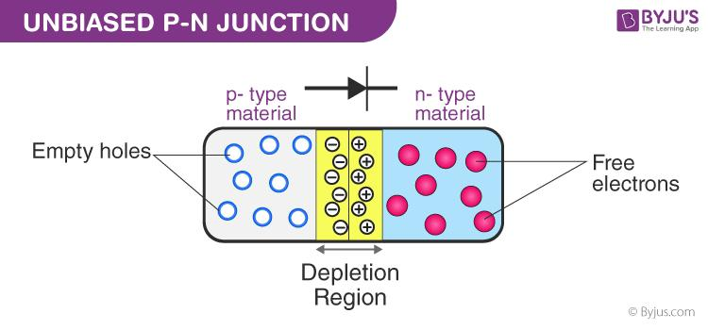

**QUESTION 6**

**photoelectric effect is the emission of electrons from the surface of a substance in response to incident light.**

**Photovoltaic mechanism is a process in which two dissimilar materials in close contact produce an electrical voltage when struck by light.**

**The following are differences between photoelectric effect and photovoltaic mechanism.**

1. **Electrons are emitted in photoelectric effect while electrons are not emitted in photovoltaic mechanism**
2. **In photoelectric effect electric current is not generated while in photovoltaic mechanism electric current is generated.**
3. **Photoelectric effect occurs when energy provided by protons is enough to overcome the electron binding energy while photovoltaic mechanism occurs when energy provided by protons is enough to overcome the potential barrier of excitation.**

**QUESTION 7**

**How batteries are different from photovoltaic cells.**

**Batteries generate electricity from light indirectly by using chemical reactions to create an electric current while photovoltaic cells directly converts sunlight into electrical energy through photovoltaic conversion process.**

**Batteries work by using chemicals such as lead sulfide while photovoltaic cells works by using electrons which are energized by protons to create an electric field.**

**QUESTION 8**

**Different technologies used for improving efficiency of a photovoltaic cell.**

**Efficiency of a cell is affected by the following.**

* **Intensity of solar radiation**
* **Quality of semiconductor in use**
* **Temperature of the photovoltaic cell**

**To increase efficiency of a photovoltaic cell, a passive cooling mechanism (PCM) is used.**

**A PCM does not require pumping water or air for cooling.**

**A PCM has thermal regulation effects which helps create a shift in temperature rise.**

**An effective PCM must have a large latent heat of fusion and should be neither toxic nor corrosive.**

**PCM are used to control the temperature of a photovoltaic cell.**

**QUESTION 9**

**Multi junction cell**

**Refers to solar cells with multiple p-n junctions made up of different semiconductor materials.**

**These cells are connected in series I order to obtain higher performance.**

**Individual component cells are connected in series through the tunnel junctions.**

**These individual component cells have different material qualities.**

**Multi junction cells have a metal organic chemical vapour deposition technique which contribute to their high efficiency.**

**Multi junction cells have a possibility to grow three or more junctions which leads to increased efficiency.**

**QUESTION 10**

**Queisser Shockley- limit**

**This refers to maximum efficiency of a solar cell using a P-N junction to collect power from the cell where the only loss mechanism is radiative recombination in the solar cell.**

**Shockley–Queisser limit is calculated by examining the amount of electrical energy that is extracted per incident photon.**

**The calculation places maximum solar conversion efficiency around 33.7% assuming a single p-n junction with a band gap of 1.4 eV (using an AM 1.5 solar spectrum). Therefore, an ideal solar cell with incident solar radiation will generate 337 Wm-2**

**QUESTION 11**

**The process of solar electricity generation in a P-N junction cell.**

When light reaches the p-n junction ,the light photons can easily enter in the junction, through very thin p-type layer.

The light energy, in the form of photons, supplies sufficient energy to the junction to create a number of electron-hole pairs.

The incident light breaks the thermal equilibrium condition of the junction. The free electrons in the depletion region can quickly come to the n-type side of the junction and holes towards p type and act as battery.

This leads to formation of an electric current.

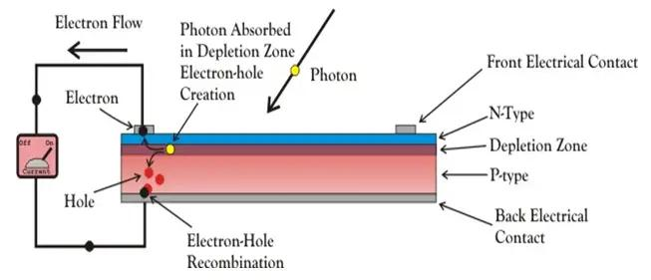

**QUESTION 12**

**Power and voltage characteristics of a typical solar cell**

The power delivered by a solar cell is (I x V).

Below are curves showing the current voltage (I-V) characteristic of a typical cell.

These curves shows a maximum PowerPoint at I Max and V max.

