**Field: engineering-electrical engineering**

**Topic: motors**

An electric motor is an electrical machine that converts electrical energy into mechanical energy. Most electric motors operate through the interaction between the motor's magnetic field and electric current in a wire winding to generate force in the form of torque applied on the motor's shaft. An electric generator is mechanically identical to an electric motor, but operates with a reversed flow of power, converting mechanical energy into electrical energy.

Below is internal diagram of motors.



Electric motors can be powered by direct current (DC) sources, such as from batteries, or rectifiers, or by alternating current (AC) sources, such as a power grid, inverters or electrical generators.

Electric motors may be classified by considerations such as power source type, construction, application and type of motion output. They can be powered by AC or DC, be brushed or brushless, single-phase, two-phase, or three-phase, axial or radial flux, and may be air-cooled or liquid-cooled.

Standardized motors provide convenient mechanical power for industrial use. The largest are used for ship propulsion, pipeline compression and pumped-storage applications with output exceeding 100 megawatts.

include industrial fans, blowers and pumps, machine tools, household appliances, power tools, vehicles, and disk drives. Small motors may be found in electric watches. In certain applications, such as in regenerative braking with traction motors, electric motors can be used in reverse as generators to recover energy that might otherwise be lost as heat and friction.

Electric motors produce linear or rotary force (torque) intended to propel some external mechanism, such as a fan or an elevator. An electric motor is generally designed for continuous rotation, or for linear movement over a significant distance compared to its size. Magnetic solenoids are also transducers that convert electrical power to mechanical motion, but can produce motion over only a limited distance.

**Split-Phase Motors (isir)**

The split-phase motor is a single-phase motor that does not have any capacitors or other devices in its circuit to alter its torque characteristics. Diagrams of this motor are presented in Fig. 1. This motor is also called the split-phase motor or the ISIR (induction start, induction run) motor, since it uses only induction to start and run.

Fig. 1

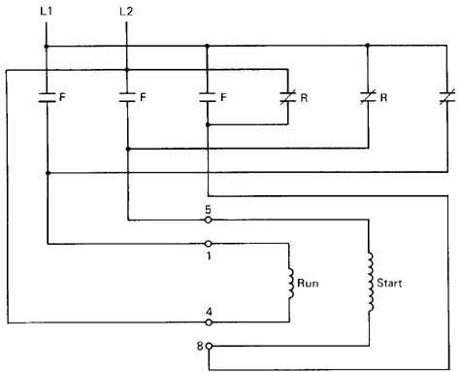

Diagram of a split-phase motor connected to a forward & reversing motor starter. The run winding (T1-T4) remains connected the same way in both forward & reverse operation. The start winding (T5-T8) gets reversed to make the motor run in the opposite direction.

Above: Fig. 1: Diagram of a split-phase motor connected to a forward and reversing motor starter. The run winding (T1-T4) remains connected the same way in both forward and reverse operation. The start winding (T5-T8) gets reversed to make the motor run in the opposite direction.

This type of motor has the lowest starting torque of all single-phase motors. It uses the physical displacement of the run and start windings in the stator to provide the phase shift required to start the rotor moving. Recall that the three-phase motor uses the 120° phase shift that naturally occurs in the three-phase voltage to cause starting torque. Since the single-phase motor does not have a natural phase shift, the split-phase motor uses the difference of the coil size to create a phase difference along with physically locating the start winding out of phase with the run winding to cause a magnetic phase shift that is large enough to cause the rotor to start spinning.

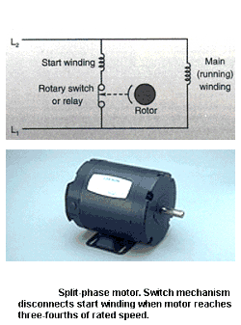

When voltage is first applied to the motor's stator, the rotor is not turning and the windings will draw maximum current. This current is called inrush current or locked-rotor amperage (LRA). After the rotor starts to turn, it will induce current from the stator and produce its own magnetic field. This field will cause the rotor to increase speed until it reaches its rated speed. The rated speed is determined by the number of poles the motor uses and the frequency of the applied voltage. That is, at a two-pole motor will operate at 3600 rpm, a four-pole motor will operate at 1800 rpm, a six-pole motor will operate at 1200 rpm, and an eight-pole motor will operate at 900 rpm.

**Split sphase motor (CSIR), Capacitor start induction run.**

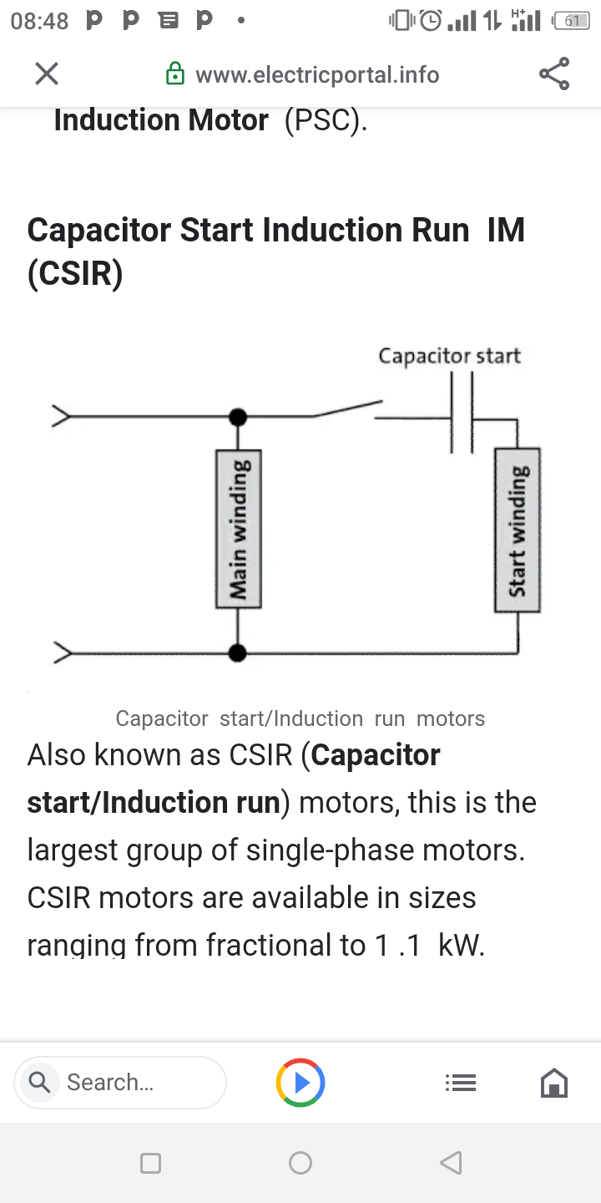

Capacitor start/Induction run motors

Also known as CSIR (Capacitor start/Induction run) motors, this is the largest group of single-phase motors. CSIR motors are available in sizes ranging from fractional to 1 .1 kW.

Capacitor start motors feature a special capacitor in a series with the starting winding. The capacitor causes a slight delay between the current in the starting winding and main winding. This causes a delay of the magnetization of the starting winding, which results in a rotating field effectively in producing torque.

As the motor gains speed and approaches running speed, the starting switch opens. The motor will then run in the normal induction motor mode. The starting switch can be a centrifugal or electronic switch.

Applications of Capacitor start Induction run

Capacitor start/Induction run type motors have a relatively high starting torque, between 50 to 250 percent of the full-load torque. This makes them a good single-phase motor choice for loads that are difficult to start, e .g . for conveyors, air compressors, and refrigeration compressors.

**Split phase motor; Capacitor Start and Capacitor Run Induction Motor (CSCR**)

Capacitor-start/Capacitor run single phase induction motorKnown as a CSCR motor for short, this type of motor combines the best features of the Capacitor start/Induction run the motor and the permanent-split capacitor motor. Even though their construction makes them somewhat more expensive than other single-phase motor types, they are the perfect choice for demanding applications. A Capacitor start capacitor run type 1 phase induction motor has a start-type capacitor in series with the starting winding, just like the capacitor-start motor. This provides high starting torque. Capacitor start capacitor run motors also resemble Permanent-split capacitor (PSC) motors in so far as they have a run type capacitor which is in series with the starting winding once the start capacitor is switched out of the circuit. This means that the motor can handle a high breakdown or overload torque. CSCR motors can be designed for lower full-load currents and higher efficiency.

One of the advantages of this feature is that it allows the motor to operate at smaller temperature rises than other, similar single-phase motors.

Application Of Capacitor start and Capacitor run induction motor

Capacitor start capacitor run motors are the most powerful single-phase motors and can be used for quite demanding applications, e .g. high-pressure water pumps and vacuum pumps and other high-torque applications which require 1 .1 to 11 kW.

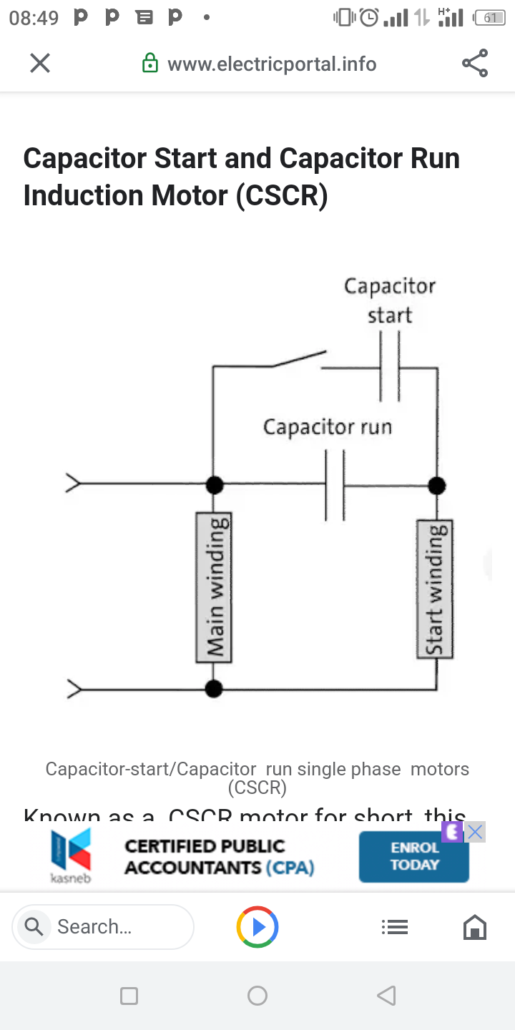

**Permanent split capacitor Induction Motors (PSC**)

Permanent-split capacitor single phase induction motor diagram

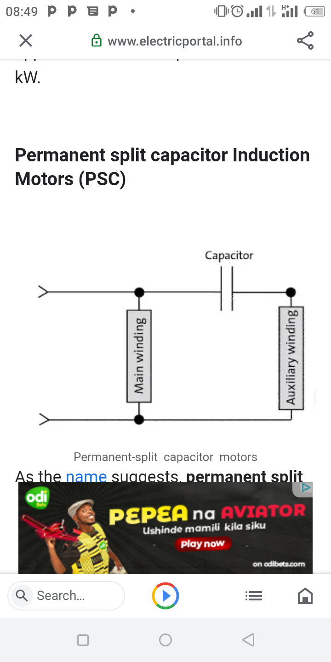

Permanent-split capacitor motors

As the name suggests, permanent split capacitor types of single phase induction motor (PSC) have a run-type capacitor which is left permanently in series with the starting winding during operation.This is to say that they do not have a starting switch or a capacitor which is used only for starting. Thus, the starting winding becomes an auxiliary winding when the motor is up to running speed. The design of PSC motors means that they cannot provide the same initial boost as motors with separate capacitors. Their starting torques are quite low, between 30 to 90% of rated load, so they cannot be used for applications which are hard to start. This is offset by their low starting currents - usually less than 200% of rated load current - which makes them the perfect choice for applications with high cycle rates. Permanent-split capacitor motors offer many benefits. Their running performance and speed can be tailored to meet specific needs, and they can be designed for optimum efficiency and high power factor at rated load. As they need no starting mechanism, they can be reversed easily. Finally, they are the most reliable single-phase motors available.

Applications of Permanent split capacitor induction motors

Permanent-split capacitor motors can be used for many different applications, depending on their design. Low-inertia loads such as fans and pumps would be common example.

**Shaded-pole motor**

The shaded-pole motor is the original type of AC single-phase induction motor, dating back to at least as early as 1890.[1] A shaded-pole motor is a small squirrel-cage motor in which the auxiliary winding is composed of a copper ring or bar surrounding a portion of each pole.[2] When single phase AC supply is applied to the stator winding, due to shading provided to the poles, a rotating magnetic field is generated. This auxiliary single-turn winding is called a shading coil. Currents induced in this coil by the magnetic field create a second electrical phase by delaying the phase of magnetic flux change for that pole (a shaded pole) enough to provide a 2-phase rotating magnetic field. The direction of rotation is from the unshaded side to the shaded (ring) side of the pole.[2] Since the phase angle between the shaded and unshaded sections is small, shaded-pole motors produce only a small starting torque relative to torque at full speed. Shaded-pole motors of the asymmetrical type shown are only reversible by disassembly and flipping over the stator, though some similar looking motors have small, switch-shortable auxiliary windings of thin wire instead of thick copper bars and can reverse electrically. Another method of electrical reversing involves four coils (two pairs of identical coils).[3]

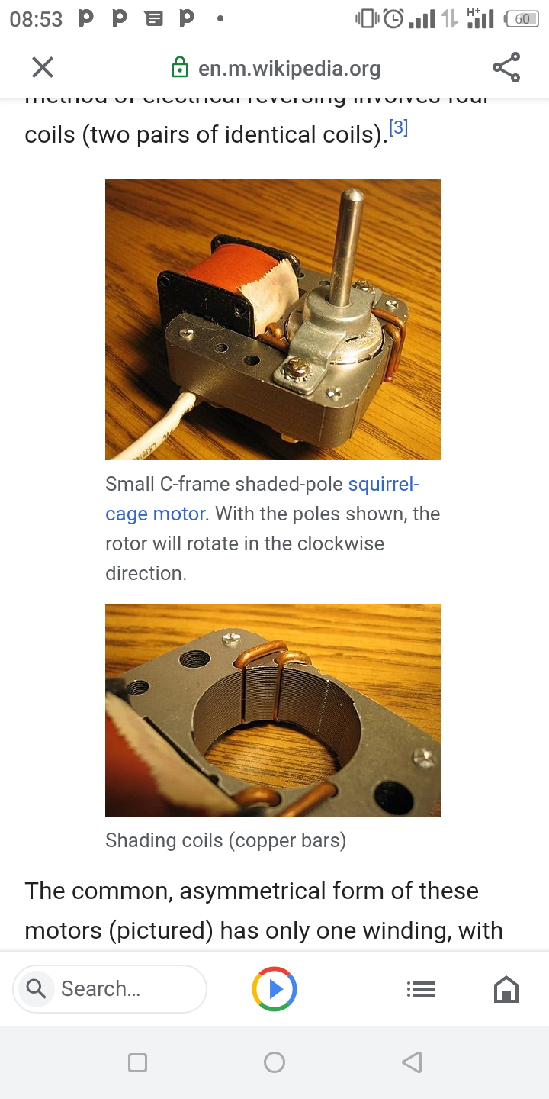

Small C-frame shaded-pole squirrel-cage motor. With the poles shown, the rotor will rotate in the clockwise direction.

Shading coils (copper bars)

The common, asymmetrical form of these motors (pictured) has only one winding, with no capacitor or starting windings/starting switch,[4] making them economical and reliable. Larger and more modern types may have multiple physical windings, though electrically only one, and a capacitor may be used. Because their starting torque is low, they are best suited to driving fans or other loads that are easily started. They may have multiple taps near one electrical end of the winding, which provides variable speed and power by selection of one tap at a time, as in ceiling fans. Moreover, they are compatible with TRIAC-based variable-speed controls, which often are used with fans. They are built in power sizes up to about 1⁄4 horsepower (190 W) output. Above 1⁄3 horsepower (250 W), they are not common, and for larger motors, other designs offer better characteristic.

***Multi-Speed Motors***

**Motor, Motor control**

Some motors are designed to operate at two, three, or four separate designated speeds. The speed of an induction motor depends on the number of poles built into the motor and the frequency of the electrical power supply. Multi-speed motors are available up to 500 hp, and are very reliable, but have several drawbacks.The stator slots have to be bigger than those of single-speed motors in order to accommodate two or more sets of windings. As a result, the motors are bulkier and cannot be easily retrofitted. The current-carrying capacity of the copper is poorly utilized since only one set of windings is active at a time. Because of their dual speed design, however, they still have lower operating efficiencies than comparably sized single speed motors.

**Multiple speed motor stator**

Multiple speed motor starters typically cost up to twice as much as single-speed motor starters. Multi-speed motors themselves cost 50-100 percent more than single-speed motors. Two-speed motors can be used to save energy in such applications as air volume control in facilities that have large differences in day-to-night or weekday-to-weekend air flow requirements. A dual speed fan rated for 1,200 and 1,800 rpm, for instance, can reduce fan energy requirements at night and on weekends by 70 percent.

**Pole-Amplitude Modulation (PAM) Motors**

The pole amplitude modulation motor is a single-winding, two-speed, squirrel cage induction motor that avoids some of the drawbacks of conventional two-speed designs. PAM motors are available in a more broad range of speed ratios than standard multi-speed motors, but these are all synchronous speed ratios. Since PAM motors require no additional windings, they are more compact than other multi-speed motors using the same frame size designations. The low speed setting of a PAM motor functions well for soft-starting, producing lower inrush current and heating.

**PAM Motors**

PAM motors are especially well suited for two-speed duty cycle applications,including large fans and pumps, rating from a few to thousands of horsepower. In retrofits, PAM motors allow for continued use of a pre-existing throttle device, such as a valve or damper, while eliminating the heavy losses normally associated with throttle-only controls. Like multi-speed motors, PAM motors are available for variable-torque, constant-torque or constant-horsepower applications. PAM motors with starters cost about the same as standard multi-speed motors.Common PAM motor speeds are:

900/720 rpm

1,200/720 rpm

1,200/900 rpm

1,800/720 rpm

1,800/1,200 rpm

3,600/720 rpm

3,600/900 rpm