IUpDevastation Unleashed: The Catastrophic Effects of Mass Wasting

**Nature's Unstoppable Force: The Devastating Impact of Mass Wasting**

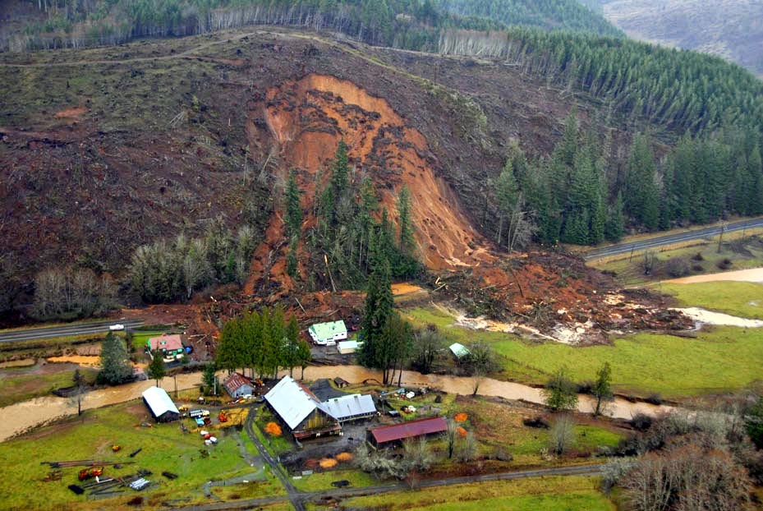

By Jonny cruise

The world is currently facing a major crisis that is affecting our environment in a significant way. The event in question is the mass wasting event that has been happening across the globe. This phenomenon is causing immense damage to our planet, and it is essential that we take action to prevent further destruction. In this article, we will explore what mass wasting is, its causes, and the impact it is having on our environment. We will also discuss the steps we can take to mitigate its effects and protect our planet.

1. **What is mass waisting**

Land wasting refers to the degradation or loss of land due to various human activities such as deforestation, soil erosion, mining, urbanization, and agricultural practices. This leads to a reduction in the land's productivity and the loss of its natural resources, which can have significant environmental, social, and economic impacts. Land wasting can also result in the loss of biodiversity, increased greenhouse gas emissions, and the displacement of local communities.

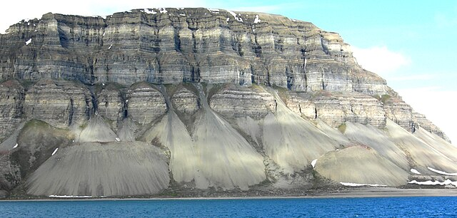

As you can see from the picture above this is just a mass waisting. Since you now have the understanding and image of land slide let’s venture into :

*Courses of landslide.*

Landslide courses are designed to provide individuals with the knowledge and skills needed to understand, assess, and manage landslide risks. These courses cover a range of topics, including the causes and types of landslides, landslide mapping and monitoring techniques, hazard assessment and management, and mitigation strategies. Whether you are a geologist, engineer, planner, or emergency manager, these courses can help you develop the expertise necessary to effectively address landslide risks in your field. With hands-on training and real-world case studies, these courses offer a comprehensive and practical approach to landslide management that can benefit professionals and communities alike.

Introduction to Landslides: This course provides an overview of the causes, types, and effects of landslides, as well as the methods used to assess and mitigate landslide hazards.

2. Landslide Hazard Assessment: This course covers the techniques and tools used to evaluate the risk of landslides, including field investigations, remote sensing, and modeling.

3. Landslide Mitigation and Remediation: This course focuses on the design and implementation of measures to reduce the risk of landslides, such as slope stabilization, drainage improvements, and vegetation management.

4. Landslide Monitoring and Early Warning Systems: This course covers the use of sensors, instrumentation, and remote sensing to detect and monitor landslides, as well as the development of early warning systems to alert communities of impending landslide hazards.

5. Landslide Case Studies: This course examines real-world examples of landslides, including their causes, effects, and mitigation strategies. Case studies may include landslides triggered by earthquakes, rainfall, and human activities.

***Nutural courses of landslide***

1. Heavy rainfall: Excessive rainfall can saturate the soil and destabilize the slope, leading to a landslide.

2. Earthquakes: Earthquakes can trigger landslides by shaking the ground and causing the soil to lose its cohesion.

3. Volcanic eruptions: Volcanic eruptions can cause landslides by destabilizing the slope and causing the soil to become loose.

4. Erosion: Erosion can occur due to natural causes such as wind, water, and ice. This can weaken the slope and cause a landslide.

5. Freeze-thaw cycles: Freeze-thaw cycles can cause the soil to expand and contract, leading to cracks and weakening of the slope.

6. Soil composition: The composition of the soil can also contribute to landslides. For example, clay soils are more prone to landslides than sandy soils.

7. Vegetation: The type and density of vegetation on a slope can affect its stability. Trees with shallow roots, for example, can destabilize the slope and increase the risk of a landslide.

# *Anthropogenic causes*

Anthropogenic causes of landslides refer to human activities that directly or indirectly contribute to the occurrence of landslides. These activities may include:

1. Deforestation: Cutting down trees and vegetation destabilizes the soil, making it more susceptible to erosion and landslides.

2. Mining: Excavation and removal of soil and rock can alter the stability of slopes and cause landslides.

3. Construction: Building structures on steep slopes or altering the natural drainage patterns can increase the risk of landslides.

4. Irrigation: Over-irrigation or improper drainage can saturate soil and increase the weight on slopes, leading to landslides.

5. Land use change: Changing the land use from natural to agricultural or urban can alter the natural drainage patterns and soil stability, increasing the risk of landslides.

6. Road construction: Building roads on steep slopes can destabilize the soil and increase the risk of landslides.

7. Landfills: Improperly constructed or managed landfills can create unstable slopes and increase the risk of landslides.

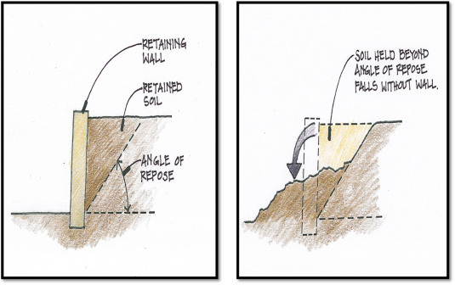8. Earthquakes: Anthropogenic activities such as oil and gas exploration and extraction can induce earthquakes, which can trigger landslides.

When it comes to angle of repose it is an important factor in slope stability as it determines the maximum angle at which a slope can remain stable without collapsing or sliding. The angle of repose is the steepest angle at which a material can be piled up without slumping or sliding down.

In general, the angle of repose for dry, granular materials such as sand, gravel, and rocks is between 30-45 degrees. However, the angle of repose can vary depending on the size, shape, and density of the material, as well as the presence of water or other factors that can affect the frictional forces between particles.

When designing slopes or embankments, engineers must take into account the angle of repose of the materials being used and ensure that the slope angle does not exceed this value. If the slope angle is too steep, the weight of the material can exceed the frictional forces holding it in place, leading to slope failure, landslides, or other types of slope instability.

*ways of preventing landslide*

Yes, there are several ways to prevent landslides or reduce their impact:

1. Slope stabilization: This involves reinforcing the slope with retaining walls, terracing, or other structures to prevent soil erosion and reduce the risk of landslides.

2. Drainage control: Proper drainage can help prevent landslides by reducing the amount of water that accumulates in the soil, which can cause instability.

3. Vegetation management: Planting trees and other vegetation can help stabilize slopes by reducing soil erosion and absorbing excess water.

4. Early warning systems: Installing sensors and monitoring equipment can help detect early signs of slope instability and trigger early warning systems to alert people in the area.

5. Land use planning: Proper land use planning can help prevent landslides by avoiding development in high-risk areas or implementing measures to reduce the risk of landslides in these areas.

*Effect of landslide in an area*

Landslides can have devastating effects on an area. Some of the effects include:

1. Loss of life: Landslides can cause loss of life and injury to people living in the affected areas.

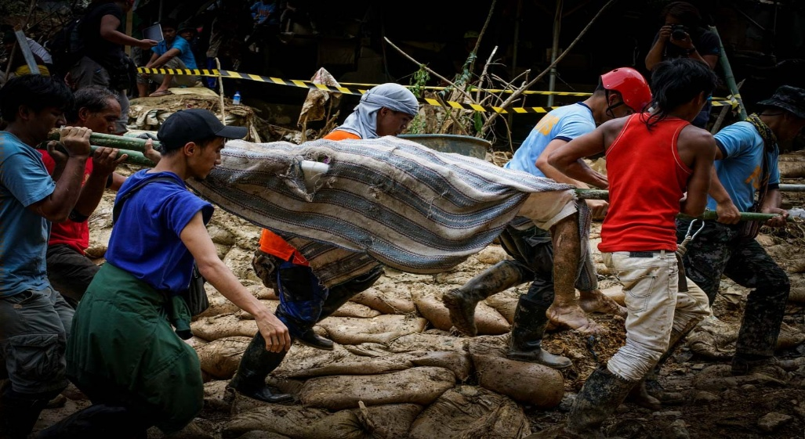

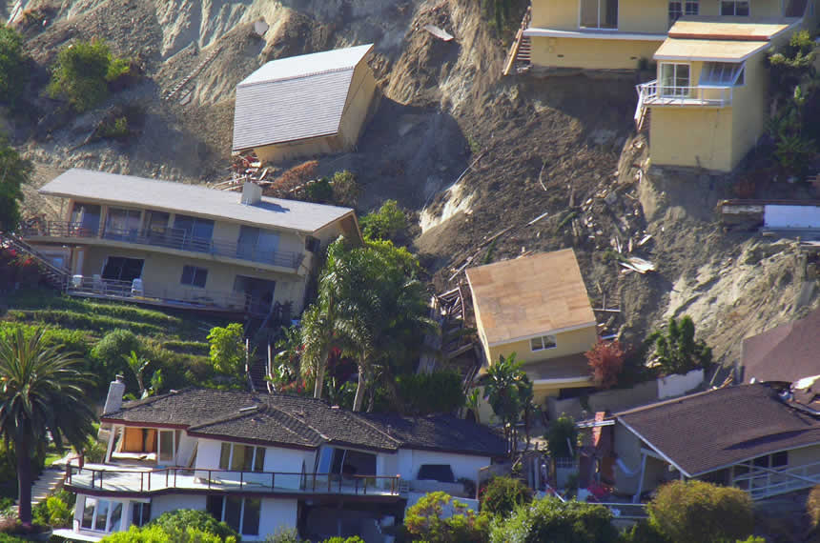2. Property damage: Landslides can damage or destroy homes, buildings, and other structures in the affected area.

3. Displacement of people: Landslides can force people to evacuate their homes and move to safer areas, leading to displacement and disruption of their lives.

4. Environmental damage: Landslides can cause environmental damage by altering the landscape and destroying natural habitats.

5. Economic impact: Landslides can have a significant economic impact on the affected area, including loss of income, damage to infrastructure, and increased costs for recovery and reconstruction.

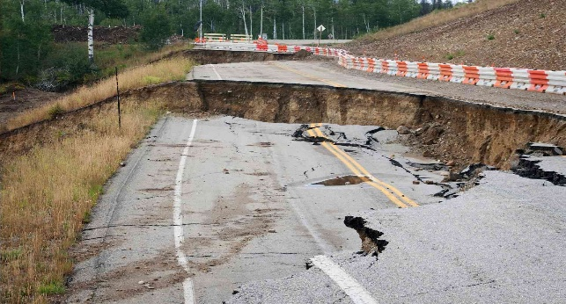6. Disruption of transportation: Landslides can disrupt transportation systems, making it difficult for people to travel and access essential services.

7. Increased risk of other natural disasters: Landslides can increase the risk of other natural disasters, such as flooding and mudslides, in the affected area.

In conclusion, the issue of mass wasting is a critical environmental concern that requires urgent attention. As we have seen, it not only affects the natural landscape but also poses a significant threat to human lives and infrastructure. However, with proper management and mitigation strategies, we can reduce the impact of mass wasting and protect our communities and ecosystems. It is essential that we work together to raise awareness, promote sustainable practices, and invest in research and technology to address this pressing issue. By doing so, we can ensure a safer and more sustainable future for ourselves and generations to come.