DISASTER RESILIENCE

IMPROVING DISASTER RESILIENCE IN TAITA TAVETA

|  |
| --- |
| **Key Messages**  Significant space-time variations **were observed in rainfall characteristics in Taita-Taveta County.**  **Increase in mean, maximum and minimum temperatures were observed at all locations within Taita-Taveta County.**  Climate related risks emphasized **the need for reliable, accurate and timely climate information that requires investment in weather observation instruments, data management, prediction and early warning systems, as well as capacity building for all** |

TAITA TAVETA, Kenya situated along Mombasa-Nairobi highway. The area is a vulnerable ecosystem and home to abundant wildlife in the county. The community largely depends on agriculture and livestock to get their daily food but due to the effects of climate change, life has proven to be hard and the very survival of their livestock and farm inputs is hanging in the balance.

For four decades, experts say Taita Taveta has seen adverse effects of climate change, which has led to drought. As a result, there have been long-term environmental effects like soil degradation, reduction of water volumes in rivers, landslides, deforestation, drying of wells and rivers, and increased human-wildlife conflicts.

Mirium Kasumuni, who is a village elder and a widower with 8 children told us that her husband passed away due to high blood pressure complications. A condition which she said, developed after they lost almost 100 cows in one period due to drought

# Introduction

“My husband got high blood pressure when a hundred cows suddenly died because of lack of food. The drought also brought a strange disease which also contributed to the death of the cows” she said during an interview.

It’s a similar story among many others in her village. Sinyati Kiringoli had more than 10 cows due to drought, she lost 6

“We never used to experience this prolonged drought. Most of my neighbors have lost their livestock and are now struggling even with providing food for their children,” she said.

With that in mind, the community has little to depend on so that they can look after their family needs. “Traditionally, women were not allowed to go out and look for a living in the community. But with most of their livestock gone, they have now defied the odds.” Its survival for the fittest, they say, “and we have to adapt and explore other means of livelihood. The women started going to the forests to cut down trees for charcoal, which in a way is destroying an already fragile ecosystem, even further.

For years, they would sell charcoal along Mombasa-Nairobi highway. The little cash they would get would be used to provide food, clothing and pay for school fees, for their children. For years, they would sell charcoal along the Mombasa-Nairobi highway. The little cash they would get would be used to provide food, clothing and pay for school fees, for their children.

One of the villagers, Tonkei Kotina is aware that the illegal logging and charcoal burning has largely contributed to the drought situation that they are now facing. “We have been experiencing weird changes in our weather patterns. Even in the times when we normally get rain, we don’t receive it anymore,” Kotina said.

The forest cover decline as a result of illegal logging and charcoal burning is also a threat to the wildlife. More and more species are unable to survive as the practice denies the habitat the crucial natural interconnectedness. This also leads to human-wildlife conflicts due to the scarce resource.

According to African Wildlife Foundation Executive Director Maurice Nyaligo, already 98 percent of indigenous trees in Taita Taveta county have been lost to illegal logging and charcoal burning.

Disasters disrupt hundreds of thousands of lives every year. Floods, fire, earthquakes, tornadoes and hurricanes have lasting effect, both to people and property. And these disasters can happen anywhere- from third world countries with weak infrastructure…to our nation’s financial headquarters… to our own neighborhoods.

Weather data and economic studies are combining to show an increasing trend in extreme weather events and related costs of recovery over the past 10 years. Significant space-time variations were observed in rainfall characteristics in Taita-Taveta County. The location-to-location variation in rainfall amounts as well as the observed rainfall trends is now well documented. There is clear evidence of recurrences of above and below normal rainfall extremes with indications of changes in frequency and severity of the above and below rainfall events that are often associated with droughts and floods. Some of the observed climate extremes occurred during ENSO and positive/negative Indian Ocean Dipole (IOD) years, making ENSO and IOD based prediction and early warning extremely useful in the local climate risk management.

Increase in mean, maximum and minimum temperatures were observed at all locations within Taita-Taveta County. Although increasing trends were evident in all places consistent with global warming trends being observed worldwide, the short duration of data used could not enable an associate the observed warming trends in Taita-Taveta to climate change and global warming signals.

The observed climate extremes such as floods and droughts that are common in the area often had far reaching socio-economic implications that include lack of water and food; migrations, wildlife/livestock/ human conflicts, unemployment, loss of life, etc. The climate risks seem to be increasing the vulnerability of the poor local community.

The observed climate related risks emphasized the need for reliable, accurate and timely climate information that requires investment in weather observation instruments, data management, prediction and early warning systems, as well as capacity building for all including climate scientists, policy makers, and the sector specific climate sensitive local users.

The climate data and the derived products and information including those associated with climate change provides a basis for investment in effective and well-integrated strategies for mainstreaming disaster risk reduction and build climate change resilience in all development plans that are county-driven, gender-sensitive, participatory and fully transparent, taking into consideration vulnerable groups, communities and ecosystems.

There is clear need for enhanced county level institutional framework and integrated policies, coordination and collaboration in the local use of climate information and services by all climate sensitive sectors in Taita-Taveta with a clear role of Kenya Meteorological Department (KMD) and the relevant local systems.

**Background Information and Recommendations**

Climate change and variability remains a threat to sustainable development in the County. The climate data from the Kenya Meteorological Department for Taita-Taveta County is insufficient. There is therefore the need to invest more on weather observation systems including the use of remotely sensed data in the County. The available data shows that there is significant variability not only the annual rainfall received, but also from one month to another. Peak rainfall months are centered around March to May (MAM) and October to December (OND) period. Positive and negative rainfall trends were also observed that were not consistent in all locations within the county. Inter-annual variability patterns further showed evidence of recurrences of rainfall extremes associated with floods and droughts, as well as increasing frequency and severity of extreme events such as drought and floods. Some of the observed recurrent positive and negative rainfall anomalies were observed during El Nino / Nina (commonly represented as ENSO) years and positive/negative Indian Ocean Dipole (IOD) years. Rainfall amounts and intensity in Taita-Taveta differs from place to place with amounts ranging between 300mm to 1100 mm annually. The spatial variability in rainfall is evident in Voi sub-county where some parts of Ngolia ward record the highest rainfall amounts in the county, while other parts of the sub-county like Mbololo and Sagalla wards generally experience the lowest amounts of rainfall.

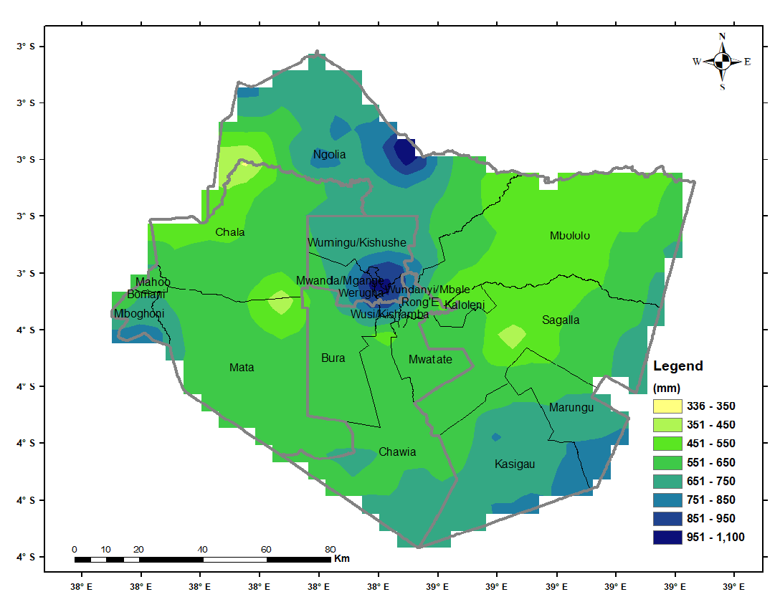

**Figure 1: Long Term Annual Mean Rainfall (1981-2010)**

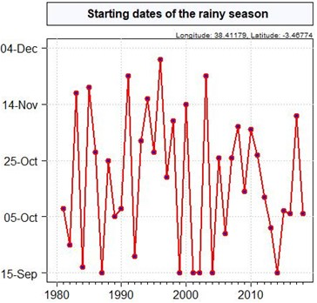

**Figure 2: Seasonal Onset over a Point in Taita-Taveta during OND**

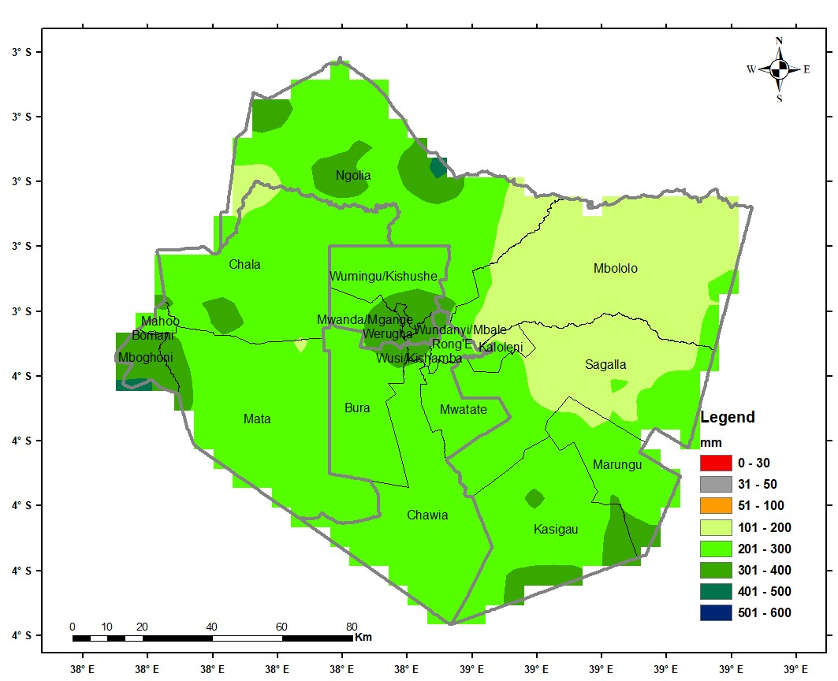

**Figure 3: MAM Long Term Mean Rainfall (1981-2010)**

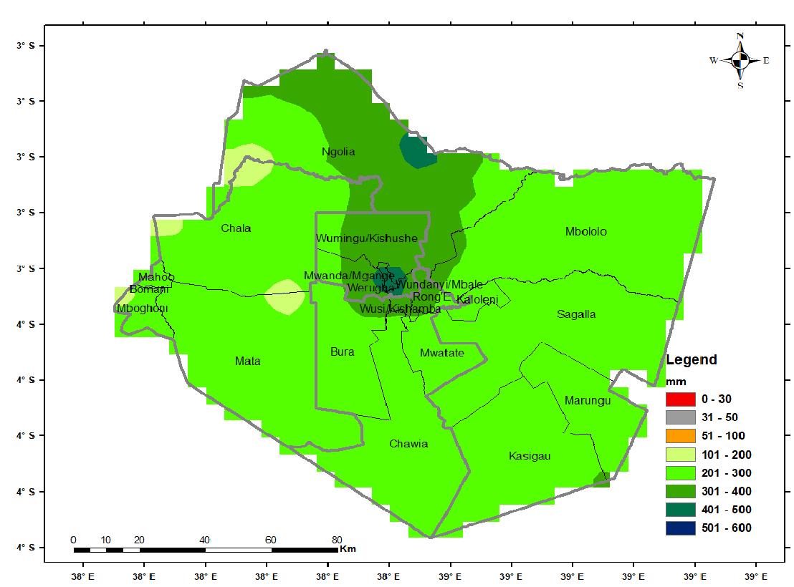

**Figure 4: OND Long Term Mean Rainfall (1981-2010)**

Taita Taveta rainfall generally showed decreasing trends in both the March to May as well as October to December seasons. Recurrence in climate extremes, also observed in the county, often have far reaching socio-economic implications that include lack of water and food; hunger, migrations, wildlife/ livestock/ human conflicts, unemployment, loss of life, etc.

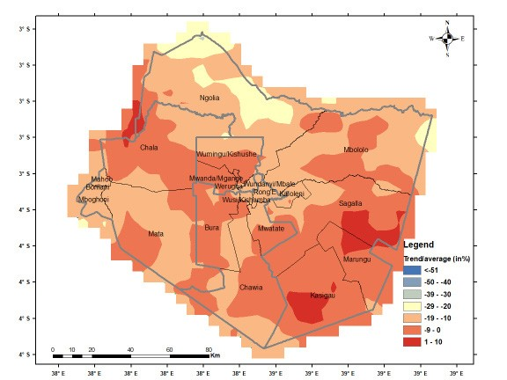

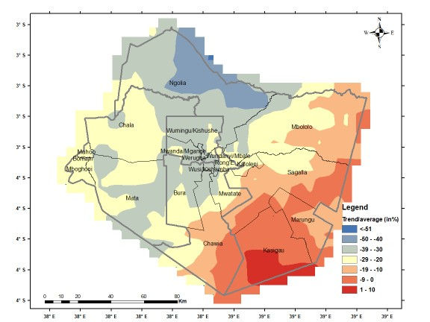**Figure 5: MAM Season Rainfall % Trend**

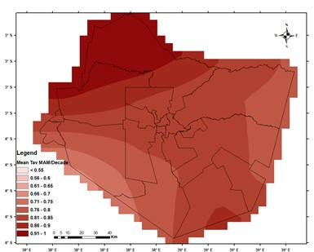**Figure 6: OND Season Rainfall % Trend**

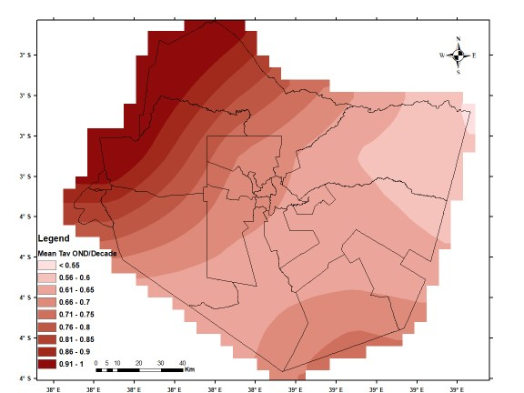**Figure 7: Mean MAM Season Surface Temperature Trends**

**Figure 8: Mean OND Season Surface Temperature Trends**

The analysis of the observed temperature data showed an increase in both minimum and maximum temperatures at all locations and all seasons.

The results are consistent with regional and global data that have reported an increase in temperature, which has been linked with high confidence to global warming and climate change. The increase in temperature has been linked to an increase in the occurrence of pests and diseases (IPCC 2014).

The data supports the need for integration of local knowledge in the planning and development of national climate change adaptation strategies. Policy makers should strengthen inter-linkages between adaptation and development strategies that enable communities to build climate resilience. Policies should be linked across different sectors of government at both the sub-national and national level. Sectoral level policy makers, planners and managers should be given information in suitable forms as they are most likely to mainstream adaptation efforts into their planned work.

Other critical baseline rainfall characteristics for Taita-Taveta including rainfall intensity; probability of exceedance of specific rainfall thresholds; mean characteristics of wet/dry days; probability of occurrence of specific wet/dry spells; onset, cessation and length of crop growing seasons have been well documented.

-Defying The Odds-

Hadithi handicrafts are one of the non-governmental organizations in Maungu which has come up to support climate change adaptation efforts in the area and the County at large.

This is through empowering the women to do beadwork and also actively helping them to provide income for over 1,700 women from 59 women’s groups- the Maasai women included.

Their artistry has enabled them to earn a decent living as each woman participating in the project earns at least Sh15,000 per month.

Hadithi acts as a creative and supportive hub for these women’s groups by helping them build their capacity, improve the quality of their products, improve sales through joint marketing efforts and most importantly instill various life skills and an entrepreneurial know-how that have enabled them to have a decent living as they support their families.

Kate Sau is in charge of the beading projects at Hadithi handicrafts, she said the project is a solution to preserving the environment and as a result mitigate the effects of climate change in the community.

Sau said they have been providing the women with the required materials to make beads and baskets. When they are ready, “we buy them from the women, and then they either sell them locally or export them. By doing that, the women get money which helps them look after their families,”

She added that “We normally provide the women with the raw materials they use to make the jewelry. By doing the beadwork, the women are engaged for the whole day and don’t get time to go cut down trees. That alone has helped us to preserve our environment,”

One of the beneficiaries is Miriam Kasumuni, who has been engaged in beadwork for 5 years now. She said the project has changed her way of life. “I can now provide for my family without difficulties,” the mother of five said.

Kotina, who joined the project after losing her livestock, said the money she gets after selling the jewelry has helped her take her grandchildren to school. “I joined the women group to make the beads after losing my 20 cows,” she said.

According to Sinyati Kiringoli, the assistant chairperson of the Nasirian women group, which has 21 members, even their husbands have embraced it. Jacob Kasumuni, one of the men living in the village, agreed that drought has affected their way of life due to the lack of pasture for their livestock. This, Kasumuni said has seen them change their traditional way of life as women play an active role in supporting their families.

“Because we don’t have enough livestock as we used to have before, we have now allowed our wives to go out and look for money so that they can also help in meeting the family needs,” he said. According to the United Nations, 80 percent of people who are forced to migrate because of climate change are women. Hence there is a need for all stakeholders to address the issue as an emergency.

Hamisa Zaja, a coordinator at an international organization dealing with environmental matters, pointed out that several social and community activities have been interfered with because of climate change. With women being the most affected, she urged the government to support projects offered by non-governmental organizations to women who have been affected by climate change.

Former President Uhuru Kenyatta declared drought a national disaster with more than two million Kenyans across the 47 counties at risk of starvation. “The President has instructed The National Treasury and the Ministry of Interior and Coordination of National Government to spearhead Government efforts to assist affected households including water and relief food distribution as well as livestock uptake,” State House said in a statement.

According to Kenya’s National Drought Management Authority, the number of those affected by the ongoing drought could double to a possible 4 million if rainfall is not experienced in some of the affected areas. Experts say that climate change mostly affects those who depend mainly on natural resources and whose livelihoods are climate-sensitive—many are poor farming women.

According to a 2015 report by the United Nations Department of Economic and Social Affairs (DESA), about two-thirds of the female workforce in developing countries is involved in agricultural labor, and that number is higher in Africa’s rural areas.

Natural resources are becoming ever scarcer due to climate change, which presents additional challenges for women.

**Policy Recommendations**

the governor met delegations from World Agroforestry and Africa Wildlife Foundation (AWF) to discuss a range of issues touching on climate and conservation.

At the top of the agenda was the adoption of nature-centric solutions backed by policy implementation, building institutional capacity, and enhancing monitoring and reporting on environment protection, conservation, and restoration.

“It is time we rethink our approach to environmental conservation to avert the crisis occasioned by climate change. What we need are nature-centered solutions through policy implementation, building institutional capacity, and enhancing our monitoring and reporting capabilities on issues on environment conservation, protection, and protection,” said Governor Mwadime.

The governor proposed the construction of check dams in the hilly areas as rainwater reservoirs, which will be connected to the lowlands as sources of water for irrigation.

He further cited the areas of Mghange, Mwanda, Nyache, and Mbololo as the perfect careas for the dam projects that would become the cornerstones to building agricultural capital for a food-secure county.

“Check dams at the areas of Mghange, Mwanda, Nyache, and Mbololo could be a game changer in our fight against climate change. We can build agricultural capital for our people through irrigation and water for livestock and become a food-secure county,” said Mwadime.

The governor’s sentiments were echoed by Leigh Winowiecki, ICRAF’s soil system scientist, who announced an upcoming project in the county aimed at the restoration of forests, range lands, and farms.

“I would like to concur with the governor’s views and call on other partners to come on board and support the journey of climate change transformation. Indeed, there is an upcoming project in partnership with the county aimed at the restoration of forests, range lands, and farms,” said Leigh.

Leigh also emphasized the need for use of scientific research to come up with and implement solutions that are not only practical but also meet the needs of the people. “It is crucial to use scientific research to arrive at practical solutions that are within the needs of the people,” she said.

According to the county drought management coordinator Gabriel Mbogho, climate change has been the single most contributor to the status quo that has pushed human populations to the verge of food and water crises.

He said that while a lot has been done to avert the county from descending into an alarming drought status, a lot remains to be done at the individual, county, and national government levels.

“Climate change has been at the center of everything we’re witnessing now and has significantly contributed to the dire water and food situation the county is in right now. Of course, a lot has been done in the past but there is more that individuals, the county, and the national government have to do,” said Mbogho.

The drought outlook for the county according to National Drought Management Authority (NDMA) is at an alert level with areas like Kasighau, Sagalla, Kishushe, and Maktau more likely to drop into alarm level if nothing changes in October.

“In general, the county is at the alert level and we’re doing everything to improve the situation. However, if nothing changes this month we’ll have areas of Kasighau, Sagalla, Kishushe, and Maktau dropping into the alarm level,” read the NDMA report.

For its part, the county drought management task force is working day and night to make water and food for humans and livestock available as they hope for the rains to start later in October.

Among the interventions are multi-million projects of sinking boreholes in Paranga, and Miasenyi; rehabilitation of water pans in Kasighau and Mbololo; and construction of pipe water projects in Sagalla, Rong’e, and Tausa.

“With the help of the national government and non-governmental partners, the county is doing everything to avert a drought disaster. We’re currently undertaking multi-million projects in sinking boreholes in Paranga and Miasenyi; rehabilitating water pans at Kasighau and Mbololo; and constructing water pipe systems at Sagalla, Rong’e, and Tausa,” said Mbogho.

The change of tact in combating climate change and the biting drought in Taita Taveta comes at a time when the county has been predicted to receive less than average rainfall in the coming short rain season according to the latest weather statement released by the Kenya Meteorological Department.

“The South-eastern lowlands of Kitui through to Kajiado and Taita Taveta, the Coast and North-eastern Kenya are likely to receive below average rainfall with sunny and dry spells prevailing through October,” said a statement read by Bernard Chanzu, the Deputy Director of Forecasting Services at the Kenya Meteorological Department.

The significance of the observed rainfall data shows continued exposure to recurring events of drought and flooding for communities in Taita Taveta. The following are recommendations from the research:

* There is need to integrate local knowledge in the national development strategies to cope with climate variability and adaptation to climate change;
* Need for increased investment for collection and processing climate data throughout the county as this would help improve planning and timely intervention;
* Need to invest in climate information services including prediction, multi hazards early warning systems at all-time scales ranging from daily to climate change time scales. This will also require the following among others;
* The right infrastructure to generate accurate downscaled, location specific climate information services;
* Capacity building for all including scientists, users and policy makers;
* Established Communication and feedback systems to disseminate this information to end users, and for feedback and evaluations of the impacts; and
* Awareness to end users on how to use climate information provided.

Strengthen inter-linkages between adaptation and development strategies that enable communities to build resilience. This calls for all sectoral level policy makers, planners and managers to take into account climate information to mainstream adaptation efforts into their planned work.

County Climate Risk Profiles are a key tool to guide climate smart agriculture investments and priorities at the county level in Kenya. These are documents that provide analyses of the underlying causes of vulnerability and on-going and potential climate change adaptation strategies. They also provide a snapshot of the enabling environment for building resilience by providing a snapshot of the enabling environment for building resilience by providing a synthesis of the policy, institutional and governance context. Complementary materials such as map books and annexes for productivity of major agricultural commodities, climate analysis, adaptation options and methodological details are also provided