Classification and Functions of Operating System (OS)

Student’s Name:

Institutional Affiliation:

Course:

Instructor:

Due Date:

# Introduction

An operating system, alias OS, is a package of varied software that manages computer system resources, that is, software and hardware resources and also caters varied services to the computer system users (Francis-Mezger & Weaver, 2018). Thus, an operating system is a foundational middleware layer that facilitates interaction between computer hardware and software. It is key in ensuring proper, efficient and secure computer system operations. According to Tutorial point, an operating system component is embedded in an application called kernel (TutorialsPoint, 2019). This paper aims to discuss the classifications and functions of an OS. It will begin by exploring the architecture of the OS and identify the most popular OS, and finally discuss the classification and functions of the OS.

## Architecture of an Operating System

The below diagram illustrates the simple architectural diagram of an operating system.

Figure 1: The Architecture of an OS

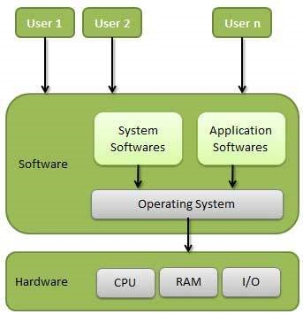

Source: (TutorialsPoint, 2019).

## Popular Operating systems

Commonly used operating systems in the contemporary world are Android and Apple’s iOS for mobile-based and personal digital assistant devices while for personal computers Windows, MAC OS and Linux-based OS are domineering with market coverage of approximately 93% (Francis-Mezger & Weaver, 2018). However, we still have some operating systems, namely; Symbian, Blackberry, Chrome OS - usually runs on the Chrome books, Firefox OS and KaiOS.

# Classification of Operating System

Conventionally operating systems are categorized based on three major criterion that is number of users supported concurrently, number of tasks performed momentarily and number of programs handled at a time (Francis-Mezger & Weaver, 2018). However, there are special classification of operating systems categorized based on the unique environment of their deployment. See below the detailed explanation of the various types of the operating system.

In this first section, I explain Batch operating system.This operating system undertakes its task servicing role by grouping together jobs of similar nature into small groups named batches as indicated by (Geeksforgeeks, 2019). The system then queues the jobs and process them on basis of first in first out. The figure below illustrates the batch operating system workflow ("Batch operating system," 2015).

Figure 2: The batch operating system

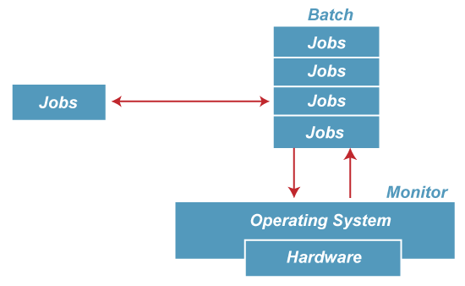

Source: (Javapoint, 2021).

Secondly,we look at Multi-Programming operating system. This system undertakes its role by allocating the memory partition to various jobs at ago while the CPU is processing the jobs. It operates on the basis of two system time; CPU time and I/O time (Francis-Mezger & Weaver, 2018). That is while a process is conduction I/O operations the CPU time is utilized in execution of other tasks. This system enhances increase in system throughput and aid in reducing the system response time.

Thirdly I look at, Multi-Processing operating system. This system is designed and developed for computer systems with multiple processing powers that enable parallel processing. The system involves utilization of more than one CPU in execution of task hence enhancing the system throughput (Francis-Mezger & Weaver, 2018). Examples of such include the current version of Windows-200, UNIX and Linux. The below diagram illustrates the multiprocessing.

Figure 3: Multi-Processing Operating System

  
Source: (Geeksforgeeks, 2019).

Multi-User Operating System comes in the fourth place. This operating system supports concurrent users, usually within the same network. Examples of this operating system include Unix-based systems, Windows servers and Linux servers (Smith, 2019). It is deemed to be a complex and expensive operating system.

Additionally,Multi-Tasking operating system is another category of OS. This type of OS can concurrently execute multiple programs in a moment. It is logically a subset of multiprogramming operating system (Santos et al., 2018). For the OS to achieve the tasking capacity, it is augmented with multiple processors, which facilitate faster speed of execution within the same time (Smith, 2019). Examples include Windows, Linux and macOS modern versions. The below diagram illustrates multitasking.

Figure 4: Multi-Tasking Operating System

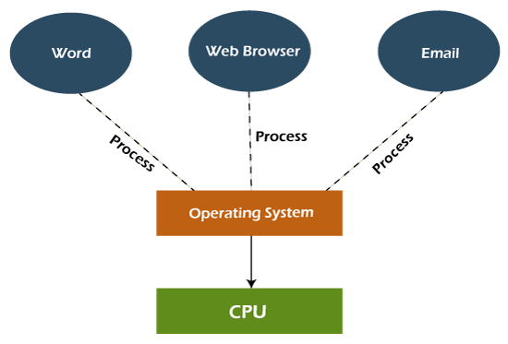

Source: (Javapoint, 2021).

Another category of OS is the Distributed operating system. This operating system is designed and developed for a distributed computing environment where several interconnected computing systems or devices operate together. The processors of devices interconnected by distributed OS can differ in size and functionalities (Geeksforgeeks, 2019). The system is expensive and always ceases operations due to failure on the main network else every node is fault-tolerant from the other nodes. Examples of such OS include cluster computing OS and LOCUS.

Moreover there exist some unique category of the OS, namely; Real-Time and Time-Sharing operating system.Real-Time OS is classified depending on its capacity to process and execute jobs quickly within a strict timeline (Yang & Shinjo, 2020). The operating system intends to execute data as immediately as possible to eliminate delays between processing inputs and output. The time taken to process the input to output is known as response time. Usually, the operating system is used in critical computing or response systems, like an industrial control system, Air traffic control system, and patient health observation system in the ICU (Geeksforgeeks, 2019). The real-time OS can be further divided into two: Hard real-time and Soft-real time OS.

Hard real-time OS ensures that the critical jobs are done within the time restriction while Soft real-time system includes attaching preference to jobs and ensuring ones of high priority are completed. The application is known for its error-free nature, single focus on application execution, proper memory allocation and maximum utilization of computing devices (Yang & Shinjo, 2020).

### Secondly, Time-sharing OS enables and facilitates mechanisms for job time allocation for execution. Time-sharing OS ensures the smooth execution of tasks without competition for limited computing resources. The concept is also known as a time slot, slice, or quantum (Yang & Shinjo, 2020).

# Functions of Operating System

The operating system has several functions to support within a computing system environment. Below are some of the key functions:

Management of processes; An operating system always ensures proper allocation of the computer processing unit time to process jobs through scheduling and prioritization following the first-in-first-out concept. Additionally, an operating system ensures the creation and termination of processes (Javapoint, 2021).

Management of computing system memory resource; An operating system usually ensures proper allocation and deallocation of memory resources to processes running in a computing system. It also extends this capacity to manage the virtual memory to optimize RAM utilization (Francis-Mezger & Weaver, 2018).

Management of Computer File system; An operating system ensures proper organization and arrangement of files and directories, enables provision of various access controls and privileges of access to files, and implements file input and output operations (Smith, 2019).

Management of Peripheral Device(s); An operating system manages the connectivity of external devices into a computing system; the devices include keyboards, mice, printers and storage devices. It also caters to essential drivers for hardware communication in a computing system (Smith, 2019).

Management of security and Access control;An operating system facilitates and enforces user authentication and access permissions and privileges (Burtsev et al., 2023). Through protecting the computing system from malware and unauthorized access.

Management of Network communication; An operating system enables and facilitates networked devices connection and communication via implementing network protocols and services (Burtsev et al., 2023).

Management of Error Handling; An operating system enables detection and recovery from errors, system crashes, and failures by providing error messages and logs to facilitate troubleshooting the root cause of errors (Michele & Regis, n.d.).

Management of file and data backup; An operating system supports data backup and recovery mechanisms to prevent data loss. That is incase of any disastrous incident in computer system such as file crash, corruption, an operating system enables a computer system to be restore back to a point in time (Burtsev et al., 2023).

Manages system performance monitoring and optimization; An operating system enables the management of file collections and analysis of system performance metrics through the implementation of optimal system efficiency (Smith, 2019).

# Conclusion

Notably, the operating system has played and will continue to play a critical and key role in underscoring the functionality and usability of computing systems. The operating system has evolved to enable support for a wider range of devices and computing environments. Varied operating systems are customed to support particular gaps within the computing environment.

**References**

Batch operating system. (2015). Computer-Based Problem Solving Process, 273-279. <https://doi.org/10.1142/9789814663748_0018>

Burtsev, A., Narayanan, V., Huang, Y., Huang, K., Tan, G., & Jaeger, T. (2023). Evolving operating system kernels towards secure kernel-driver interfaces. Proceedings of the 19th Workshop on Hot Topics in Operating Systems. <https://doi.org/10.1145/3593856.3595914>

Francis-Mezger, P., & Weaver, V. M. (2018). A raspberry Pi operating system for exploring advanced memory system concepts. Proceedings of the International Symposium on Memory Systems. <https://doi.org/10.1145/3240302.3240311>

Geeksforgeeks. (2019, April 30). *Operating System | Types of Operating Systems - . GeeksforGeeks*. GeeksforGeeks. Available at: <https://www.geeksforgeeks.org/types-of-operating-systems/>

Javapoint. (2021). Types of operating systems (OS). www.javatpoint.com. <https://www.javatpoint.com/types-of-operating-systems>

Michele, P., & Regis, L. (n.d.). Operating system function reuse to achieve low-cost fault tolerance. Proceedings. 10th IEEE International On-Line Testing Symposium. <https://doi.org/10.1109/olt.2004.1319676>

Santos, A., Cunha, A., & Macedo, N. (2018). Property-based testing for the robot operating system. Proceedings of the 9th ACM SIGSOFT International Workshop on Automating TEST Case Design, Selection, and Evaluation. <https://doi.org/10.1145/3278186.3278195>

Smith, S. (2019). Linux operating system services. Raspberry Pi Assembly Language Programming, 131-143. <https://doi.org/10.1007/978-1-4842-5287-1_7>

TutorialsPoint. (2019). *Operating System Overview*. Www.tutorialspoint.com. Available at: <https://www.tutorialspoint.com/operating_system/os_overview.htm>

Unwana, Timothy E.; Udoh, Edna I. and Umoh, Vincent O. (2022). A Study of the Importance of Operating System (OS) in a Computer System. Journal of Computer Science Review and Engineering, 1(1), 1-12.

Yang, C., & Shinjo, Y. (2020). Obtaining hard real-time performance and rich Linux features in a compounded real-time operating system by a partitioning hypervisor. Proceedings of the 16th ACM SIGPLAN/SIGOPS International Conference on Virtual Execution Environments. <https://doi.org/10.1145/3381052.3381323>

‌

‌

‌