**Full Title of Paper**

First Name Last Name

Department, Bow Valley College

Course Code: Course Name

Instructor’s Name

Due Date

**Full Title of Paper**

Nursing theories integrate information, define the field, and address issues in education, research, and patient care. Less abstract notions and verified testing are used in middle-range nursing theories, which concentrate on precise, tangible linkages between grand nursing theories and nursing practice. They are more constrained in scope compared to big theories. They describe, explain, or predict clinical events. Middle-range theories concentrate on a specific aspect of nursing reality and offer recommendations for clinical work and academic study in the field. To bridge the gap between nursing practice and grand theories, nursing scholars provide middle-range theories based on grand theories (Alligood. M.R, 2017).

These theories are crucial for the growth of nursing because they reduce scope, improve proximity to empirical data, and make abstraction easier (Jaarsma, Riegel, & Stromberg, 2012). Middle-range theories are further described by Smith. M.J & Liehr. P. R, (2013) as those theories “that lie between the minor but necessary working hypotheses that evolve in abundance during day-to-day research and the all-inclusive systematic efforts to develop unified theory.” This is further explained as the principal ideas of middle-range theories are relatively simple. Here, simple means rudimentary, straightforward ideas that stem from the focus of the discipline. Thus, middle-range theory is a basic, usable structure of ideas, less abstract than grand theory, and more abstract than empirical generalizations or micro-range theory.

Middle-range theories enhance the application of grand theories and models in nursing by constricting their reach through the use of particular concepts and a concentration on particular phenomena. They remain more practical. Predictive theories, which are more specific and predictable than explanatory theories and which strengthen connections between ideas like Orlando's deliberative nursing process, might be classified as middle-range theories.

According to Jaarsma, Riegel, and Stromberg (2012), middle-range theories are applicable to day-to-day nursing practice. For instance, in order to manage chronic diseases in adults, this essay explores the use of middle-range theories in nursing practice, particularly self-care. It connects Dorothea Orem's big idea to caring for people with long-term illnesses. Key principles include self-care maintenance, monitoring, and management, concentrating on lifestyles and interventions to ameliorate chronic diseases.

A middle-range notion in self-care, self-monitoring is patients checking their chronic conditions, such as diabetes, on a regular basis and giving nurses a few, but helpful, ideas to actual data, therefore simplifying complex ideas to make them more applicable to nursing practice (Bandura, A. 1977).

Below is a diagram to help us understand the categorization of nursing theories followed by explanation on the applicability of some middle range theories in nursing practice:

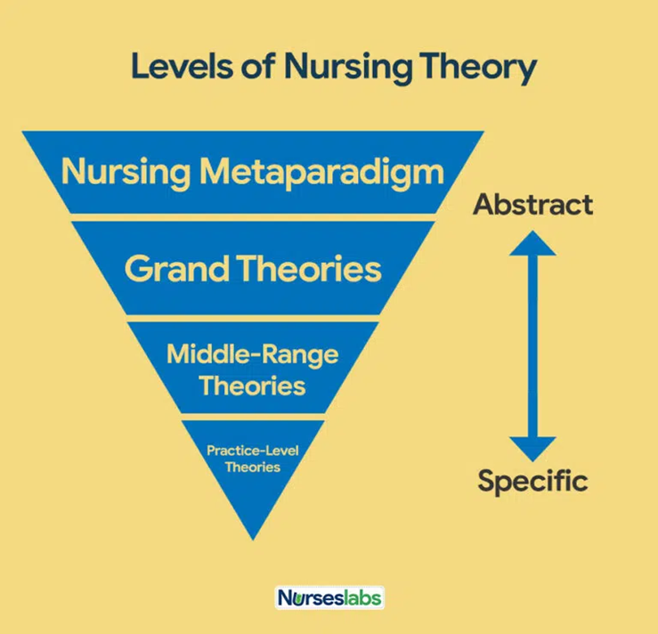

One of the Mid-range theories of nursing is the theory of holistic care**.** While attending to a patient, as a nurse I do not focus only on the patient’s presenting complaint. It is paramount to take into account the patient’s holistic self. To further explain, holistic care of the patient entails taking into account body, mind, and spirit. This is the focus of contemporary nursing practice. It fosters a balanced lifestyle and raises the patient's quality of life. Nursing entails professional counseling and communication between the patient and the expert. (Beebe et al.,2012).

Another Middle range theory of nursing is the Group power theory in organizations. The group power theory, according to Christina Sieloff, places a strong emphasis on cooperation and teamwork in nursing groups. It promotes harmony and excellence in nursing by enhancing competency, teamwork, and service delivery **(**Smith. M.J & Liehr. P.R, 2013). Also, most of the cases require a multi-disciplinary approach. Everyone needs to bring their best into action for the sake of the patient

Empathy theory as well is a mid-range theory of nursing. Empathy is the capacity to comprehend and identify with the emotions of another person. It fosters learning, understanding, and self-worth. Nurses are a constant contact with the patient. They should be compassionate and understanding with their patients since this promotes a therapeutic relationship between the patient and the healthcare practitioner. Useful phrases with kind and healing words like "I totally understand how you feel" and "I can feel the pain in how you explain it" might help the patient feel better and establish a bond with the nurse (Haugan, G., & Innstrand, S. 2012).

The interpersonal relationship theory is equally important. The interaction between a person and their surroundings is emphasized by nursing's notion of interpersonal relationships. Environmental needs, nursing leadership, listening, negotiating, and having a positive attitude are its four main parts. In order to offer patients, hope and support, nurses must control their patients' emotions, speak positively, and keep a positive outlook.

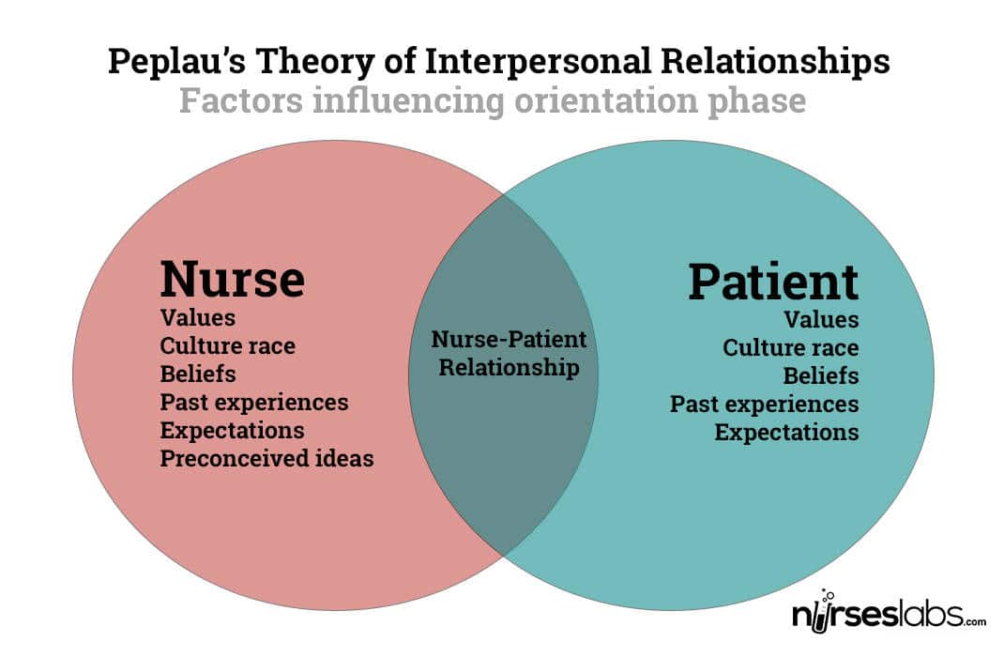

The theory of persistent grief cannot be forgotten. Chronic sorrow is the term used to describe persistent sadness or grief-related emotions brought on by a substantial loss. This idea aids nurses in comprehending the emotional breakdown and coping mechanisms of patients with chronic illnesses. This should be accepted by nurses who can then provide support, coping mechanisms, and encouragement. Nurses should offer consolation and explain that pain is common in loss situations (Jaarsma, T., Riegel, B., & Stromberg, A. 2012).

Summarily, middle-range nursing theories are developed from grand theories, which cover a wider discipline, while middle-range theories focus on specific concepts. They are applicable and practical every day nursing practice. Nurses and scholars have influenced grand theories, and middle-range theories have been improved over centuries.

**References**

Alligood, M. R. (2017). Nursing Theorists and Their Work-E-Book. *Elsevier Health Sciences Generating Middle Range Theory by Callista Roy; Roy Adaptation Association Staff* <https://shop.elsevier.com/books/nursing-theorists-and-their-work/alligood/978-0-323-75702-7>

Bandura, A. (1977). Self-efficacy: Toward a unifying theory of behavioral change.*PsychologicalReview*

<https://www.sciencedirect.com/science/article/abs/pii/0146640278900024>

Haugan, G., & Innstrand, S. (2012). The effect of self-transcendence on depression in cognitively intact nursing home patients. *Psychiatry*, 12(1), 1-10 <https://www.researchgate.net/publication/228090565_The_Effect_of_Self-Transcendence_on_Depression_in_Cognitively_Intact_Nursing_Home_Patients_Academic_Editors_B>

Jaarsma, T., Riegel, B., & Stromberg, A. (2012). A middle-range theory of self-care of chronic illness. *Advances in Nursing Science*, 35(3), 194-204. <https://scirp.org/reference/referencespapers.aspx?referenceid=1753930>

Smith. M.J &. Liehr. P.R (2013). Middle Range Theory for Nursing <http://stikespanritahusada.ac.id/wp-content/uploads/2017/04/Mary-Jane-Smith-PhD-RN-Patricia-R.-Liehr-PhD-RN-Middle-Range-Theory-for-Nursing_-Third-Edition-Springer-Publishing-Company-2013.pdf>

Sieloff. C.L & Frey A.M (2013). Middle Range Theory Development Using King's Conceptual <https://www.researchgate.net/publication/281524092_Middle_Range_Theory_Development_Using_King's_Conceptual_System>