**All About Landslides**

Many types of mass-wasting earth movements alter the ground structure and aesthetic, and one of such as landslides. Also known as landslips, landslides involve many ground movements, such as slope failures, rockfalls, debris flows, and mudflows. Landslides occur underwater, on coastal cliffs, on mountain ranges and are defined by both gentle and steep slope gradients (Lacroix, Handwerger, & Bièvre, 2020). Geologists explain that gravity is the primary driving force that leads to a landslide. However, there are many other factors that affect slope stability, and they produce certain conditions that make these slopes prone to the movements mentioned above.

The word landslip is made up of various types of slope movement, such as slides, topples, falls, flows, and spreads. Depending on the geological material, these modes are further divided into bedrocks, earth, and debris (Wang & Li, 2021). Each landslide has many causes depending on the location, but the common characteristic is that slope movement is witnessed whenever forces acting down a slope (because of gravity) exceed the earth’s materials strength that makes up the slope (Lissak, 2020). Landslides are recorded to range from localized events to catastrophic disasters, depending on their magnitude.

**Why Landslides Occur in Specific Locations**

The primary reason why landslides occur in most locations is because of slope characteristics. A slope’s stability is a critical element in the occurrence of a landslide since steep slopes have a bigger gravitational force that makes the are more prone to landslides since the force acts more on the soil, rocks, and other surface materials (Wang & Li, 2021). Slopes that have poorly consolidated and weak rick formations plus geological faults are more likely to experience mud slips.

Properties and types of geological formations have a significant role to play when underlying causes of landslides are evaluated, as it will be seen throughout the paper. There are rock types that have a high clay composition, such as shale, that have a higher probability of sliding or failing compared to other stable rock types (Lissak, 2020). Weak planes, fault lines, and bedding planes in rock layers are also considerable slope instability contributors.

Climate and weather are considerable contributors of landslips. Weather conditions such as heavy rainfall can trigger landslips, as will be elucidated in other sections of the article. Whenever rainfall is prolonged and intense, the soil becomes saturated thus reducing its cohesion and strength, making it more prone to failure. Areas with a high annual monsoon and precipitation season are susceptible to landslides induced from rainfall (Lombardo & Castro-Camilo, 2021).

The configuration and shape of a land surface can lead to landslide activities. There are times when slope direction can influence the amount of rainfall, or sunlight received this soil composition is affected and in turn, landslides are experienced (Lacroix, Handwerger, & Bièvre, 2020). Topography is an essential element when looking at drainage patterns, natural water cause ways such as rivers and streams which can increase instability after erosion.

**Signs of Landslides**

Even though landslides do not exhibit similar signs, there are common indicators as proposed by geologists. Development of ground cracks that were not previously there on slopes and in areas where landslides are common is a warning sign. Such cracks can be in form of small fractures or large fissures in rocks and soils. Another sign of a future landslip activity is leaning poles and tilting trees (Wang & Li, 2021). This occurs whenever the land starts to shift or move because the base and roots of such objects are affected when the underlying soil begins to move.

Deformation of slopes is another sign, and it comes with visible changes in the contour or shape of a slope in form of depressions, large slumps, and bulges. Such a distortion signifies potential landslip activity since it is caused by internal rock layer and soil movement. Similar changes are seen with water flow alterations where new springs appear on slopes and seepage increases (Lissak, 2020). Water starts to saturate the soil, and its strength is reduced, and this may, in turn, trigger a landslip in future.

Cracking infrastructure is another factor when geologists study landslide occurrences. Ground movements can cause damages to roads, building walls, and other structures (Wang & Li, 2021). These cracks appear on foundations, walls, paved surfaces, or walls, thus indicate instability. Sudden rock and soil displacement can be an indication that a landslide is likely to occur. Such debris may have originated from sloped and moved downwards during landslip events (Lacroix, Handwerger, & Bièvre, 2020). Additionally, unusual vibrations and sounds are common when landslide activities are about to occur. An example is cracking sounds caused by falling rocks and debris.

**Types of Landslides**

For the most part, the word landslide has historically been used to cover all types of regolith and mass movements on the earth’s surface. After 1978, there were changes that were implemented by geologists to come up with a better scheme to define and explain the earth’s movements (Lombardo & Castro-Camilo, 2021). It is crucial to note that these categories are not very distinct to geologists since many types of landslides can occur at the same time, while in other instances, they transition from one element to another. Geologists have to assess the risks associated so they can mitigate the challenges by understanding each type of behavior associated with a particular location and landslide (Pollock & Wartman, 2020). Under the Hungr-Leroueil-Picarelli classification, there were six movement types that were documented as follows.

Whenever a movement of isolated chunks or blocks of soil in a freefall is recorded, geologists label it as a fall. When similar blocks come away from a vertical surface by rotation, the term topple is used. Falls are recorded whenever soil, debris, and rocks from a cliff or slope fall freely (Lissak, 2020). These materials are known to detach from the cliff or slope surface because of gravity, and they roll or bounce as they move downwards.

A slide is used to refer to the body of material movement that remains intact while moving along inclined surfaces. Slides can be catastrophic and, in other instances, be progressive or gradual. They occur when coherent masses of debris, soil, and rocks move along a defined surface that could be a layer or a bedding plane within the slope. Geologists have developed further classifications, such as transitional slides that involve materials moving along a planar surface (Lacroix, Handwerger, & Bièvre, 2020). This means that the sliding mass rotates backward during its movement and leaves a scar at the top. Rotational slides, in the other hand, entail the movement of material on a curved surface.

Another type of movement is spread, where layers of materials expand laterally after cracking and opening up. Slope deformations affect entire mountain portions or slopes, while flows are characterized by fluidized material moving (Wang & Li, 2021). Water can influence flow movement and be categorized further into the following. Earth flows are slow-moving and entail higher portions of fine materials such as silty soils and clay. Mudflows, on the other hand, are made up of fine-grained elements such as clay which mix with water to form a slurry material (Lombardo & Castro-Camilo, 2021). They are commonly recorded in areas that have experienced volcanic eruptions and after heavy rainfall.

**Figure 1: An example of an earth flow**

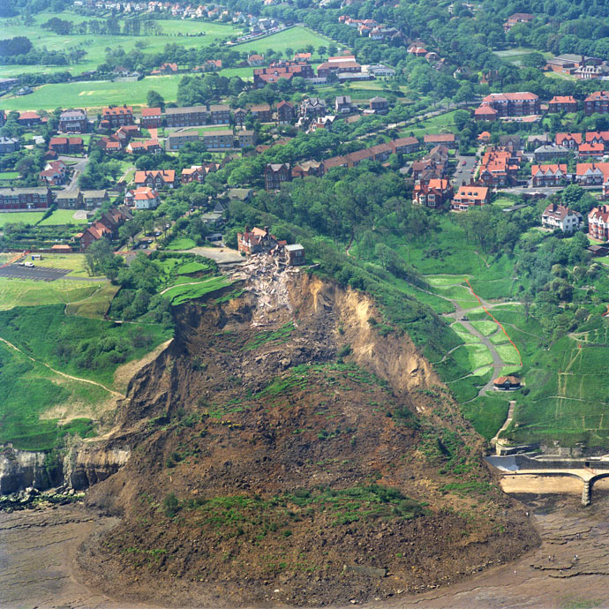

Debris flows are seen after rock fragments, water, and soil mix in steep channels. This flow type is heavily destructive because of the large sediment content and rapid movements. Another type is the complex landslide, and it involves a culmination of various movement types (Wang & Li, 2021). Complex landslides showcase various elements of flows, slides and falls that could occur sequentially or simultaneously and thus, it becomes harder to manage or mitigate the associated challenges whenever they are forecasted or when they occur.

**Figure 2: Image showing an example of a landslide**

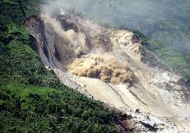

Failure mechanisms in slopes that could lead to landslides are affected by many uncertainties, such as soil property heterogeneity. There are times when the sliding surface is on a weathered bedrock or the soil mantle, and this is referred to as a shallow landslip. In such an instance, the debris flows and slides are shallow because they happen in areas with highly permeable soils found on top of soils with low permeability (Lissak, 2020). These soils trap water and thus generate high water pressure that fills top layers of soil with water making them unstable and move downslope.

Deep-seated landslides, on the other hand, can be described as those in which the surface sliding is located deeply below the depth of most trees and their roots. They involve deep weathered rocks, bedrocks, regolith, large failures in slopes, and rotational, complex, or translational movements. Geologists identify such landslides using scarps found at steep areas or at the top (Lacroix, Handwerger, & Bièvre, 2020). Deep-seated landscapes are responsible for shaping landscapes for specific timescales and geologically produce sediments that alter the fluvial streams courses.

**Causes of Landslides – Natural and Human-Induced**

The main causes of landslides are geological factors. One of such is slope steepness since such slopes are very prone to such activity because of gravitational pull that acts on surface materials such as rocks, soil, and debris. Another geological factor is rock and soil properties that are poorly and weakly consolidated (Lombardo & Castro-Camilo, 2021). Additional rock and soil elements are loose rocks on the surface and geological faults that contribute to instability on these slopes.

Fault lines, bedding planes, and weak planes on and within rocks and their formations can increase landslide susceptibility in some locations (Pollock & Wartman, 2020). A further element is erosion and weathering that can lead to slopes weakening over some time, and thus making surfaces prone to landslips (Lissak, 2020). Seismic activities such as earthquakes and tremors can destabilize slopes and trigger landslips depending on intensity and length of time they occur.

Climate and weather factors come together to influence landslides in the following ways. Heavy rainfall over a prolonged and intense period leads to soil saturation, thus reducing its cohesion and strength, which can lead to landslips. Whenever snow melts rapidly, the water content in rocks and soil can increase; thus, the slopes can then become susceptible to sliding. Thawing and freezing cycles are a part of weather and climate issues since they weaken slopes in colder climates. Hurricanes and tropical storms come with heavy rainfall, and these events can trigger landslides in the areas they are recorded in, especially coastal areas.

Human activities leave the ground susceptible to landslips in various ways, as elucidated below. As human populations continue to increase, there is need for more land for industrial activities and settlement. Furthermore, timber is in higher demand now than ever, and thus deforestation is at an all-time high. Removing vegetation from earth surfaces such as slopes destabilizes them since the plant roots being eliminated holds soils and rock particles to provide stability. Should deforestation occur, there is a higher likelihood of landslips being recorded.

Excavation and construction resulting from human activities such as industrialization and the creation of settlements alter the natural land slope setup, thus triggering landslips after disturbing surfaces (Ma, Mei, & Piccialli, 2021). There is a general disregard for the environment in many instances because of greed exhibited through human activities. Governments have failed to create rules to monitor such issues in many jurisdictions; thus, landslides can be a side effect of such oversight (Lissak, 2020).

Improper land use practices can still be evaluated under human activities that can lead to landslides. Water leakage and irrigation from water infrastructure and irrigation systems can increase landslide risks after saturation (Lombardo & Castro-Camilo, 2021). Quarrying and mining lead to removal of large amounts of rock and soil from slope surfaces, thus, instability that could lead to landslides. Additionally, improper urbanization and planning can exacerbate the associated risks.

Natural occurrences, such as alteration in groundwater conditions, can cause landslips. Overloading and saturation of water in the soil due to excessive amounts of rainfall and high groundwater levels can lead to an increase in water pressure from the ground (Pollock & Wartman, 2020). More effects include reduction of soil strength, and thus, landslides can be recorded in the long run. Whenever wells and pumping actions suddenly drain groundwater, slope instability can occur thus, landslips can be recorded. Volcanic eruptions have also triggered landslips in the past through depositing loose volcanic materials on surfaces, melting snow rapidly because of the volcanic heat and gas emissions that destabilize the slopes.

When looking at these causes, one should know that they can cause landslides individually, or the phenomenon can occur due to a culmination of various reasons. For the most part, landslides are influenced by a combination of these factors (Lombardo & Castro-Camilo, 2021). This means that human, weather, and geological can cause an area to be susceptible to landslides. For the assessment and management of the associated risks to be effectively addressed, mitigation efforts must evaluate all reasons at once to determine how to prevent landslide occurrence (Ma, Mei, & Piccialli, 2021).

**Hazards of Landslides**

From the descriptions above, one can see how landslides are hazardous to infrastructure, human life, the environment, and economic activities whenever they occur. It is, therefore, essential to assess and recognize that landslides are hazardous, thus the need to implement mitigation plans such as early warning mechanisms, measures to stabilize slopes, community preparedness, and education (Intrieri & Gigli, 2019). Here are some of the challenges with landslides in whichever environment they occur.

1. Injury and loss of life- they can cause injuries and a significant loss of life whenever they occur in areas with a high population. Landslides with rapidly moving materials, such as fast-moving slides and debris flows, have been observed to engulf roads, communities, and homes, thus giving little to no time for escape or rescue (Pollock & Wartman, 2020).
2. Destruction and property damage- they cause damages to property, infrastructure, and amenities. The impact or force from the soil, rocks, and other debris is responsible for demolishing bridges, roads, buildings, and other structures. This, in turn, disrupts daily life because utility services are destroyed, and many homes are left inhabitable.
3. Transport routes are disrupted- as already mentioned, landslides block railways, highways, and many other transportation avenues because of soil, rocks, and other debris. Such disruptions can result in isolation for communities, hinder emergency services from accessing the said areas (Lissak, 2020). Additionally, trade, commerce, and other forms of livelihood are affected. Restoring transport infrastructure to their previous state can be expensive and time-consuming.
4. Debris and sediment deposition- landslips are responsible for a large amount of rocks, debris, and sediment that goes downstream (Ma, Mei, & Piccialli, 2021). In many instances, it leads to the blockage of rivers, streams, and other water bodies, thus causing temporary dams and, in turn, leads to flooding.
5. Water sources contamination- whenever landslides occur, there is a high likelihood that contaminants will be introduced in water bodies such as lakes, streams, and rivers (Pollock & Wartman, 2020). When the contaminants get into water sources, it renders them unsafe for domestic usage, aquatic life, irrigation, and drinking.
6. Impact on the environment - geologists argue that landslips negatively impact the environment. Some of the consequences involve the destruction of ecosystems, vegetation, and natural habitats. Deposits from landslides alter river courses and affect water quality and aquatic ecosystems.
7. Landslides come with secondary hazards, such as whenever they occur in mountainous areas, they result in avalanches.

**Prediction of Landslides**

Whenever natural disasters occur, one can see how humanity is in a direct conflict with their environment. Early warnings and predictions can be used to prevent loss of life and other destructions associated (Ma, Mei, & Piccialli, 2021). Mapping and analysis are essential in providing information on landslides, which can reduce losses and help develop guidelines for better planning (Lacroix, Handwerger, & Bièvre, 2020). Landslide prediction analysis and mapping aids identify factors associated with landslides, enable estimations towards issues leading to slope failures, and predict landslide hazards after evaluating the relationship between landslips and factors.

Landslide analysis and mapping relies on factors grouped in several categories, such as land cover/use, geology, hydrogeology, and geomorphology. Because of many factors playing into landslip hazard mapping, geographic information systems become a proper tool because it functions as a manipulation, storage, storage, and display option for spatial data that can be effectively handled for mapping (Lombardo & Castro-Camilo, 2021). Remote sensing mechanisms are also important in assessing landslides too. The use of satellite imagery, on-the-ground evaluations, and geographic information systems make it possible to generate mapping that can locate future landslides (Wang & Li, 2021).

**Figure 3: Global landslide risks**

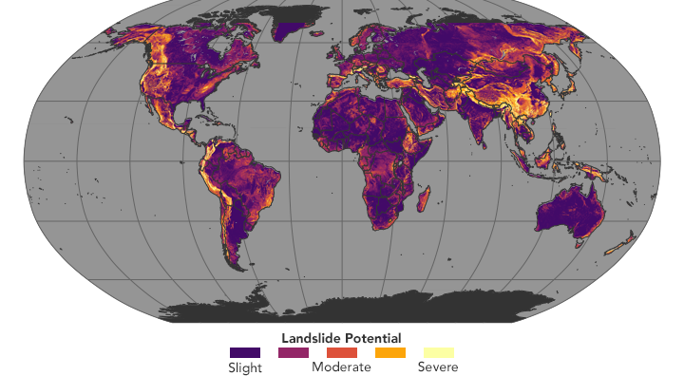

**Landslide Mitigation**

As already evaluated, landslides can be caused by many factors, thus, mitigation is crucial to preserve life and prevent associated destruction. For landslides to be prevented, proactive measures that focus on looking into the underlying causes must be combined with reducing the factors that address slope instability (Ma, Mei, & Piccialli, 2021). Geologists explain that even with the prevention mechanisms, landslides can still happen, especially in the highly susceptible areas. Populations in these areas are encouraged to remain responsive and vigilant to the changing conditions (Intrieri & Gigli, 2019). This means that they have to assess and regularly update preventive measures to be used.

Relevant authorities and agencies should conduct proper geotechnical analysis. Conducting thorough slope stability assessments and geotechnical investigations before carrying out human activities such as construction could be beneficial in the long term (Lissak, 2020). Through analysis, areas that are prone to landslips are identified, and appropriate architecture and engineering can be used for stabilization measures and design.

Planning of land usage goes a long way in addressing many challenges associated with landslides. Governments have to come up with policies that govern land usage and planning procedures, especially in areas that are highly susceptible to landslides. People should avoid or restrict development projects that involve construction in high-risk areas. These include locations with weak and unstable soils, steep slopes, and places with landslide history.

One crucial prevention mechanism against landslides is stabilizing slopes. Professionals have to be brought in to employ stabilization techniques that reinforce the vulnerable places, such as slopes. Some of the slope stabilization mechanisms are soil nailing, better drainage systems, terracing, placing rock bolts, and building retaining walls. Such measures help improve stability and strengthen slopes. Control measures to curb erosion, such as planting resistant vegetation and control blankets, would go a long way in protecting these areas.

Managing vegetation helps maintain and preserve topographies that are high-risk landslide areas. Grass, shrubs, and trees all play an essential role in stabilizing slopes by holding the soil together, absorbing excessive water, and reducing soil erosion (Ma, Mei, & Piccialli, 2021). Whenever vegetation is managed sustainably, other issues, such as deforestation, can be better addressed. Another area that has to be managed properly is water. Surface water control is effective in preventing erosion and saturation.

**References**

Intrieri, E. & Gigli, G. (2019). Forecasting the time of failure of landslides at slope-scale: A literature review. *Earth-science reviews*, *193*, 333-349.

Lacroix, P., Handwerger, A. L., & Bièvre, G. (2020). Life and death of slow-moving landslides. *Nature Reviews Earth & Environment*, *1*(8), 404-419.

Lissak, C. (2020). Remote sensing for assessing landslides and associated hazards. *Surveys in Geophysics*, *41*, 1391-1435.

Lombardo, L. & Castro-Camilo, D. (2021). Landslide size matters: A new data-driven, spatial prototype. *Engineering geology*, *293*, 106288.

Ma, Z., Mei, G., & Piccialli, F. (2021). Machine learning for landslides prevention: a survey. *Neural Computing and Applications*, *33*, 10881-10907.

Pollock, W. & Wartman, J. (2020). Human vulnerability to landslides. *GeoHealth*, *4*(10), e2020GH000287.

Wang, H. & Li, J. (2021). Landslide identification using machine learning. *Geoscience Frontiers*, *12*(1), 351-364.