A state transition diagram is a graphical way of viewing truth tables. This is accomplished by looking at each individual initial state and its resultant state. The transition from one state to another is represented by an arrow. Then they are pieced together like a jigsaw puzzle until they fit in place. When one state leads to itself it simply points to itself. The following example is based on the truth table in the previous section.

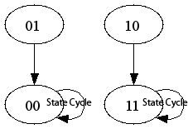

In this example, there are two state cycles. A state cycle is a combination of states around which the system continually enters and reenters. For a finite number of states, there will always exist at least one state cycle. A state cycle is also a pathway or a flowchart that shows the "decision making process" of a Boolean network. This feature is a direct result from two attributes of Boolean networks:

1. Finite number of states
2. Deterministic (there is a certain set of rules that determines the next state that will be entered)

In the example presented in the previous section, there were two state cycles. One advantage of state cycles is it easily allows you to see where your model will end up cycling and if there are any states that are not accounted for properly by your model. In the previous diagram, if the moisture controller indicated the humidity was below the set value, it would close the valve or hold the valve closed. If the moisture controller indicated that the humidity was above the set value, it would either open the valve or hold it open.  
  
Consider this alternate system.

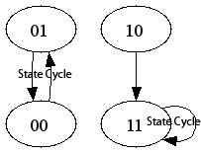

In this example, the state cycle says that if the meter says that the humidity is below the set point it would cycle the vent valve open and closed. This would hurt the system and is not a desired outcome of the model.  
  
For safety and functionality issues, a process control engineer would want to consider all possiblities in the design of any Boolean network modeling a real system.